Environmental Monitoring Report

PUBLIC

Project Number: 55307-001
Semi-Annual Report (April - September 2025)
October 2025

Bangladesh: Improving Urban Governance and Infrastructure Program

Prepared by the Management Design and Supervision Consultancy Services under Improving Urban Governance and Infrastructure Program (IUGIP) Local Government Engineering Department (LGED) for the Asian Development Bank (ADB).

This environmental monitoring report is a document of the borrower. The views expressed herein do not necessarily represent those of ADB's Board of Directors, Management, or Staff, and may be preliminary in nature. Your attention is directed to the “terms of use” section of ADB’s website.

In preparing any country program or strategy, financing any project, or by making any designation of or reference to a particular territory or geographic area in this document, ADB does not intend to make any judgments as to the legal or other status of any territory or area.

 |  | 

Government of the People’s Republic of Bangladesh
Local Government Engineering Department

Management Design and Supervision Consultancy Services under
Improving Urban Governance and Infrastructure Project [IUGIP]

Semi-Annual Environmental Monitoring Report
April 2025 - September 2025

Prepared by: Management Design and Supervision Consultancy Services under
Improving Urban Governance & Infrastructure Program (IUGIP)
Local Government Engineering Department (LGED)

TABLE OF CONTENTS

Abbreviations 1
Executive Summary 3
1. Introduction 22
1.1. Impact and Outputs 22
1.2. Location Map for the Program 23
1.3. Purpose of the Report 24
1.4. Scope of Works 24
1.5. Program Component and Status 24
1.6. Implementation Arrangement 25
1.7. Implementation Progress 25
1.8. Result Based Lending, RBL, Disbursement Link Indicator, DLI 26
2. Program’s Environmental Safeguards 26
2.1. ADB Safeguard Policy Statement, 2009 26
2.2. Status on environmental and social activities during the reporting period 26
2.2.1.Screening of Sub-Project by Result Based Lending (RBL) 26
2.2.2.REA Check list 27
2.2.3.Public Consultation 27
3. Statutory Environmental Requirements 27
3.1. Compliance Status on legislations 27
3.2. Compliance Status with Program Action Plan (PAP) for Environmental Safeguard related Actions 27
4. Loan Covenant Compliance 30
5. Compliance with the steps of ESMF 31
6. Compliance with EMP Implementation 31
6.1 Compliance with EMP measures 31
6.2 Mission Corrective Action Plan (CAP) for Environmental Safeguards 33
6.3 Items incorporated in the BoQ for each sub-projects 38
6.4 EMP on Bidding Documents 38
6.5 Monitoring and Reporting on EMP 39
6.6 Summary of Quantitative and Qualitative Monitoring Data 39
6.7 Summary of Quantitative and Qualitative Monitoring 39
6.8 Summary of Environmental Monitoring Tests Performed 40
6.9 Trainings Conducted 40
6.10 Occupational Health and Safety Compliance 41
7. Public Consultation 42
8. Grievance Redress Mechanism (GRM) 52
9. Conclusion and Recommendations 55
ANNEXURES 56
Annex 1: Name of 88 (including O&M) numbers of Pourashavas 56
Annex 2: Participants Attendance and Photograph sheet of All Training Program. 59
Annex 3: Environmental and Social Management Plan Checklist 63
Annex 4: Site-specific environment management plan (SEMP) in Bangla 64
Annex 5: DoE’s letter on ECC exemption 67
Annex 6: Checklist on mitigation & monitoring of Environmental Compliance of Kaliakoir Poureshava 68
Annex 7: RBL and REA Checklist 72
Annex 8: GRM Diagram 74
Annex 9 : EMP Test Total Report 75
Annex 10: Environmental management Plan (EMP) items in BOQ 121
Annex 11: Environmental management Plan (EMP) items in detail Estimate Munshiganj Pourasava. 123
Annex 12 :Quarterly Environmental Monitoring Report of Araihazar Pourashava 125
Annex 13 : Program Related Photographs 134
Annex 14 : Sample of Grievance Register book picture 135
Annex 15 : Monthly Progress Report of sub-project 137
Annex 16 : Monthly Progress Report of LIN 147
Annex 17 : Environmental Focal Person & Safeguard Officer list 149

TABLES

Table 1: Compliance status of all packages IUGIP till 30 September 2025 4
Table 2: Scope of the program 24
Table 3: Status on environment safeguards PAP 28
Table 4: Compliance Status of Loan Covenant 30
Table 5: Status of Mission Corrective Action Plan (Environmental Safeguards) 33
Table 6: Summary of the environmental monitoring tests 40
Table 7: Summary on trainings conducted during Apr-Sep 2025 40
Table 8: Summary of Accident/Incident during this reporting period 42
Table 9:Total list of Public Consultation (October 2023 to till September 2025) 43
Table 10:Sample of Public Consultation 44
Table 11: First level GRC 53
Table 12: Second level GRC 53
Table 13:PMU (third level) GRC 54
Table 14:Summary of grievances during this reporting period 54

FIGURE

Figure 1: IUGIP Program Map 23

ABBREVIATIONS

ADB - Asian Development Bank
AFD - Agence Francaise de Development
Ap - Affective Person
DoE - Department of environment
DLI - Disbursement Link Indicator
EARF - Environmental Assessment and Review Framework
ECA - Environmental Conservation Act
ECC - Environmental Clearance Certificate
ECR - Environmental Conservation Rules
EIA - Environmental Impact Assessment
EMP - Environmental Management Plan
FD - Forest Department
GoB - Government of Bangladesh
GRC - Grievance Redressal Cell
GRM - Grievance Redress Mechanism
IEE - Initial Environmental Examination
IFT - Invitation for Tender
IUGIP - Improving Urban Governance and Infrastructure Program
LCC - Location Clearance Certificate
LGED - Local Government Engineering Department
MDSC - Management Design and Supervision Consultant
MLGRDC - Ministry of Local Government, Rural Development, Cooperatives
O&M - Operation and Maintenance
PAP - Program Action Plan
PMU - Project Management Unit
PPTA - Project Preparatory Technical Assistance
PRSP - Poverty Reduction Strategy Paper
RBL - Result-Based Lending
RP - Resettlement Plan
SEMR - Semi-annual Environmental Monitoring Report
SPS - Safeguard Policy Statement
ToR - Terms of Reference
UGIAP - Urban Governance Implementation Action Plan

GLOSSARY OF BANGLADESHI TERMS

Crore - 10 million (= 100 lakh)
Ghat - boat landing station
Khas, khash - belongs to government (e.g., land)
Katcha - poor quality, poorly built
Lakh, lac - 100,000
Madrasha - Islamic college
Mouza - government-recognized land area
Parishad - authority (Pourashava)
Pourashava - municipality
Pucca - good quality, well built, solid
Thana - police station
Upazila - sub district

EXECUTIVE SUMMARY
Environmental monitoring is an instrument to assess the environmental conditions and trends, and required compliances and their implementation. This semi-annual environmental Monitoring report (SEMR) provides an overview of the Improving Urban Governance and Infrastructure Program (IUGIP) compliance status against the applicable standards, laws and regulations for environment, health and safety and environmental safeguards requirements as per loan agreement for the period of April to September 2025. This SEMR also shows the implementation status of the mitigation measures and monitoring programmers suggested in the Program environmental management plans (EMP) at sites.

The local government engineering department (LGED) is responsible for the overall implementation, technical supervision and execution of the Program. They oversee and coordinate the implementation, monitoring and evaluation of the program; execute agreements with the Pourashava to ensure the effective implementation of IUGIP that is planned for 88 Pourashavas of Bangladesh.

The proposed results-based lending (RBL) and Disbursement Linked Indicator (DLI) for the IUGIP are built upon the successes and lessons learned from previous Urban Governance and Infrastructure Improvement Projects.

The Department of Environment (DoE) is responsible for the conservation, management, and development of the country's environment and natural resources. This DoE has confirmed based on the Environmental Conservation Rules (ECR), 2023 that activities of this IUGIP will not require obtaining any environmental clearance certificate (ECC) for their nature of small scale activities. As per ADB’s Safeguards Policy Statement (SPS), this program falls under category B. Furthermore, activities all in red category as per ECR, 2023 and category A as per ADB SPS are not supported by this program and program has been screening out such activities and excluded from the list of activities.

Construction ongoing or tendering is in process for 183 Packages, among of them construction are ongoing for 147 packages, 15 packages are awarded but construction is not started yet, 15 packages are in tender/bidding stage(evaluation and NOA Stage), five packages are Bid in Process(APP) and one package is retendering stage The table below, provides the compliance status of all packages of IUGIP till 30 September 2025. Compliance status is narrated further inside this report.

Table 1: Compliance status of all packages IUGIP till 30 September 2025
Note: UR : Urban Road, DR: Drain, MF: Municipal Facilities
Sl. No. | Name of Pourashav and type of subproject | Contract Commencement Date | Cumulative Physical Progress up to Reporting (Mar 2025) month | REA checklist was filled and approved by PMU | RBL checklist was filled and approved by PMU | IEE was prepared and approved by PMU | Approved IEE published to  LGED website | SEMP prepared and approved by PMU | Contractor opened injury or death insurance for labors | Obtained license by contractor (labor license/construction work license ) | Obtained clearance from forest department or any other organization | Obtained national clearances (DoE clearance) | Remarks
Works Ongoing
 | Bhanga  UR-01. | 9-Jan-24 | 40.58% | Yes | Yes | Yes | Yes | No | Yes | Yes | Not Required | Not Required | Work Ongoing
 | Bhanga  UR-02 | 20-Feb-24 | 54.64% | Yes | Yes | Yes | Yes | No | Yes | Yes | Not Required | Not Required | Work Ongoing
 | Bhanga  UR-03 | 2-Oct-24 | 45.23% | Yes | Yes | Yes | Yes | No | Yes | Yes | Not Required | Not Required | Work Ongoing
 | Bhanga  UR+DR-01 | 4-Jun-25 | 2.53% | Yes | Yes | Yes | Yes | No | yes | Yes | Not Required | Not Required | Work Ongoing
 | Boalmari  UR+DR-01 | 23-Jan-24 | 94.66% | Yes | Yes | Yes | Yes | No | Yes. | Yes | Not Required | Not Required | Work Ongoing
 | Boalmari  UR+DR-02 | 24-Jan-24 | 93.26% | Yes | Yes | Yes | Yes | No | Yes | Yes | Not Required | Not Required | Work Ongoing
 | Boalmari  UR-01 | 20-Nov-24 | 85.5% | Yes | Yes | Yes | Yes | No | Yes | Yes | Not Required | Not Required | Work Ongoing
 | Goalanda  UR+DR-01 | 8-Jan-24 | 69.62% | Yes | Yes | Yes | Yes | No | Yes | Yes | Not Required | Not Required | Work Ongoing
 | Goalanda  MF-01. | 31-Oct-24 | 21.32% | Yes | Yes | Yes | Yes | No | Yes | Yes | Not Required | Not Required | Work Ongoing
 | Goalanda  UR-01 | 10-Mar-24 | 69.03% | Yes | Yes | Yes | Yes | No | Yes. | Yes | Not Required | Not Required | Work Ongoing
 | Naria  UR+DR-01 | 5-Dec-23 | 81.38% | Yes | Yes | Yes | Yes | No | Yes | Yes | Not Required | Not Required | Work Ongoing
 | Naria  UR-01 | 5-Dec-23 | 90.98% | Yes | Yes | Yes | Yes | No | Yes | Yes | Not Required | Not Required | Work Ongoing
 | Naria  UR+DR-02 | 18-Aug-24 | 13.85% | Yes | Yes | Yes | Yes | No | Yes | Yes | Not Required | Not Required | Work Ongoing
 | Kalkini  UR+DR-01 | 12-Feb-24 | 77.11% | Yes | Yes | Yes | Yes | No | Yes | Yes | Not Required | Not Required | Work Ongoing
 | Kalkini  UR-01 | 24-Mar-24 | 75.70% | Yes | Yes | Yes | Yes | No | Yes | Yes | Not Required | Not Required | Work Ongoing
 | Kalkini  UR-02 | 15-Apr-24 | 54.09% | Yes | Yes | Yes | Yes | No | Yes | Yes | Not Required | Not Required | Work Ongoing
 | Kaliganj  UR+DR-01 | 30-Jan-24 | 97.64% | Yes | Yes | Yes | Yes | No | Yes | Yes | Not Required | Not Required | Work Ongoing
 | Kaliganj  UR+DR-02 | 7-Feb-24 | 98.22% | Yes | Yes | Yes | Yes | No | Yes | Yes | Not Required | Not Required | Work Ongoing
 | Kaliganj  UR+DR-03 | 15-Jun-24 | 67.06% | Yes | Yes | Yes | Yes | No | Yes | Yes | Not Required | Not Required | Work Ongoing
 | Kaliakoir  UR+DR-01 | 26-Jun-24 | 49.05% | Yes | Yes | Yes | Yes | Yes | Yes | Yes | Not Required | Not Required | Work Ongoing
 | Kaliakoir  UR+DR-02 | 7-Jul-24 | 83.90% | Yes | Yes | Yes | Yes | Yes | Yes | Yes | Not Required | Not Required | Work Ongoing
 | Kaliakoir  UR+DR-03 | 28-Aug-24 | 36.71% | Yes | Yes | Yes | Yes | Yes | Yes | Yes | Not Required | Not Required | Work Ongoing
 | Kaliakoir  UR+DR-04 | 19-Aug-24 | 42.18% | Yes | Yes | Yes | Yes | Yes | Yes | Yes | Not Required | Not Required | Work Ongoing
 | Kaliakoir  DR-01 | 19-Jun-25 | 8.04% | Yes | Yes | Yes | Yes | Yes | Yes | Yes | Not Required | Not Required | Work Ongoing
 | Munshiganj  UR+DR-01 | 13-Feb-24 | 73.70% | Yes | Yes | Yes | Yes | Yes | Yes | Yes | Not Required | Not Required | Work Ongoing
 | Munshiganj  UR+DR-02 | 4-Jan-24 | 85.49% | Yes | Yes | Yes | Yes | Yes | Yes | Yes | Not Required | Not Required | Work Ongoing
 | Manikganj  UR+DR-01 | 19-Jan-25 | 30.48% | Yes | Yes | Yes | Yes | No | Yes | Yes | Not Requied | Not Requied | Work Ongoing
 | Manikganj  UR+DR-02 | 13-May-25 | 4.26% | Yes | Yes | Yes | Yes | No | Yes | Yes | Not Requied | Not Requied | Work Ongoing
 | Manikganj  UR+DR-03 | 07-April-25 | 4.67% | Yes | Yes | Yes | Yes | No | Yes | Yes | Not Requied | Not Requied | Work Ongoing
 | Araihazar  UR+DR-01 | 13-Nov-23 | 71.59% | Yes | Yes | Yes | Yes | No | Yes | Yes | Not Required | Not Required | Work Ongoing
 | Araihazar  UR+DR-02 | 13-Nov-23 | 77.33% | Yes | Yes | Yes | Yes | No | Yes | Yes | Not Required | Not Required | Work Ongoing
 | Araihazar  UR+DR-04 | 20-Nov-23 | 97.32% | Yes | Yes | Yes | Yes | No | Yes | Yes | Not Required | Not Required | Work Ongoing
 | Araihazar  UR+DR-03 | 16-Jul-24 | 21.01% | Yes | Yes | Yes | Yes | No | Yes | Yes | Not Required | Not Required | Work Ongoing
 | Araihazar  UR+DR-05. | 10-Nov-24 | 45.24% | Yes | Yes | Yes | Yes | No | Yes | Yes | Not Required | Not Required | Work Ongoing
 | Monohordi  UR+DR-01 | 25-Apr-24 | 48.76% | Yes | Yes | Yes | Yes | No | Yes | Yes | Not Required | Not Required | Work Ongoing
 | Monohordi  UR+DR-02 | 9-Jul-24 | 31.82% | Yes | Yes | Yes | Yes | No | Yes | Yes | Not Required | Not Required | Work Ongoing
 | Monohordi  UR-01 | 25-Aug-24 | 60.59% | Yes | Yes | Yes | Yes | No | Yes | Yes | Not Required | Not Required | Work Ongoing
 | Bharib  UR+DR-01 | 23-Apr-25 | 18.47% | Yes | Yes | Yes | Yes | No | Yes | Yes | Not Required | Not Required | Work Ongoing
 | Hossainpur  UR+DR-01 | 13-Feb-24 | 36.81% | Yes | Yes | Yes | Yes | No | Yes | Yes | Not Required | Not Required | Work Ongoing
 | Hossainpur  DR-02 | 13-Feb-24 | 28.01% | Yes | Yes | Yes | Yes | No | Yes | Yes | Not Required | Not Required | Work Ongoing
 | Pakundia  UR-01 | 10-Apr-25 | 11.67% | Yes | Yes | Yes | Yes | No | Yes | Yes | Not Required | Not Required | Work Ongoing
 | Madhupur  UR+DR-01 | 9-Jan-24 | 67.71% |  | Yes | Yes | Yes | No | Yes | Yes | Not Required | Not Required | Work Ongoing
 | Madhupur  UR-01 | 8-Jan-24 | 83.82% | Yes | Yes | Yes | Yes | No | Yes | Yes | Not Required | Not Required | Work Ongoing
 | Madhupur  UR-03 | 8-Jan-24 | 75.03% | Yes | Yes | Yes | Yes | No | Yes | Yes | Not Required | Not Required | Work Ongoing
 | Madhupur  UR+DR--02 | 2-Apr-24 | 32.30% | Yes | Yes | Yes | No | No | Yes | Yes | Not Required | Not Required | Work Ongoing
 | Gafargaon  UR+DR-01 | 1-Sep-25 | 0.63% | Yes | Yes | Yes | Yes | No | Yes | Yes | Not Required | Not Required | Work Ongoing
 | Brahmanbaria UR+DR-01 | 30-Nov-23 | 76.55% | Yes | Yes | Yes | Yes | No | Yes | Yes | Not Required | Not Required | Work Ongoing
 | Brahmanbaria. UR+DR-02 | 4-Jan-24 | 63.93% | Yes | Yes | Yes | Yes | No | Yes | Yes | Not Required | Not Required | Work Ongoing
 | Brahmanbaria  UR+DR-03 | 14-Mar-24 | 86.83% | Yes | Yes | Yes | Yes | No | Yes | Yes | Not Required | Not Required | Work Ongoing
 | Sandwip  UR+DR-01 | 5-Feb-24 | 76.7% | Yes | Yes | Yes | Yes | No | Yes | Yes | Not Required | Not Required | Work Ongoing
 | Sandwip  UR-01 | 27-Apr-24 | 57.82% | Yes | Yes | Yes | Yes | No | Yes | Yes | Not Required | Not Required | Work Ongoing
 | Banskhali  UR+DR-01 | 8-Feb-24 | 81.92% | Yes | Yes | Yes | Yes | No | Yes | Yes | Not Required | Not Required | Work Ongoing
 | Banskhali  UR+DR-02 | 28-Jan-24 | 93.94% | Yes | Yes | Yes | Yes | No | Yes | Yes | Not Required | Not Required | Work Ongoing
 | Banskhali  UR+DR -03 | 14-Jul-24 | 39.22% | Yes | Yes | Yes | Yes | No | Yes | Yes | Not Required | Not Required | Work Ongoing
 | Chandanaish  UR-01 | 28-Apr-24 | 56.21% | Yes | Yes | Yes | Yes | No | Yes | Yes | Not Required | Not Required | Work Ongoing
 | Chandanaish  UR-02 | 29-Apr-24 | 26.7% | Yes | Yes | Yes | Yes | No | Yes | Yes | Not Required | Not Required | Work Ongoing
 | Raozan  UR+DR-01 | 22-Apr-24 | 69.42% | Yes | Yes | Yes | Yes | No | Yes | Yes | Not Required | Not Required | Work Ongoing
 | Raozan  MF-01 | 19-May-24 | 47.79% | Yes | Yes | Yes | No | No | Yes | Yes | Not Required | Not Required | Work Ongoing
 | Raozan  UR-02 | 1-Aug-24 | 41.99% | Yes | Yes | Yes | Yes | No | Yes | Yes | Not Required | Not Required | Work Ongoing
 | Haziganj  UR+DR-01 | 14-Jan-24 | 85.16% | Yes | Yes | Yes | Yes | No | Yes | Yes | Not Required | Not Required | Work Ongoing
 | Haziganj  DR-01 | 14-Jan-24 | 90.61% | Yes | Yes | Yes | Yes | No | Yes | Yes | Not Required | Not Required | Work Ongoing
 | Haziganj  DR-04 | 20-Mar-24 | 55.18% | Yes | Yes | Yes | Yes | No | Yes | Yes | Not Required | Not Required | Work Ongoing
 | Matlab  UR+DR.-01 | 1-Feb-24 | 81.13% | Yes | Yes | Yes | Yes | No | Yes | Yes | Not Required | Not Required | Work Ongoing
 | Matlab  UR+DR-02 | 1-Feb-24 | 57.14% | Yes | Yes | Yes | Yes | No | Yes | Yes | Not Required | Not Required | Work Ongoing
 | Matlab  UR-02 | 12-Dec-24 | 62.66% | Yes | Yes | Yes | Yes | No | Yes | Yes | Not Required | Not Required | Work Ongoing
 | Matlab  UR+DR-03 | 1-Feb-24 | 2.27% | Yes | Yes | Yes | Yes | No | Yes | Yes | Not Required | Not Required | Work Ongoing
 | Faridganj  UR+DR-02 | 6-Mar-24 | 50.54% | Yes | Yes | Yes | Yes | No | Yes | Yes | Not Required | Not Required | Work Ongoing
 | Faridganj  UR-01 | 3-Mar-24 | 57.31% | Yes | Yes | Yes | Yes | No | Yes | Yes | Not Required | Not Required | Work Ongoing
 | Sonagazi  UR+DR -01 | 25-Feb-24 | 91.42% | Yes | Yes | Yes | Yes | No | Yes | Yes | Not Required | Not Required | Work Ongoing
 | Rangamati  UR+DR-01 | 10-Apr-25 | 20.27% | Yes | Yes | Yes | Yes | No | Yes | Yes | Not Required | Not Required | Work Ongoing
 | Khagrachori  UR+DR-01 | 15-Nov-23 | 94.58% | Yes | Yes | Yes | Yes | No | Yes | Yes | Not Required | Not Required | Work Ongoing
 | Khagrachori  UR+DR-02 | 19-Nov-23 | 94.32% | Yes | Yes | Yes | Yes | No | Yes | Yes | Not Required | Not Required | Work Ongoing
 | Khagrachori  UR+DR-03 | 17-Jan-24 | 95.20% | Yes | Yes | Yes | Yes | No | Yes | Yes | Not Required | Not Required | Work Ongoing
 | Khagrachori  UR+DR-04 | 30-May-24 | 91.32% | Yes | Yes | Yes | Yes | No | Yes | Yes | Not Required | Not Required | Work Ongoing
 | Bandarban  UR+DR-01 | 28-May-24 | 71.87% | Yes | Yes | Yes | Yes | No | Yes | Yes | Not Required | Not Required | Work Ongoing
 | Bandarban  UR+DR-02 | 23-Jan-25 | 72.04% | Yes | Yes | Yes | Yes | No | Yes | Yes | Not Required | Not Required | Work Ongoing
 | Bandarban  UR+DR-03 | 16-July-25 | 1.65% | Yes | Yes | Yes | Yes | No | Yes | Yes | Not Required | Not Required | Work Ongoing
 | Chowmuhani  UR+DR-01 | 27-Nov-23 | 19.06% | Yes | Yes | Yes | Yes | No | Yes | Yes | Not Required | Not Required | Work Ongoing
 | Chowmuhani  UR-01 | 27-Nov-23 | 75.61% | Yes | Yes | Yes | Yes | No | Yes | Yes | Not Required | Not Required | Work Ongoing
 | Chowmuhani  UR-03 | 30-May-24 | 24.45% | Yes | Yes | Yes | Yes | No | Yes | Yes | Not Required | Not Required | Work Ongoing
 | Raipur  UR-01 | 20-Mar-24 | 19.30% | Yes | Yes | Yes | Yes | No | Yes | Yes | Not Required | Not Required | Work Ongoing
 | Raipur  UR+DR-03 | 6-Feb-24 | 24.89% | Yes | Yes | Yes | Yes | No | Yes | Yes | Not Required | Not Required | Work Ongoing
 | Chunarughat UR-01 | 22-Nov-23 | 51.67% | Yes | Yes | Yes | Yes | No | Yes | Yes | Not Required | Not Required | Work Ongoing
 | Chunarughat  UR+DR-01 | 22-Nov-23 | 24.08% | Yes | Yes | Yes | Yes | No | Yes | Yes | Not Required | Not Required | Work Ongoing
 | Chunarughat  UR-02 | 14-Feb-24 | 19.39% | Yes | Yes | Yes | No | No | Yes | Yes | Not Required | Not Required | Work Ongoing
 | Kulaura  UR+DR-01 | 30-Jan-24 | 63.0% | Yes | Yes | Yes | Yes | No | Yes | Yes | Not Required | Not Required | Work Ongoing
 | Kulaura  UR+DR-03 | 25-Mar-24 | 31.87% | Yes | Yes | Yes | Yes | No | Yes | Yes | Not Required | Not Required | Work Ongoing
 | Kulaura  UR+DR-05 | 15-Apr-24 | 24.76% | Yes | Yes | Yes | Yes | No | Yes | Yes | Not Required | Not Required | Work Ongoing
 | Moulvibazar UR+DR-01 | 11-Feb-24 | 34.66% | Yes | Yes | Yes | Yes | No | Yes | Yes | Not Required | Not Required | Work Ongoing
 | Moulvibazar UR+DR-02 | 5-Mar-24 | 87.12% | Yes | Yes | Yes | Yes | No | Yes | Yes | Not Required | Not Required | Work Ongoing
 | Moulvibazar UR+DR-03 | 10-Aug-24 | 0.17% | Yes | Yes | Yes | Yes | No | Yes | Yes | Not Required | Not Required | Work Ongoing
 | Chakat  UR+DR-01 | 30-May-25 | 5.36% | Yes | Yes | Yes | Yes | No | Yes | Yes | Not Required | Not Required | Work Ongoing
 | Bheramara  UR+DR-01 | 4-Feb-24 | 90.93% | Yes | Yes | Yes | Yes | No | Yes | Yes | Not Required | Not Required | Work Ongoing
 | Bheramara  UR+DR-02 | 7-Jul-24 | 27.32% | Yes | Yes | Yes | No | No | Yes | Yes | Not Required | Not Required | Work Ongoing
 | Bheramara  UR+DR.-04 | 15-Feb-24 | 66.95% | Yes | Yes | Yes | No | No | Yes | Yes | Not Required | Not Required | Work Ongoing
 | Bheramara  DR-01. | 5-Jan-25 | 39.45% | Yes | Yes | Yes | Yes | No | Yes | Yes | Not Required | Not Required | Work Ongoing
 | Mohespur  UR+DR-01 | 7-Apr-25 | 3.61% | Yes | Yes | Yes | Yes | No | Yes | Yes | Not Required | Not Required | Work Ongoing
 | Kumarkhali  UR+DR-01 | 4-Mar-24 | 57.01% | Yes | Yes | Yes | No | No | Yes | Yes | Not Required | Not Required | Work Ongoing
 | Kumarkhali  UR+DR -02 | 1-Jul-24 | 59.76% | Yes | Yes | Yes | No | No | Yes | Yes | Not Required | Not Required | Work Ongoing
 | Kumarkhali  UR+DR -03 | 1-Jul-24 | 60.77% | Yes | Yes | Yes | No | No | Yes | Yes | Not Required | Not Required | Work Ongoing
 | Kumarkhali  UR+DR -05 | 1-Jul-24 | 4.18% | Yes | Yes | Yes | Yes | No | Yes | Yes | Not Required | Not Required | Work Ongoing
 | Gangni  UR+DR-01 | 8-Nov-23 | 81.0% | Yes | Yes | Yes | Yes | No | Yes | Yes | Not Required | Not Required | Work Ongoing
 | Gangni  MF-01 | 26-Dec-23 | 18.15% | Yes | Yes | Yes | Yes | No | Yes | Yes | Not Required | Not Required | Work Ongoing
 | Gangni  UR-01 | 20-May-24 | 62.92% | Yes | Yes | Yes | Yes | No | Yes | Yes | Not Required | Not Required | Work Ongoing
 | Gangni  DR-01 | 06-Apr-25 | 12.32% | Yes | Yes | Yes | Yes | No | Yes | Yes | Not Required | Not Required | Work Ongoing
 | Alomdanga  UR+DR-01 | 22-Feb-24 | 100% | Yes | Yes | Yes | Yes | No | Yes | Yes | Not Required | Not Required | Work Ongoing
 | Alomdanga  UR+DR-02 | 31-Oct-24 | 54.60% | Yes | Yes | Yes | Yes | No | Yes | Yes | Not Required | Not Required | Work Ongoing
 | Keshobpur  UR+DR-01 | 25-Jan-24 | 86.37% | Yes | Yes | Yes | Yes | No | Yes | Yes | Not Required | Not Required | Work Ongoing
 | Keshobpur  UR-02 | 29-Apr-24 | 91.55% | Yes | Yes | Yes | Yes | No | Yes | Yes | Not Required | Not Required | Work Ongoing
 | Keshobpur  UR-01 | 15-Feb-24 | 96.05% | Yes | Yes | Yes | Yes | No | Yes | Yes | Not Required | Not Required | Work Ongoing
 | Keshobpur  MF-01 | 16-April-25 | 0.10% | Yes | Yes | Yes | Yes | No | Yes | Yes | Not Required | Not Required | Work Ongoing
 | Santhia  UR-01 | 15-Nov-23 | 92.30% | Yes | Yes | Yes | Yes | No | Yes | Yes | Not Required | Not Required | Work Ongoing
 | Santhia  UR+DR-01 | 15-Nov-23 | 94.40% | Yes | Yes | Yes | Yes | No | Yes | Yes | Not Required | Not Required | Work Ongoing
 | Santhia  UR-02 | 23-Feb-25 | 5.85% | Yes | Yes | Yes | Yes | No | Yes | Yes | Not Required | Not Required | Work Ongoing
 | Naohata  UR-01 | 26-Dec-23 | 81.86% | Yes | Yes | Yes | Yes | No | Yes | Yes | Not Required | Not Required | Work Ongoing
 | Naohata  UR+DR-01 | 4-Feb-24 | 26.91% | Yes | Yes | Yes | Yes | No | Yes | Yes | Not Required | Not Required | Work Ongoing
 | Naohata-UR-02 | 12 Mar-25 | 0.58% | Yes | Yes | Yes | Yes | No | Yes | Yes | Not Required | Not Required | Work Ongoing
 | Bhawaniganj UR+DR-01 | 5-Feb-24 | 67.65% | Yes | Yes | Yes | Yes | No | Yes | Yes | Not Required | Not Required | Work Ongoing
 | Bhawaniganj UR-01 | 28-Mar-24 | 97.36% | Yes | Yes | Yes | Yes | No | Yes | Yes | Not Required | Not Required | Work Ongoing
 | Bhawaniganj UR-02 | 24-Jul-24 | 23.31% | Yes | Yes | Yes | Yes | No | Yes | Yes | Not Required | Not Required | Work Ongoing
 | Rohanpur  UR+DR-01 | 10-Feb-24 | 100% | Yes | Yes | Yes | Yes | No | Yes | Yes | Not Required | Not Required | Work Ongoing
 | Rohanpur  MF-01 | 4-Apr-24 | 52% | Yes | Yes | Yes | Yes | Yes | Yes | Yes | Not Required | Not Required | Work Ongoing
 | Rohanpur  UR-01 | 10-Feb-24 | 100% | Yes | Yes | Yes | Yes | No | Yes | Yes | Not Required | Not Required | Work Ongoing
 | Baga  UR+DR-01 | 10-May-25 | 4.61% | Yes | Yes | Yes | Yes | No | Yes | Yes | Not Required | Not Required | Work Ongoing
 | Shibganj UT+DR-01 | 16-Mar-25 | 7.50% | Yes | Yes | Yes | Yes | No | Yes | Yes | Not Required | Not Required | Work Ongoing
 | Sundarganj  UR+DR-02 | 21-Nov-24 | 38.76% | Yes | Yes | Yes | Yes | No | Yes | Yes | Not Required | Not Required | Work Ongoing
 | Sundarganj  UR+DR-01 | 12-Feb-25 | 39.92% | Yes | Yes | Yes | Yes | No | Yes | Yes | Not Required | Not Required | Work Ongoing
 | Ulipur  UR+DR-01 | 4-Dec-23 | 68.18% | Yes | Yes | Yes | Yes | No | Yes | Yes | Not Required | Not Required | Work Ongoing
 | Ulipur  UR-01 | 4-Feb-24 | 61.34% | Yes | Yes | Yes | Yes | No | Yes | Yes | Not Required | Not Required | Work Ongoing
 | Ulipur  UR-03 | 24-Nov-24 | 43.56% | Yes | Yes | Yes | Yes | No | Yes | Yes | Not Required | Not Required | Work Ongoing
 | Ulipur  UR-02 | 4-Nov-24 | 24.78% | Yes | Yes | Yes | Yes | No | Yes | Yes | Not Required | Not Required | Work Ongoing
 | Patgram  UR+DR-01 | 17-Jan-24 | 65.80% | Yes | Yes | Yes | Yes | No | Yes | Yes | Not Required | Not Required | Work Ongoing
 | Patgram  UT+DR-02 | 5-Aug-24 | 20.91% | Yes | Yes | Yes | Yes | No | Yes | Yes | Not Required | Not Required | Work Ongoing
 | Patgram  UR+DR-03 | 24-Nov-24 | 18.90% | Yes | Yes | Yes | Yes | No | Yes | Yes | Not Required | Not Required | Work Ongoing
 | Tungipara  UR+DR-02 | 16-Oct-24 | 60.04% | Yes | Yes | Yes | Yes | No | Yes | Yes | Not Required | Not Required | Work Ongoing
 | Mirkadim  UR+DR -01 | 4-Dec-24 | 64.38% | Yes | Yes | Yes | No | No | Yes | Yes | Not Required | Not Required | Work Ongoing
 | Mirkadim  UR+DR-02 | 19-Jan-25 | 66.41% | Yes | Yes | Yes | Yes | No | Yes | Yes | Not Required | Not Required | Work Ongoing
 | Madan  UR+DR-01 | 24-Jul-24 | 39.21% | Yes | Yes | Yes | Yes | No | Yes | Yes | Not Required | Not Required | Work Ongoing
 | Madan  UR-01 | 26-Dec-24 | 60.34% | Yes | Yes | Yes | Yes | No | Yes | Yes | Not Required | Not Required | Work Ongoing
 | Nazirhat  UR+DR-01 | 17-Dec-24 | 29.42% | Yes | Yes | Yes | No | No | Yes | Yes | Not Required | Not Required | Work Ongoing
- ` | Nazirhat  UR+_DR-02 | 17-Dec-24 | 15.22% | Yes | Yes | Yes | Yes | No | Yes | Yes | Not Required | Not Required | Work Ongoing
 | Basurhat  UR+DR -01 | 12-March-25 | 30.05% | Yes | Yes | Yes | Yes | No | Yes | Yes | Not Required | Not Required | Work Ongoing
 | Basurhat  UR+DR -02 | 12-March-25 | 25.88% | Yes | Yes | Yes | Yes | No | Yes | Yes | Not Required | Not Required | Work Ongoing
 | Sariakandi  UR+DR-01 | 22-JAN-25 | 20.11% | Yes | Yes | Yes | Yes | No | Yes | Yes | Not Required | Not Required | Work Ongoing
 | Sariakandi  UR+DR-02 | 22-JAN-25 | 18.37% | Yes | Yes | Yes | Yes | No | Yes | Yes | Not Required | Not required | Work Ongoing
 | Nazipur  UR+DR-01 | 18-Feb-25 | 23.84% | Yes | Yes | Yes | Yes | No | Yes | Yes | Not Required | Not Required | Work Ongoing
 | Nazipur  UR+DR-02 | 16-Apr-25 | 5.68% | Yes | Yes | Yes | Yes | No | Yes | Yes | Not Required | Not Required | Work Ongoing
Contract awarded but no construction work started
1 | Mirkadim  UR+DR-03 | 14-Sep-25 | 00% | Yes | Yes | Yes | Yes | No | Yes | Yes | Not Required | Not Required | Contract awarded but no construction work started
2 | Sonagazi-UR+DR-02 | 15-Aug-25 | 00% | Yes | Yes | Yes | Yes | No | Yes | Yes | Not Required | Not Required | Contract awarded but no construction work started
3 | Sonagazi-UR+DR-04 | 12 Aug-25 | 00% | Yes | Yes | Yes | Yes | No | Yes | Yes | Not Required | Not Required | Contract awarded but no construction work started
4 | Shibganj UT+DR-02 | 07-July-25 | 00% | Yes | Yes | Yes | Yes | No | Yes | Yes | Not Required | Not Required | Contract awarded but no construction work started
5 | Dagunbhuia  UR+DR-01 | 07-July-25 | 00% | Yes | Yes | Yes | Yes | No | Yes | Yes | Not Required | Not Required | Contract awarded but no construction work started
6 | Dagunbhuia  UR+DR-02 | 17-July-25 | 00% | Yes | Yes | Yes | Yes | No | Yes | Yes | Not Required | Not Required | Contract awarded but no construction work started
7 | sathia  MF-01 |  | Work not started | Yes | Yes | Yes | Yes | No | Yes | Yes | Not Required | Not Required | Contract awarded but no construction work started
8 | Ramgati  UT+DR-02 | 21-May-24 | 00% | Yes | Yes | Yes | Yes | No | Yes | Yes | Not Required | Not Required | Contract awarded but no construction work started
9 | Ramgati  UT+DR-01 | 21-May-24 | 00% | Yes | Yes | Yes | Yes | No | Yes | Yes | Not Required | Not Required | Contract awarded but no construction work started
10 | Monirampur  UR+DR-01 | 27-July-25 | 00% | Yes | Yes | Yes | Yes | No | Yes | Yes | Not Required | Not Required | Contract awarded but no construction work started
11 | Charghat  UR+DR-01 | 18-Aug-25 | 00% | Yes | Yes | Yes | Yes | No | Yes | Yes | Not Required | Not Required | Site not handover to contractor due to land problem.
12 | Kesorhat  UR+DR-01 |  | 00% | Yes | Yes | Yes | Yes | No | Yes | Yes | Not Required | Not Required | Site not handover to contractor due to land problem.
13 | Gangni  MF-02 |  | Work not started | Yes | Yes | Yes | Yes | No | Yes | Yes | Not Required | Not Required | Site not handover to contractor due to land problem.
14 | Nakla  UR+DR-01 | 20-July-25 | 00% | Yes | Yes | Yes | Yes | No | Yes | Yes | Not Required | Not Required
15 | Mohespur  UR+DR-02 | 25-Aug-25 | 00% | Yes | Yes | Yes | Yes | No | Yes | Yes | Not Required | Not Required
Package in tender/bidding stage
1 | Kalkini  UR+DR-03 | Work not started | 00% | Yes | Yes | Yes | Yes | No | Yes | Yes | Not Required | Not Required | Package  in tender/  bidding stage
2 | Manikganj UR+DR-04 | Not Finalized | 00% | Yes | Yes | Yes | Yes | No | Yes | Yes | Not Required | Not Required | Package  in tender/  bidding stage
3 | Munsiganj  UR+DR-03 | Not Finalized | 00% | Yes | Yes | Yes | Yes | No | Yes | Yes | Not Required | Not Required | Package  in tender/  bidding stage
4 | MADAN  UR+DR-02 | Not Finalized | 00% | Yes | Yes | Yes | Yes | No | Yes | Yes | Not Required | Not Required | Package  in tender/  bidding stage
5 | Raipur  UR+DR-01 | Not Finalized | 00% | Yes | Yes | Yes | Yes | No | Yes | Yes | Not Required | Not Required | Package  in tender/  bidding stage
6 | Kaliganj  UR+DR-04 | Not Finalized | 00% | Yes | Yes | Yes | Yes | No | No | Yes | Not Required | Not Required | Package  in tender/  bidding stage
7 | Daganbhuiyan  UR+DR-03 | Not Finalized | 00% | Yes | Yes | Yes | Yes | No | No | Yes | Not Required | Not Required
8 | Ramganj  UR+DR-01. | Not Finalized | 00% | Yes | Yes | Yes | Yes | Yes | No | Yes | Not Required | Not Required
9 | Ramganj  UR+DR-02 | Not Finalized | 00% | Yes | Yes | Yes | Yes | Yes | No | Yes | Not Required | Not Required
10 | Ramgati  UR+DR-02 | Not Finalized | 00% | Yes | Yes | Yes | Yes | Yes | No | Yes | Not Required | Not Required
11 | ALAMDANGA  UR+DR-03 | Not Finalized | 00% | Yes | Yes | Yes | Yes | Yes | No | Yes | Not Required | Not Required
12 | BHERAMARA  UR+DR-03 | Not Finalized | 00% | Yes | Yes | Yes | Yes | Yes | No | Yes | Not Required | Not Required
13 | Baga  UR+DR-02 | Not Finalized | 00% | Yes | Yes | Yes | Yes | Yes | No | Yes | Not Required | Not Required
14 | Rohanpur  UR+DR-02 | Not Finalized | 00% | Yes | Yes | Yes | Yes | Yes | No | Yes | Not Required | Not Required
15 | Monirampur  UR+DR-02 | Not Finalized | 00% | Yes | Yes | Yes | Yes | Yes | No | Yes | Not Required | Not Required
Bid in Process

1 | Kaliganj  UR+DR-04 | Not Finalized | 00% | Yes | Yes | Yes | Yes | Yes | No | Yes | Not Required | Not Required | Bid in Process
2 | Bhairab  UR+DR-02 | Not Finalized | 00% | Yes | Yes | Yes | Yes | Yes | No | Yes | Not Required | Not Required | Bid in Process
3 | Modupur  UR-02 | Not Finalized | 00% | Yes | Yes | Yes | Yes | Yes | No | Yes | Not Required | Not Required | Bid in Process
4 | Matlab  UR+DR-04 | Not Finalized | 00% | Yes | Yes | Yes | No | Yes | No | Yes | Not Required | Not Required | Bid in Process
5 | Ramganj  UR+DR-03 | Not Finalized | 00% | Yes | Yes | Yes | Yes | Yes | No | Yes | Not Required | Not Required | Bid in Process
Work Order Cancelled
1 | Tungipara  UR | N/A | N/A | Yes | Yes | Yes | No | No | No | Yes | Not Required | Not Required | Work Order Cancelled
Work Retendered
1 | Pakundia  UT+DR-01 | Not Finalized | N/A | Yes | Yes | Yes | Yes | No | No | Yes | Not Required | Not Required | Re-biding process

Total 183 number of subprojects are in construction ongoing / tender processing stages and total 28 Low-income Neighborhoods (LIN) (total 128 lots) packages have been approved. Out of the total of 183 packages, 126 are urban transport road and drainage packages, seven are drainage, 15 are urban transport, and seven are market facilities. During this reporting period (April 25 to September 25), a total new 17 sub-projects have been contracted and construction is underway, and under tender/Bid process. All of the subprojects have been screened by Environmental checklist and none of this sub-project was dropped due to high-risk category meanng none of them selected were of category A as per ADB SPS 2009 or red category as per ECR, 2023 of Bangladesh government . REA checklist for subproject, filled in different Pourashavas. Public Consultation conducted as a continuous process by the PIU as ongoing basis and starting from April till September 2025, Thirty-two (32) Public Consultations have been conducted. A total of 170 Initial Environmental Examinations (IEE) have been published in the LGED website.

In LGED, the Program Management Unit (PMU) is responsible for the overall compliance to the ADB’s SPS 2009 and the all-applicable laws and rules under the Ministry of Environment, Forest and Climate Change (MoEFCC). The PMU has been supported by a Senior Resettlement/Social Safeguard Specialist (consultant) and an Environmental Specialist (consultant) responsible to ensure the Program complies with the social and environmental safeguard requirements of the ADB. Monitoring of mitigation measures during construction are the responsibility of the PIU, Environmental Management is supported by the Environmental Specialists. As of the end of September 2025, sub-projects work status in the Pourashavas (Road and Drainage) are in various stages of tendering process. IEE along with Environmental Management Plan (EMP) have been prepared for all of these Pourashavas for Road and Drainage. To ensure proper and effective implementation of various measures of EMP even by associated contractors, EMP has been made as part of contract document.

IUGIP has agreed Program Action Plan (PAP) for environment safeguards issues, and it has made good progress on the action items of the PAP.

Reference to para 9 of the Loan Agreement, in IUGIP all program actions, in the area of Environmental and Social Safeguards, are in the line of implementation in a timely and efficient manner. To be compliant with loan covenant, a thorough screening has already been conducted, prior to the commencement of any construction or rehabilitation work under IUGIP. It has been ensured that neither of the packages may be classified as category A for Environmental Impacts as per SPS 2009. It has been ensured that the preparation, design, construction, implementation, operation and decommissioning of all activities under IUGIP comply with (i) all applicable laws, regulations and guidelines of Bangladesh relating to Environment, Health and Safety. (ii) Environmental Safeguards and (iii) All measures and requirements, including monitoring requirements set forth in the PAP.

As a continual process, the PMU is monitoring the progress of EMP implementation. The monitoring activities were noted corresponding with the program’s risks and impacts. The contractors have submitted monthly Environmental Monitoring Report covering the mitigation measures listed in this EMP. The findings say that the EMP has been followed at the site and implementation of the EMP has found satisfactory.

LGED has conducted eight training courses from April to September 2025 which were- April 16 to 17, 2025 at RTC, LGED, Jeshore, May 04 to 05, 2025 at RTC,LGED, Mymensing, May 13 to 14, 2025 at RTC, LGED, Bogra, May 25 to 26, 2025 at RTC,LGED,Chattogram, May 27 to 28, 2025 at RTC, LGED,Comilla, May 29, 2025 at RTC,LGED, Comilla, June 19, 2025 at
RDEC Bhaban, Level-11,Dhaka, and June 22, 2025 at RDEC Bhaban, Level-11, Dhaka. Training courses covered topics on Gender, Environmental & Social Safeguard , Contract Management , Climate change & quality control of infrastructure for Contarctors and Engineers working at pourashava level. Social Safeguard Specialist, Environmental Safeguard Specialist, Procurement Specialist, Climate Change Specialist and Quality Control Engineers from Management Development and Supervision Consulting Services (MDSC) and Gender Specialist from GICD Consultants of IUGIP participated the training programs as resource persons. Information of these training programs have given in the following Table 7.
In IUGIP, the Grievance Redress Mechanism (GRM) has already been established and it is functional. However, Some Pourashavas have registered some grievances during the reporting period. Picture of grievance registered books included Annex 14

Introduction
This Urban Governance and Infrastructure Improvement Program (UGIIP)—supported and financed by the Asian Development Bank (ADB) as the results-based lending (RBL) program that is being implemented to improve urban governance and services in 88 pourashavas of Bangladesh from . The program will (i) strengthen institutional capacity for inclusive municipal governance; and (ii) improve municipal infrastructure in terms of quality, access, resilience, and gender responsiveness. The program will support the Government of Bangladesh in achieving integrated and sustainable urban development to improve the livability of pourashavas.IUGIP will contribute in reducing regional disparities and encounter local economic development. The ESMF was prepared to provide guidance framework aligned with national laws of GoB and SPS 2009 of ADB. This program under RBL modality will cover 88 Pourashavas listed in Annex 1.

Impact and Outputs

The RBL program's impact is urban poverty reduced and living conditions improved and it has the below Outputs:

Output 1: Institutional capacity for inclusive municipal governance strengthened. The RBL program will improve the livability and holding tax collection efficiency of target pourashavas by supporting the LGD, the LGED, and selected pourashavas to achieve inclusive municipal governance by (i) institutionalizing the criteria-based government development budget transfer to pourashavas (DLI 2); (ii) implementing urban governance improvement action plans (UGIAPs) in 88 pourashavas (DLI 3); (iii) computerizing (web-based) revenue management systems in 88 pourashavas (DLI 3); (iv) establishing a gender and climate-responsive operation and maintenance (O&M) management system in 88 pourashava (DLI 6); (v) training 1,550 staff (including 90% of eligible women staff and female councilors of pourashavas, the LGED, and the LGD) on urban governance, tax management, citizen participation, and climate-resilient urban planning (DLI 3 and DLI 5); (vi) earmarking at least 1% of the municipal revenue budget for implementation of pourashava-specific Gender Equality and Social Inclusion (GESI) action plans by 88 pourashavas (DLI 7); (vii) training at least 5,100 residents (including 50% women) of low- income neighborhoods on resilient livelihood skills (DLI 7); (viii) forming 252 at least low income neighborhood improvement committees with at least 50% women members (DLI 7); (ix) approving 63 climate and disaster risk-informed master plans by respective pourashava councils (DLI 5); (x) completing at least 300 resilient and gender-responsive municipal infrastructure component detailed designs (DLI 4); and (xi) adopting climate-resilient and socially inclusive public open space guidelines (DLI 5).

Output 2: Municipal infrastructure improved in quality, access, resilience, and gender responsiveness. The RBL program will support the development of priority municipal infrastructure and essential services for improving livability in 63 target pourashavas, by (i) rehabilitating and reconstructing of stormwater drainage including natural drainage, to reduce climate and disaster risk (DLI 8); (ii) rehabilitating or reconstructing roads with stormwater drainage, bridges, and culverts for improved connectivity and access to municipal services (DLI 9); (iii) improving other infrastructures including market facilities and climate resilient and socially inclusive public open spaces (DLI 10); and (iv) implementing income neighborhood improvement programs, including the construction of elderly (old age), women, children-friendly sanitation facilities for poor households.

Location Map for the Program

The location map of the program is depicted below. The location of the program is 88 pourashavas and the list of the pourashavas under the program is included in the Annex 1.
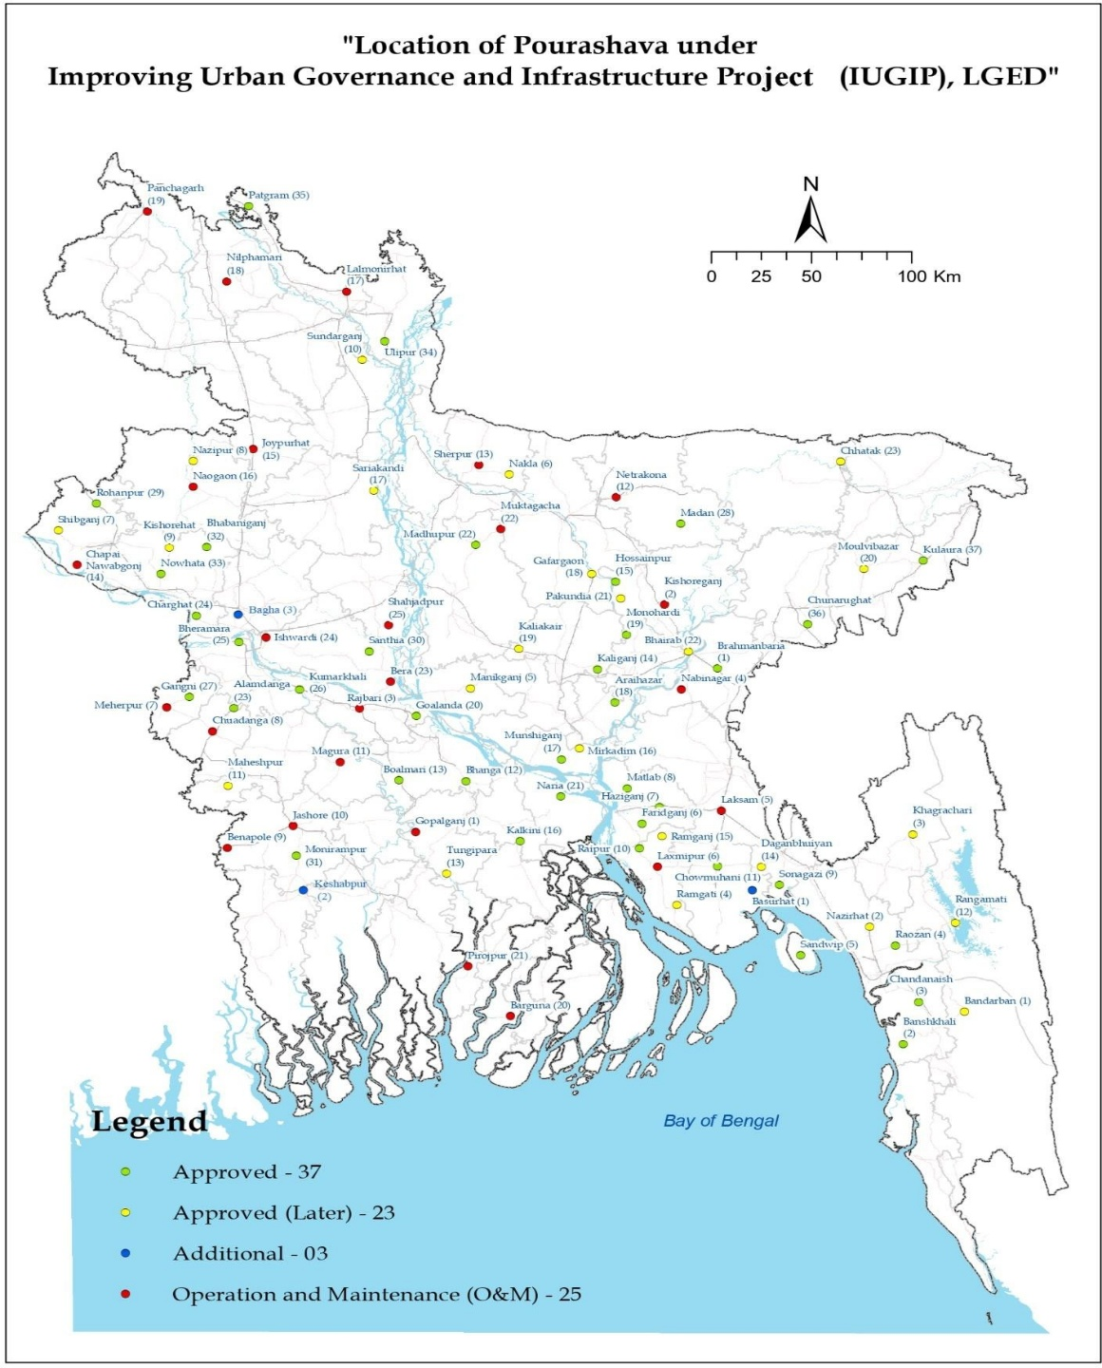

Figure 1: IUGIP Program Map

Purpose of the Report

This SEMR has been prepared by LGED with the supports of their consultants and ADB Environment Safagurds Specialist (TA consultant) for the period of April to September 2025. This is the fourth SEMR after the loan effectiveness of the program. This reports provide status of the program compliance of ADB RBL policy and ADB Safeguard Policy Statement (SPS) along with national regulations.

Scope of Works
Below table represents the scope of the RBL program:

Table 2: Scope of the program
Item | Scope
Outcome | Municipal services and governance in target pourashavas improved.
Key outputs | (i) Institutional capacity strengthened for inclusive municipal governance  (ii) Municipal infrastructure improved in quality, access, resilience, and gender responsiveness.
Activity types | Prepare UGIAP, develop a web-based revenue management system, prepare central government fund transfers, construct municipal and low-income neighborhood infrastructure civil works, undertake capacity development activities, and prepare GESIAP preparation and budgeting
Expenditure size | $689.29 million
Main financiers and their respective total amounts | Government: $189.29 million  ADB: $300.0 million  AFD: $200.0 million
Geographic coverage | 88 pourashavas
Implementation period | 2024–2028

Program Component and Status
The components of the program are as follows:
- Urban roads and drains improvement
- Urban drains improvement
- Urban roads improvement Low-income neighborhoods Infrastructure [Water hand pumps and/or bore wells, community toilets, footpaths]
- Development of market centers
- Development of parks.

The overall Program is estimated to cost US $ 689.29 million. The GoB contribution is US $ 189.29 million, ADB loan is US $ 300.00 million and TA grant amount US $ 2.00 million. AFD loan is US $ 200.00 million. The start date of the Program is 01July 01, 2023 and the completion date is 30 June 2028. The ADB loan signed on 14 August 2023. This ADB loan was effective from 12 October 2023. The AFD loan was signed and effective from 11 August 2023.

Implementation Arrangement

The Ministry of Local Government, Rural Development and Cooperatives (MLGRDC) acting through its Local Government Engineering Department (LGED) is the Executing Agency. The implementation of the RBL program is being carried out through LGED at the local level. The respective Pourashavas (PIUs), where the program is being implemented, are also active stakeholders of the program. After construction of the subproject components, these will be transferred to Pourashavas.

At the LGED, PMU has been established and this PMU is being supported by the consultants. At the Pourashava level, PIU is implementing the program related construction works. One environmental and social safeguard specialist focal has been designated at the end of PMU from LGED is reporting to the Project Director. In the operation phase, Pourashavas will take care of operation and maintenance of facilities constructed with the assistance of district team of LGED. At PIU level, one officer of Assistant Engineer rank are designated as safeguard focal person, who will ensure EMP and resettlement plan implementation. Project Management, Design and Supervision Consultants (PMDSC) have been engaged to work closely with and advise the PMU and PIUs including the safeguards matters. Contractors at each subproject site designated one site engineer as environment, health, and safety officer.

Implementation Progress

As para 9 of the Loan Agreement, in IUGIP all program actions, in the area of Environmental and Social Safeguards, are in the line of implementation in a timely and efficient manner. Subprojects of program are designed, constructed, operated, and maintained in accordance with Borrower’s Environmental Conservation Rule (ECR), 2023, and ADB’s SPS 2009. and EARF prepared for the Program and agreed between the Borrower and ADB. Monitoring of mitigation measures during construction are the responsibility of the PIU Environmental Management Officer, supported by the MDSC Environmental Specialists. As of the end of September 2025, sub-projects work status in the Pourashavas (Road and Drainage, only Drain and Market Facility) are in various stages of tendering process, as stated above. IEEs have been prepared for all of these Pourashavas for Road and Drainage,Drain and market facility.

On the other hand,as of the end of September 2025, urban improvement Low-income neighborhoods Infrastructure (water hand pumps and/or bore wells, community toilets, footpaths, drain, solar street light, bins) work status in the Pourashavas are in various stages, and 23 no of LINs already approved (Annex 16). Environmental Screening Reports (ESR) have been prepared for all of these Urban improvement Low-income neighborhoods (LINs) Infrastructure [Water hand pumps and/or bore wells, community toilets, footpaths, solar street light, Dustbin] .

The EMP describes detailed site-specific mitigation measures including monitoring indicators with responsibility allocation in different stage of program cycle i.e. pre-construction, construction, and operation and maintenance phase. For ensuring proper and effective implementation of various measures of EMP even by involved contractors, EMP has also been made as part of contract condition/document. The Cumulative Physical Progress up to end September 2025 is in Annex 15 and Annex 16.

Result Based Lending, RBL, Disbursement Link Indicator, DLI

RBL is a new performance-based form of financing, where disbursements are linked to results rather than expenditure. Worldwide, demands are growing for governments and development agencies to deliver measurable results. Better results are essential for fiscal sustainability, economic growth, human development, and poverty reduction. These increasing demands have driven a wide range of public sector reforms. Many innovative instruments have emerged viz the results-based Lending (RBL) in particular.

The working paper proposes that the Asian Development Bank (ADB) introduce a results-based Lending (RBL) for programs modality.

This IUGIP, is a result-based Lending (RBL) program, considering through DLIs matrix. Under this component, Program resources will be disbursed based on the achievement of targets under performance-based outputs.
The subcomponent will finance operation and maintenance (O&M) of urban infrastructure in Pourashavas which meet the requirements stipulated in the RBLs. The implementing agency of the IUGIP of Local Government Engineering Department (LGED) will support Pourashavas in meeting the RBLs; evaluate their performance; and allocate funds to those that meet the RBLs. Under this, Program resources will be disbursed based on the achievement of targets under the Performance-based Conditions.
The IUGIP under the Result Based Lending (RBL) modality will improve infrastructure facilities such as drains, roads, streetlights, low-income neighborhoods improvement (footpaths, drains, streetlights, tube wells, dustbins and community toilets), market centers and parks in selected Pourashavas.

Program’s Environmental Safeguards

ADB Safeguard Policy Statement, 2009

The Safeguard Policy Statement (SPS) categorizes proposed components into categories (A, B or C) to determine the level of environmental assessment required to address potential impacts.

According to the safeguard policy statement, 2009 of ADB the Program falls under Category B and hence an IEE is sufficient to meet the environmental requirements. These policies apply to all ADB-financed Programs.

Status on environmental and social activities during the reporting period

Screening of Sub-Project by Result Based Lending (RBL)

Till the end of September 2025, 183 subprojects have been sent to Pourashavas for invitation for tender (IFT). All of the sub-projects have been screened by Environmental checklist and none of these subproject was dropped due to high risk category.

REA Check list

This checklist has been sent to all the Pourashava Engineers of 63 Pourashavas. The technical personnel of the Pourashava are entrusted to complete this Checklists, for the better accomplishment of the program. Out of the 183 subprojects sent to Pourashavas for IFT, 183 have been screened through the REA checklist.

Public Consultation

Public Consultations is ongoing task and from April to September 2025, a total 32 of Public Consultations have been conducted. But during this period, 17 sub-projects have been completed/are under the tender process. Public consultation meetings for each sub-project, which have already been completed before October 25.
As of September 2025, 170 meetings were conducted with 2,876 participants: 648 female (22.5%) and 2,228 male.Information on the subproject along with environmental impacts of them and mitigation measures and their views are being covered by such consultation meetings.

Statutory Environmental Requirements

Compliance Status on legislations

The covenants to the loan agreement with ADB require that the sub-programs are designed, constructed, operated, and maintained in accordance with Borrower Environmental Conservation Rule 2023, ADB Safeguard Policy Statements (2009) as agreed between the Borrower and ADB.

Reference to the memo number 22.02.0000.018.72.029.23.177 dated June 25,2023, the DOE opined that, no Environment Clearance is required, as the programs under IUGIP are smaller than that described in schedule 1 of ECR, 2023. Letter of DoE enclosed in the Annex 5.

To be complied with national regulations, program has also confirmed that contractors opened injury or death insurance for labors and obtained license by contractor (labor license/construction work license).

Compliance Status with Program Action Plan (PAP) for Environmental Safeguard related Actions

Sound environmental management is critical to sustainable development. IUGIP’s environmental safeguards aim to ensure the environmental soundness and sustainability of IUGIP and to support the integration of environmental considerations into the program decision-making process. IUGIP has agreed PAP for environment safeguards issues, and it has made good progress on the action items of the PAP. The status of the implementation of the PAP items are provided in below table.

Table 3: Status on environment safeguards PAP
Actions as per PAP | Current status  PMU | Remarks
3.1 Environment and Social Monitoring Framework (ESMF)  developed and operationalized  in 63 Pourashavas. | 1.PMU has assigned staff for responsibilities of ESMF and, all records of screening, document preparation, approval etc. is maintained.  2. PMU has Updated ESMF on the basis of ADB reviewed comments.  3. Total 82 projects has been Updated by using screening and categorization forms appended to ESMF in PID  4. As per Above screening and categorization approach it is following for new subprojects.  5. As per Above screening and categorization its always excluded from RBL program  6. 170 nos of IEE published in LGED website  - PIUs and PMU to maintaining records  8. First quarter SEMR submitted and moderation under process on the basis of ADB’s comments. | Done  Done  Done  Ongoing on regular basis  Being followed  Done and ongoing for other subprojects  Being followed  Done
3.2 Water quality test requirement  practiced in the low-income  neighborhoods under the Third  UGIIP adopted and  operationalized in 63 pourashavas. | 9.Before construction water quality test will be done. | 120
3.3. Guidelines /protocols  developed to:  (i) identify and exclude tube  wells/bore wells contaminated  arsenic from RBL program activities  (ii) Toilet / septic tank siting and  design guidelines to prevent  and contamination of groundwater  (iii) safe disposal/recycling of discarded and end-of-life solar  in streetlights. | 10.Guidelines /protocols already been updated with the help of MDSC consultants. | Done
3.4 Obtain and renew ECC in accordance with DOE conditions; if a common environmental clearance certificate is obtained, ensure that all individual program activities to which ECC is applicable are specified in ECC. | 11. PMU has taken exempted letter from DOE that confirms that IUGIP will not require ECC as for all projects ECR 2023 for the nature of activities. | Not required
3.4 3 Environmental and Social Safeguard focal persons or specialists are assigned to LGED Program Management Unit, and pourashavas to strengthen the  coordination for environmental  social safeguards compliance.  Appoint dedicated environmental  social safeguards staff at PMU  build capacity to implement ESMF  Appoint safeguards staff in PIUs  build capacity for implementation  RBL program activities in  with ESMF | 12. Safeguard Officer for PMU and Pourashava’s formation done. | Done

Loan Covenant Compliance

Reference to para 9 of Schedule 4 of the Loan Agreement, status of the compliance of the environmental safeguards’ matters are provided in below table.

Table 4: Compliance Status of Loan Covenant
SI | Para/ Clause no. | Description | Compliance Status | Action to be Taken
1 | 9 | The Borrower shall ensure that all Program Actions in the area of Environmental and Social Safeguards are in the line of implementation in a timely and efficient manner. | Complied | Compliance will be fulfilled throughout the Program life.
2 | 10 (a) | The Borrower shall ensure, or cause the Program Executive Agency to ensure, that no construction or rehabilitation works under the Program involve significant adverse environmental impacts that may be classified as category A under the SPS. Prior to commencing any construction or rehabilitation works under the Program, the Borrower shall conduct, or cause the Program Executive Agency to conduct, a screening to ensure that any works that may be classified as category A for the environment impacts within the meaning of SPS are excluded from the Program | Complied | A through screening has already been conducted, prior to the commencement of any construction or rehabilitation work under IUGIP. It has been ensured that neither of the packages may be classified as category A for Environmental Impacts, within the meaning of SPS 2009.  This screening will be continued throughout the Program life.
3 | 10 (b) | The Borrower shall ensure, or cause the Program Executive Agency to ensure, that the preparation, design, construction, implementation, operation and decommissioning of all activities under IUGIP comply with (i) all applicable laws, regulations and guidelines of the Borrower relating to Environment, Health and Safety; (ii) the Environmental Safeguards; and (iii) all measures and requirements, including monitoring requirements set forth in the Program Action Plan. | Complied | Compliance will be fulfilled throughout the Program life.

Compliance status with Government Regulations

A per DoE’s decision based on ECR, 2023
No Environmental Clearance from DoE is required when:
(i) The road length does not exceed 5 Km
(i) The bridge span does not exceed 100 m

No Environmental Clearance from DoE is required for IUGIP, as road length for any of the packages, does not exceed 5 Km. There is no bridge in IUGIP. All roads fall within the administrative authority of the Pourashava.So, no road cutting permission will be required. all The roads will be also made within the existing Right of Way (RoW). In any case if any tree required to be uprooted, two trees will be planted for each tree cutting. Mostly local labors work in the construction site. The contractor has already acquired a “Labor License” to engage labor at work.

Compliance with the steps of ESMF

Till date 195 IEEs has been Prepared. One hundred Seventy (170) numbers of IEE have already been disclosed in LGED website. The rest are in the process of disclosure. Both the IEE and EMP has been included in the bid and contract documents.

All the packages complied with each step of Environmental and Social Management Framework (ESMF). The steps of ESMF were policy and legal framework, screening and environmental social assessment process, negotiated settlement and donation of land, environmental and social (involuntary resettlement) impacts, environmental management plan, resettlement plan and indigenous peoples community development plan, participation consultation and disclosure, grievance redress mechanism, institutional arrangement for safeguard compliance and capacity building.

However, specific ESMF compliance status as per PAP is provided in PAP status table 4 in section 3.2.

Compliance with EMP Implementation

The compliance is monitored from PMU. A checklist has been sent to the site to be filled by PIU. They are filling it up and sending regularly it to PMU.

Compliance with EMP measures

For the infrastructures under the program, design included relevant provision for ensuring protection and adequate safety of the assets being created long-term sustainability. Stakeholder consultation is being carried out on a regular basis. Construction activities under the program have been commenced and in summary the below EMP measures have been ensured on the ground which are not limited to:

- All construction materials being procured from sources compliant with regulations of GoB and local levels.
- In collection of soil, the fertile top layer ( top soil) is hipped/stored at the site. It is replaced after the transportation of the soil from the borrow pit.
- Potable drinking water free from arsenic and fecal and total coliform contamination has been provided to the labor shed and work sites.
- The waste is collected in two separate bins: bio-degradable and non-biodegradable bins. The bio-degradable wastes are being dumped in pits that serve as source of compost for agriculture latter. Whereas the non-biodegradable wastes are placed for re-cycling and the residue will ultimately taken by Pourashava to dispose them within their capacity. Such wastes collection storage are always far from any waterbody and at selected area of Pourashavas.
- To prevent dust pollution, the stockpiling of construction material is covered with tarpaulin. The construction waste is covered and stored at a pre-selected location, to avoid dust pollution. Water is spread at the site to suppress the dust.
- The GoB Noise Pollution Control Rues, 2006 has been strictly followed at the site in deploying/using of machineries and equipment. Equipment that produces less sound, has been deployed at the site. Restriction has been imposed for noise producing equipment from operation, during the night-time between 10.00 pm to 6.00 am.
- Steps/ measures to protect slope has been taken as per design to control soil erosion especially when any excavation works are taken up in the open areas, near drains/canals and Ponds.
- The Contractor has already taken all precautionary measures to prevent waterlogging condition at sites to avoid breeding grounds for mosquitoes and danger of other vector borne diseases near the construction sites.
- The Contractor strictly follows the environment, health and safety (EHS) instructions which are not limited to: not to park/repair vehicle, refueling and spillage of any lubricants around any water bodies to avoid ground contamination.
- Storing fuel and lubricants at sites has been strictly prohibited, to avoid soil pollution.
- The Contractor has already been instructed to minimize impacts on flora and fauna during construction phase.
- Use of personal protective equipment (PPE) viz. protective footwear, protective goggles, welder’s protective eye-shields etc. are considered as a must at the work site.
- Use of demarcation, barricade/fencing and safety signage at the worksite to address the community health and safety issues including the workers occupation health and safety issues.
- Contractor has been instructed to use any hazardous chemical (e.g., fuel oil) in accordance with the manufacturer’s instructions.
- Onsite emergency plan has already been chalked out to cater accidents and mishaps. Disaster Management Plan for natural calamities has also been made.
- Involving communities and regulatory bodies in environmental decision-making.
- Ensuring all activities align with environmental laws and approval conditions.
- Regularly assessing environmental performance and documenting findings.
- Preparing for environmental incidents and ensuring swift corrective actions.
- Preparing Semi-annual Environmental Monitoring report (SEMR) and subsision to ADB and disclosure.

Mission Corrective Action Plan (CAP) for Environmental Safeguards

During the last ADB mission in April 2025 and ADB TA Consultant (Environment Specialist) visit, some of the areas of improvement were identified. This compliance status of those areas of improvement is provided in below table.

Table 5: Status of Mission Corrective Action Plan (Environmental Safeguards)
SI | Action to be taken | Implementation | Monitoring | Deadline | Status of Mission CAP (Environmental) | Some Photos Related to CAP
Rohanpur Pourashava
1 | Hard barricade needs to be ensured  surrounded the construction site of market  building. | Contractor | PMU & MDSC | 15 May 2025 | Complied | 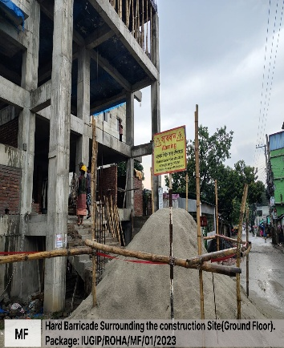
2 | Hard barricade needs to be ensured  surrounding the raised floor of under  construction market building. | Contractor | PMU & MDSC | 15 May 2025 | Complied | 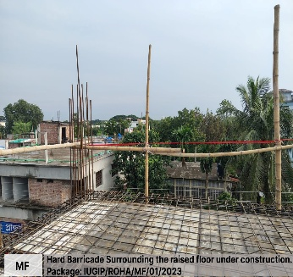
3 | Grievance box needs to be ensured at the  construction site of under construction market  building. | Contractor | PMU & MDSC | 10 May 2025 | Complied;  Both grievance box and grievance register are being maintained | 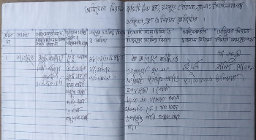
4 | Adequate number of fire extinguishers need  to be ensured at the labor camp. | Contractor | PMU & MDSC | 15 May 2025 | Ensured the fire extinguishers in site | 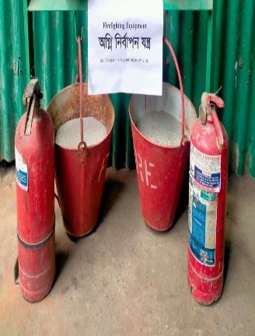
5 | Empty plastic bags found stored in front of the  storeroom that needs to be at designated  area. | Contractor, MDSC | Contractor, MDSC | 7 May25 | Complied | 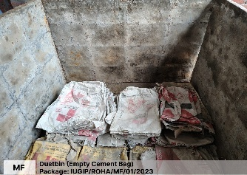  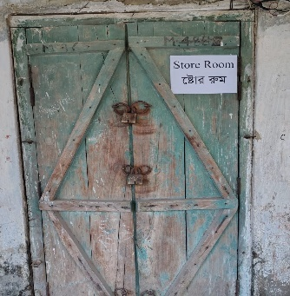
6 | Safety boots with hard shield need to be used  by the workers. | Contractor, MDSC | Contractor, MDSC | 7 may 2025 | Partially complied
7 | All incidents involving minor, moderate, or  severe injuries (in case of fatality, ADB should  be reported within 24 to 48 hours) must be  systematically reported in the SEMRs, along  with a description of the corrective and  remedial actions undertaken. | Contractor, MDSC  & PMU | PMU &  MDSC | On going | Complied
8 | EHS toolbox talk needs to be carried out at the  site before the start of works every day. | Contractor PMU & | Contractor PMU & | On going | Complied | 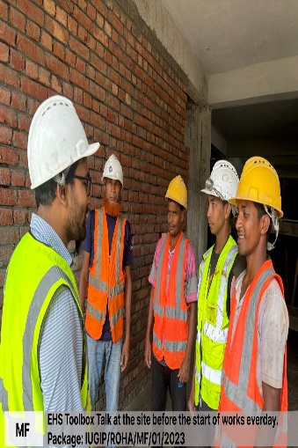
9 | IEE and Site Specific EMP in Bangla needs to  be ensured at worksite. | Contractor, MDSC | Contractor, MDSC | 15 may 2025 | Complied | 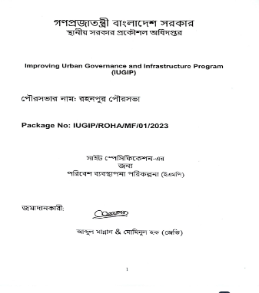
Bhabaniganj Pourashava
1 | Adequate measures need to be included with  the constructed roads and drains to prevent  waterlogging to the agriculture land and  houses. | Contractor | PMU & MDSC | September 2025 | Need to complied | 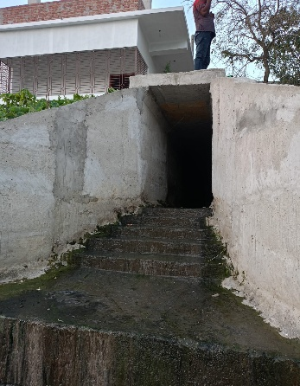
2 | The pourashava will need to enforce  regulations at the household level to prevent  connections of toilets/septic tanks and  implement robust community awareness  programs since the outfall of the drains is into  the river. | Bhabaniganj  Pourashava | PMU & MDSC | On going Basis | Complied and ongoing | 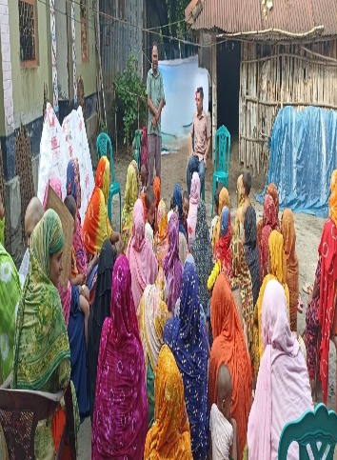
3 | If the construction of a municipal facility, such  as a market, requires the demolition of an  existing structure, an IEE must be conducted.  The IEE should include an assessment of  occupational health and safety risks,  proposed mitigation measures, and screening  and assessment for the presence of asbestos.  If asbestos is identified, the IEE must also  specify appropriate handling, removal, and  disposal measures in compliance with  relevant health and environmental  regulations | Contractor | PMU & MDSC | Before  tender/demolition | All running sub-project of Bhabaniganj pourashava’s IEE completed with including an assessment of  occupational health and safety risks,  proposed mitigation measures, and screening  and assessment for the presence of asbestos. | N/A
Common CAP items for all Pourashavas need immediate attention
1 | Grievances recorded at site level registers  should be reported to SEMRs including their  details (e.g., number of grievances, type of  grievances, status of resolution of grievances) | Contractor ,PMU &  MDSC | PMU & MDSC | ongoing | Complied | 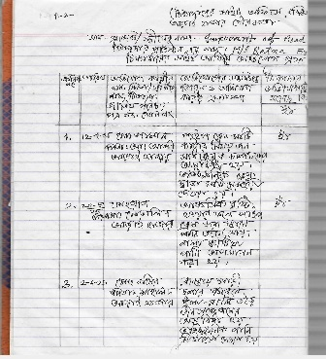
2 | IEE and Site Specific EMP in Bangla needs to  be ensured at worksite. | Contractor, PMU & MDSC | PMU & MDSC | On going | Complied | 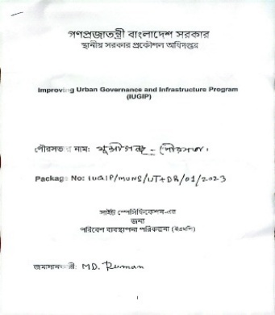
3 | Safety boots with hard shields need to be  used by the workers. | Contractor | PMU & MDSC | Immediate | Partially complied | 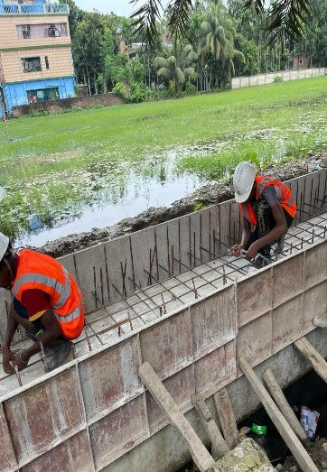
4 | EHS toolbox talk needs to be carried out at  the site before the start of works every day. | Contractor | PMU & MDSC | Ongoing  basis | Complied | 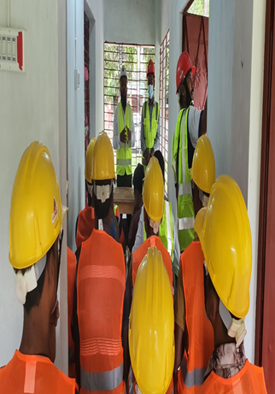
5 | If municipal facility like market construction  needs demolition of existing building, IEE  needs to be prepared that will also cover OHS  aspects including asbestos screening. | Contractor | PMU & MDSC | Before  tender/demo  lition | At present no need to demolition any existing building. If need to demolition any existing building then will ensure to include asbestos screening in IEE Report. | N/A
6 | Hard barricade needs to be ensured surrounding the DRAIN of under construction and market building. | Contractor | PMU & MDSC | On going | Complied | 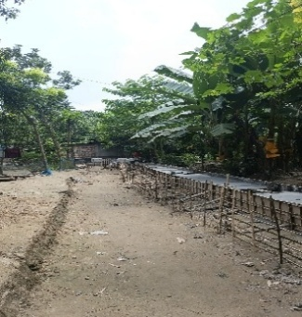

Items incorporated in the BoQ for each sub-projects

Following items are being included in the BoQ for each of the subprojects:

- Providing and maintaining adequate portable water supply, sanitation, and cleanliness facilities at camp site and work site.
- Temporary Toilet: Construction of temporary toilets in work site/rest area
- Dust suppression measures at unpaved road surface or any other place suspect to dust blowing.

- Air Quality: Periodic air quality monitoring construction site 1st time at commencement of work, (before construction), 2nd time during construction period and 3rd time after completion of work. Also, water spray at the construction site in everyday during the construction period. The parameters to be monitored are suspended particulate matter (SPM), respirable particulate matter (RPM), sulfur dioxide (SO2) and oxides of nitrogen (NOx), carbon monoxide (CO), Lead (Pb). Each monitoring schedule shall be over duration of 24 hours (in 8 hour shifts) for three seasons per year. IUGIP follow the latest Air Pollution Control Rules 2022.

- Water Quality: Water quality monitoring during construction phase at locations. The sampling shall be carried out for three seasons per year and cover all parameters as per WHO's Guidelines for Drinking-Water Quality including heavy metals. Groundwater Quality test parameters are pH, DO, Lead, Fe, EC, TDS, Nitrate, As, TC, FC, Cl, Ca, and Manganese and Surface Water Quality test parameters are pH, ORP, DO, Phosphate, Alkalinity, Sulfate, Fe, EC, TDS, TSS, Nitrate, COD, and BOD. IUGIP follow the latest ECR, 2023.

- Noise Quality: Noise quality monitoring at specified silent receptors along Program Road, at construction camp sites, batching plants, crusher plants (if specifically established for Program), and at major settlement areas along Program Road.Each monitoring schedule shall be over a duration of 12 hours (6 AM to 6 PM) for three seasons per year. construction site 1st time at commencement of work, (before construction), 2nd time during construction period and 3rd time after completion of work. IUGIP follow the latest Noise Pollution Control Rules 2006.

- Soil Quality Test proposed construction site 1st time at commencement of work, (before construction), 2nd time during construction period and 3rd time after completion of work .Soil Quality test Parameters Organic Matter, Zn, Sulfur, Lead and Nitrate.

- Maintain First Aid box at campsite to the entire satisfaction of the EIC.

- In each of the bidding documents of the signed contracts a general Environmental Management Plans (EMP) has included. The contractors are fully aware of their responsibilities and requirements for compliance to environmental safeguards.

EMP in Bidding Documents

In all the bidding documents, Environmental management Plan (EMP) has been included. It has been included in the Invitation for Tender (IFT) i.e. incorporated in the contract document. No amendment has been made in any package since the contract signed. Compliance of EMP and its proper monitoring are noted at the site. Nomenclature of an EMP from a Bidding Document BOQ Matlab Pourasava, Chandpur Pourashava (Annex 10) and the detail estimate of Munshiganj (Annex 11)

Monitoring and Reporting on EMP

As a continual process, the PMU is monitoring the progress of EMP implementation. The monitoring activities was noted corresponding with the program’s risks and impacts. The contractors have submitted monthly Environmental Monitoring Report that is Site-Specification Environmental Management Plan (SSEMP) (Annex 4) covering the mitigation measures listed in this EMP. The findings say that the EMP has been followed at the site and level of compliance to the EMP requirements found satisfactory.

Summary of Quantitative and Qualitative Monitoring Data
In order to consolidate the overall safeguard compliance (qualitative and quantitative monitoring data) of packages are being implemented properly, activity wise a common checklist in line with the Program IEE, was provided to all Pourashava Engineers (PEs) and and dedicated Focal Person, and Safeguard Officer (Annex 17) to collect the EMP implementation status with the assistance of contractor’s environmental focal person. Further, the photography of the environmental compliance and non-compliance issues were collected during the monitoring period. Checklist received by the end September 2025, is 184 numbers.

Summary of Quantitative and Qualitative Monitoring

Labor shed provided with sanitation system and potable water facilities. Separate toilet facilities for male and female labor were observed. Use of cautionary sign found in position. Use of PPEs and first aid kit by the contractor at working site was found in order. Female labor found at the site. No child labor found working. No vehicle was found emitting black smoke & unburned fuel. Dust suppression measures has been taken as required. Environmental compliances have been fully complied at the site.

Dumping and disposal of wastes: The use of personal protective equipment (PPE) has been strictly followed at the site. Wastes have stored safely in a separate dustbin and disposed quickly into a safe place. Hygienic situation ensured all around the labor shed and office premises by spraying disinfectant.

Summary of Environmental Monitoring Tests Performed

The summary of the environmental monitoring tests is provided in the below table:

Table 6: Summary of the environmental monitoring tests
Sl # | Test Required for EMP | Number of Sub-projects Awarded | Test performed in number of Awarded Sub-projects before commencement of construction | Test performed in number of Awarded Sub-projects during construction | Test performed in number of Awarded Sub-projects during construction
Sl # | Name of the Tests
01 | Air Quality Test | 183 | 120 | 94 | 2
02 | Noise Level Measurement
03 | Soil Quality Test
04 | Ground Water Quality Test
05 | Surface Water Quality Test

Trainings Conducted

Traning provided during the reporting period on Gender, Environment and Social Safeguard, Contract Management, Climate Change and Quality Control of Infrastructure for Contractors and Pourasava Engineers:

- April 16 to 17, 2025: at RTC, LGED, Jeshore.
- May 04 to 05, 2025: at RTC,LGED, Mymensing.
- May 13 to14, 2025: at RTC, LGED, Bogra.
- May 25 to 26, 2025: at RTC,LGED,Chattogram
- May 27 to 28, 2025: at RTC,LGED,Comilla
- May 29, 2025: at RTC,LGED, Comilla
- June 19, 2025: at RDEC Bhaban, Level-11,Dhaka
- June 22, 2025: at RDEC Bhaban, Level-11, Dhaka

Table 7: Summary on trainings conducted during Apr-Sep 2025
Sl # | Venue | Date of Commencement | Number of Male Participants | Number of Female Participants | Number of Total Participants
1 | Jeshore | April 16 to17, 2025 | 25 | 01 | 26
2 | Mymensing | May 04 to 05, 2025 | 31 | 00 | 31
3 | Bogra | May 13 to14, 2025 | 39 | 00 | 39
4 | Chattogram | May 25 to 26, 2025 | 24 | 00 | 24
5 | Comilla | May 27 to 28, 2025 | 33 | 00 | 33
6 | Comilla | May 29, 2025 | 26 | 00 | 26
7 | Dhaka | June 19, 2025 | 27 | 00 | 27
8 | Dhaka. | June 22, 2025 | 27 | 00 | 27
Total |  |  | 232 | 01 | 233
During this reporting period, a total of 8 training sessions were held, with 233 participants, 232 men and 1 woman. Total number of 17 Batches 450 persons( XEN, AE,SAE,Contractor’s participants) received training from 63 Pourashavas .The main topic of discussion, were as follows:

- Fundamental Aspects of Construction Work Supervision.(during reporting )
- Supervision of Construction Works of WBM, WMM, Bituminous Carpeting Road, Uni-Block Paved Road, RCC Road, Drain and Municipal Facilities( beyond reporting period)
- Construction Management and Quality Control. ( beyond reporting period)
- Supervision of Infrastructure Construction Technique ( beyond reporting period)
- Road Safety & Traffic Sign Maintenance( beyond reporting period)
- Sub-Soil Investigation ( beyond reporting period)
- Road site tree plantation& care taking (during reporting)
- Result Based Lending (RBL) & Disbursement Link Indicator (DLI) ( beyond reporting period)
- Gender Issues & Role of Woman in Infrastructure Improvement. ( beyond reporting period)
- Environment & Social safeguard Issues( beyond reporting period)
- Procurement & Contract Management. ( beyond reporting period)
- Climate Change & its Environment Impacts(during reporting)
- Social Safeguard Principles(during reporting)
- Meaningful Consultation in Context of Social Safeguard(during reporting)
- Grievance Redress Mechanism(during reporting)
- Land Acquisition Law and Methods, Negotiated Settlement and Donation of Land(during reporting)
- Social Safeguard Monitoring Report from Pourashavas(during reporting)
- Discussion on Environmental Safeguard Issues, Training to Workers arranged by Contractors(during reporting)
- Environmental Screening and Categorization, RBL Checklist, REA Checklist, Quarterly Environmental Monitoring Report. ( beyond reporting period)
- Climate Change and its Impact on Infrastructure, Possible Mitigating Measures. (during reporting)

The Pourashava Engineers and the contractors or the Engineers/representatives from the contractor’s end were the main participants. Among the trainers: the Quality Control Engineer, Environment Specialist, Gender Specialist, Procurement Specialist & the Training Specialist were noteworthy.Attached attendance sheet Annex 2.

Occupational Health and Safety Compliance

The contractors have adopted the safety measures, such as placing of barricades/safety fencing, erection of metal sheet fencing, safety signs, and appointment of national safety staff and traffic management staff. Contractors have posted new safety signs and billboards at the critical work sites. As mandatory, the laborers wear Personal Protective equipment (PPE) viz. hard hat, safety glasses, and footwear etc, at the site to ensure their safety. Nonetheless, contractors have ensured workers welfare and good housekeeping practices at workers’ camp.

Reporting of Accidents and Injuries including Fatalities:

There were some minor injurires at the IUGIP site, till 30 September 2025. Indeed, there is a liability to report to ADB any major incident, fatality, or significant injury within three working days of its occurrence. Some report has been submitted as minor accident or incident took place at the site.

Table 8: Summary of Accident/Incident during this reporting period
Type of accident/incident | Number and Position of Person/s Involved/ including the community people if applicable | Paurashava name | Detailed Description of Incident | Time-bound Corrective Action
Non-fatal Injury (Minor) | 3 person | Kaliakor | Cutting of toes finger | Enforcing PPE and providing frist aid supports by 31 October 2025
Illness | 3 persons | Araihazar | Headache and fever | Providing basic medical supports by 31 October 2025

Exposure to Disease: The IUGIP has taken into consideration differentiated exposure to, and higher sensitivity of, disadvantaged or vulnerable groups and has already developed appropriate mitigation measures in meaningful consultation with such groups and the competent government authorities.

Sexual Exploitation, Abuse & Harassment (SEAH): IUGIP has already adopted specific and differentiated measures to prevent and address SEAH, following a survivor-centered approach, and has established a confidential grievance mechanism for reporting incidents and referral systems to provide support to SEAH survivors.

Awareness on gender issues publicized at the work site. The awareness on sexual abuse and sexual intimidation, has been widespread at the site. It is not only sexual abuse and sexual intimidation, but awareness on gender issues has also been publicized.

Not a single incidence of sexual exploitation, abuse and harassment took place at the site. No accident of any magnitude took place in either sub-project.

Public Consultation
ADB is committed to put meaningful consultation processes into practice. Meaningful consultation is a process that (i) begins early in the project preparation stage and is carried out on an ongoing basis throughout the project cycle; (ii) provides timely disclosure of relevant and adequate information that is understandable and readily accessible to affected people; (iii) is undertaken in an atmosphere free of intimidation or coercion; (iv) is gender inclusive and responsive, and tailored to the needs of disadvantaged and vulnerable groups; and (v) enables the incorporation of all relevant views of affected people and other stakeholders into decision making, such as project design, mitigation measures, the sharing of development benefits and opportunities, and implementation issues.

Accordingly, the public consultation has been conducted. Starting from April 2025 to till the end of September 2025, Total 32 number of public consultations has been conducted. On an average 22 participants participates in this type of public consultation. The female participant is around 33% there.

Topic Discussed in the “Public Consultation”

Potential environmental impacts from project activities.
- Project safeguard policy to mitigate environmental impacts.
- Role of communities to inform GRC on adverse environmental impacts or on negligence of contractors on environmental safeguard compliances.
- Improved Road Network connectivity.
- Expansion of economic opportunities of rural poor through the improvement of rural infrastructure & Poverty reduction
- Gender development
- Improvement of local governance.
- Environmental sustainability
- Increased agricultural production i.e. higher incomes
- Better educational attainment.
- Consultant welcome community monitors and Engagement.
- To explain mitigation, and community safety.
- Sustainability Commitments(Use of green technologies or renewable energy, Long-term reforestation or conservation plans,Climate resilience efforts)

The participants in the “Public Consultation” expressed their opinion on an all-weather road. To have an uninterrupted illumination on the streets, they were insisting on ‘Solar Powered Street Light”. The height of the roads should be above the highest flood level (HFL). The drains by the side of the road should be covered with slabs, so that the drains may not be used as dustbin & simultaneously it may be used as a footpath. They emphasized on tree plantation by the side of the roads. Inclusion of more labor from the local community was also their demand.

Table 9:Total list of Public Consultation (October 2023 to till September 2025)

Public Consultation
Sl # | Duration | Number of Consultation | Participants
Sl # | Duration | Number of Consultation | Male | Female | Total
01 | October 2023-March 2024 | 18 | 221 | 58 | 279
02 | April 2024-Sept 2024 | 77 | 958 | 220 | 1178
03 | October 2024-March 2025 | 43 | 585 | 138 | 723
04 | April 2025-June 2025 | 13 | 191 | 111 | 302
05 | July 2025-Sept 2025 | 19 | 273 | 121 | 394
Total |  | 170 | 2,228 | 648 | 2,876

Table 10:Sample of Public Consultation
SL No | Pourashava  name | Public consultation meeting date | Pic of PC meeting | Attendence of PC meeting | Key points from the consultation meetings
 |  |  |  |  | Key Concerns of the Participants | Key Responses of the Facilitators
1 | Madan | 24.04.25 | 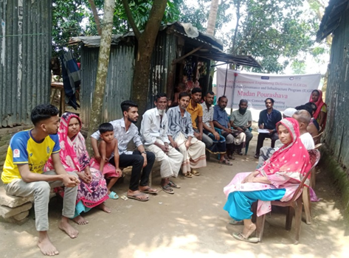 | 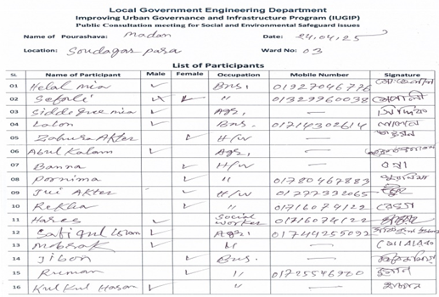 | Will there be any protection for noise pollution?  How dusts will be control from construction works  Suggest to use store room for all material and machine?  Have there any scope to work for local female workers? Whether their wages will be equal to male workers?  Whether the drains will be covered with slabs?  What will be approximate the completion date?  How contamination will be prevented from the toilet of labor camp? | It will be informed the time of using the mixer machine.  Water will be sprayed and construction materials will be kept covered.  All material and Machine should be at store room or safe zone.  The female workers are always welcome to work.They will equally paid as male workers will receive for same kind of work.  The under-construction drain will be covered with slabs.  The completion date and up to date progress of the sub-projects were disclosed.  Toilet with the labor camp will be with treatment arrnagment like soak pit/septic tank.
2 | Alamdanga Pourashava | 13.05.25 | 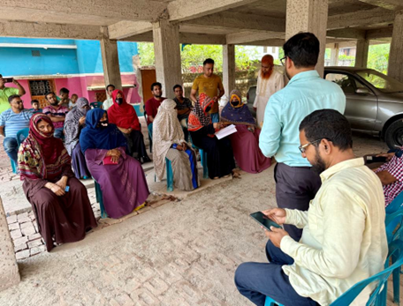 | 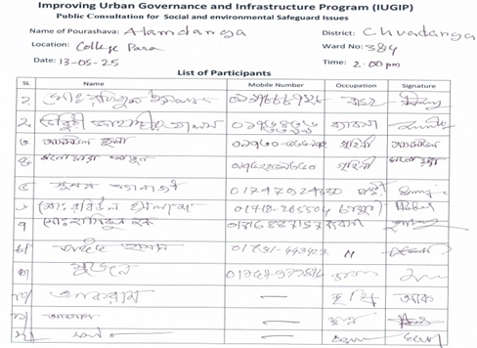
3 | Naohata | 03.01.25 | 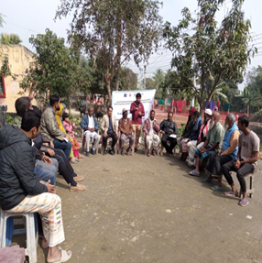 | 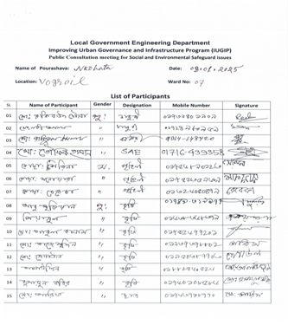 | How people can express their complaints during construction works and how will be addressed by the program?  How community accident/infrastructural damage will be managed? | The participants were informed that that there will be Complaint Box and Complaint Registers at Pourashava offices. Any aggrieved person can submit their complaints at Pourashava by written,mail,post or by phone.They also can submit their complaints to Contractors office by written in registrar at contractor office.All complaints will be collected by GRCs at pourashava offices or at field level azre registered in the complaint book.Heraring of their complaints will be arranged in presence of complainants. Complainants have the scope to appeal to higher GRCs if they are not satisfied with the decision of first level GRCs.They can also submit their complaint to the upper level GRCs and finally to Complaint receiving officer (CRO) at ADB Headquarters or the ADB Bangladesh Resident Mission (BRM.  Speed limit will be maintained by the construction vehicles while using community roads, efficient traffic management plan will be considred and if any community infrastrure is damged that will be repaired by the program.
4 | Haziganj | 21.06.25 | 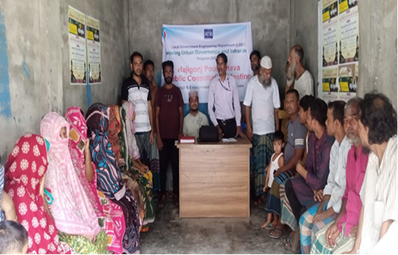 | 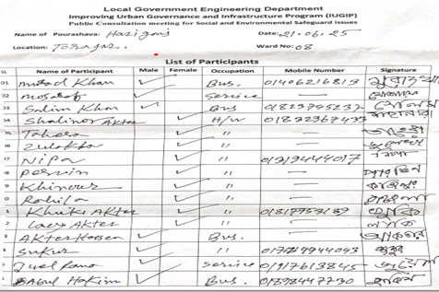 | Where will be the outfall of the drains?  Is it possible to complete the subproject works earlier?  Which path should be used during construction?  Is it possible to complete the work before rainy season and the possibility or the real situation were discussed in the meetings?  Request to maintain lower noise limit during construction?  Do the PIU controls the quality of construction materials?  Will there be any labor shade?  As many chemicals will be used for construction, fire can be broke out, Is there any fire extinguisher?  What will be steps after cutting trees? | The outfalls were shown in the design.  Contractors discussed on possibility of completion of the subproject works before the completion date.  There will be diversion road for using.  Request to complete the construction works before rainy seasons.  Everyone will be informed before construction work begins and also will be maintained lower noise limit.  Mainly quality of the construction works will be controlled by PIUs.There are one Monitoring Engineer(ME) from MDSC at each program of Pourashava.The PIU Engineers and ME of MDSC jointly control the quality of construction works at field level.  Yes, there will be labor shed and all the arrnagment will be there with labor shed to prevent contamination to surrounded environment and community conflict.  Ensure the labore shade for labore in construction area.  Ensured fire extinguisher in site.  compensatory plantation for trees lost at a rate of 3 trees for every tree cut.
5 | Madhupur | 17.07.25 | 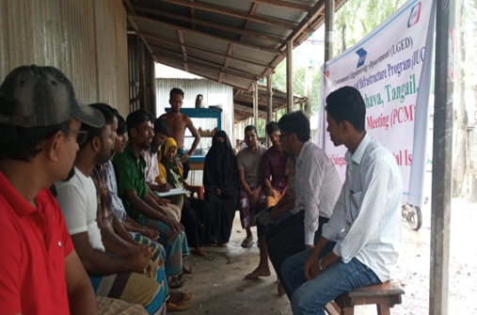 | 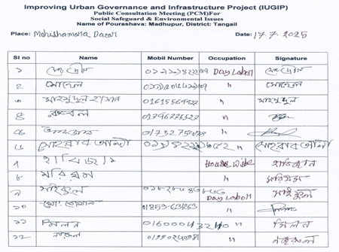
6 | Shibganj | 18.08.25 | 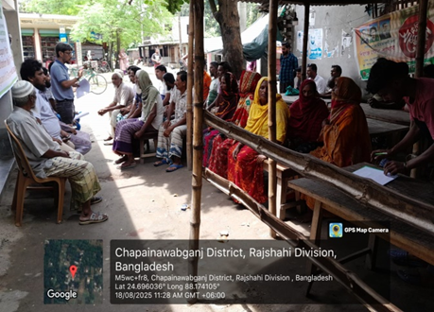 | 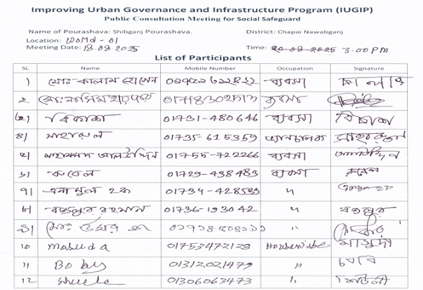
7 | Matlab | 26.08.25 | 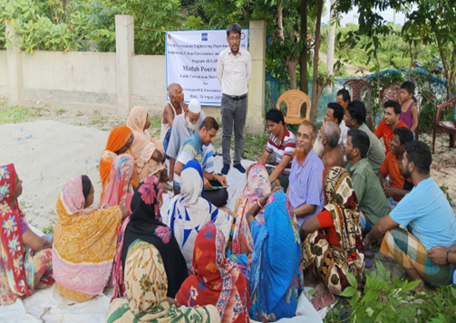 | 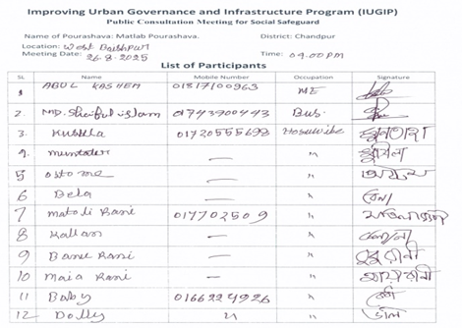
8 | Boalmari | 13.08.25 | 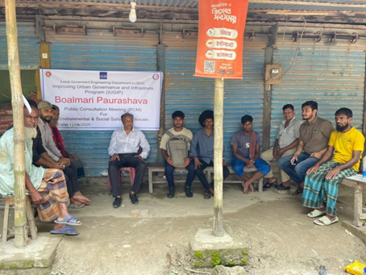 | 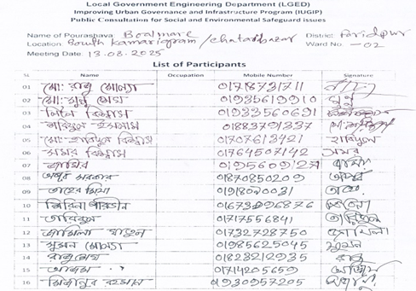 | What is the safety for construction surrounding area?  Will there any bins for bio-degradable and de-gradable things?  Will there be performed any quality test for different parameters?  Hauling of construction materials and operation of equipment on-site can cause traffic problems ? | Suggestion for putting hard barrier in construction surrounding area.  Requesting to setup separate bin for both bio-degradable and de-gradable things.  EMP test will be covered 3 times in every sub-project.  Maintain safe passage for vehicles and pedestrians throughout the construction period. Schedule truck deliveries of construction materials during periods of low traffic volume.
9 | Naria Pourashava | 12.08.25 | 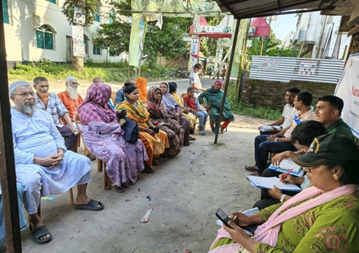 | 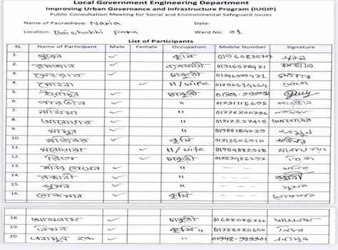
10 | Munshiganj | 03.09.25 | 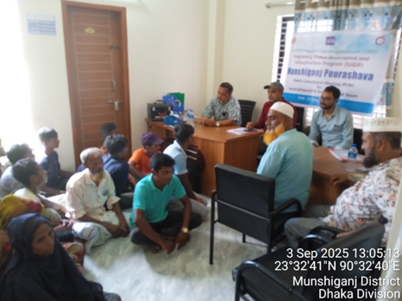 | 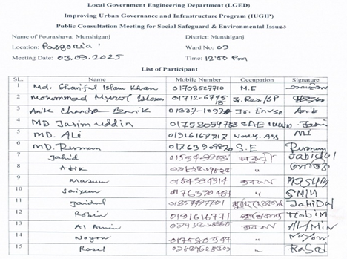 | Poor safety signage and lack of barriers at work site and trenches will create hazard to pedestrians and children. | Provide safety signage at construction sites visible to public.Provide safety barriers near any trenches, and cover trenches with planks during non-work hours.

Grievance Redress Mechanism (GRM)

A grievance redress mechanism has already been established to voice and resolve the social and environmental concerns linked to the Program, which ensures greater accountability of the Program authorities towards the affected persons. This mechanism is not intended to bypass the government’s own legal process, but to provide a time-bound and transparent mechanism that is readily accessible to all segments of the affected people. All costs involved in resolving the complaints (meetings, consultations, communication and reporting/information dissemination) has borne by the Program.
Public awareness campaigns in the Pourashava ensures the awareness on grievance redress procedures. The PIU under the guidance of Chief Executive officer/ Secretary/ Sociologist of the Pourashava acts as a focal person at Pourashava. He/she used to run the awareness campaigns to ensure that the poor and vulnerable households are aware of grievance redress procedures.
The Program Affected Persons (PAPs) have the right of conveying grievances/suggestions by dropping the grievance redress/suggestion forms in the complaints/suggestion boxes, set in the Pourashava or to lodge complaints in writing in the Grievance Register of the 1st Level Grievance Redress Committee at Pourashava. On Line Complaints are also acceptable to GRCs. But in that case complainant/s have submit the complaint in written within two days. If the complainant wants the privacy will be strictly maintained.
Contact number of Member Secretary are displayed in the notice board placed at the starting point and other places of the scheme. To maintain records in an easy way formats of GRC Register and guidelines for operating GRC will be prepared. Both the format and guidelines will be prepared in Bengali so that the GRC procedure become more easier to the operators of GRCs. A complaint Register will also be available at the Site office of the contractor. The Contractor will receive the complaint with acknowledgement and forward the complaint to the 1st Level Grievance Redress Committee at Pourashava within one day after receiving the complaint. Formats of Registers will be provided to the GRCs and contractors.
- 1st Level Grievance. The phone number of the PIU office was available at the construction site signboards. The contractors and PIU safeguard focal person immediately resolved on-site in consultation with each other and it was solved within 7 days of receipt of a complaint/grievance.
- 2nd Level Grievance. All grievances that cannot be redressed within 7 days at field/ward level was reviewed by the grievance redress cell (GRC) headed by Administrative officer of the Pourashava with support from PIU designated safeguard focal person and MDSC regional environment and resettlement specialists. GRC attempted to resolve it within 15 days. The PIU designated safeguard focal person was responsible to see it through the process of redressal of each grievance.
- 3rd Level Grievance. The PIU designated safeguard focal person referred any unresolved or major issues to the PIU safeguard officer and MDSC national environmental and resettlement specialists. The PIU in consultation with these officers/specialists resolved it within 30 days.
Till the reporting period no grievance was informed and noted at the site.

An orientation on GRC procedure and recording process to the GRC registers is to be given to the GRC Member Secretary and all contractors/ their representatives. During visiting the Pourashava the Resettlement Specialist/Environmental Specialists or Jr. Resettlement Specialists / Jr. Environment Specialist will review GRC registers. The GRCs will prepare Quarterly Report on GRC activities following the formats provided to them and will send the reports to PMU. The GRM Diagram is as per Annex 8.

Grievance Redress Committee (GRC)

Table 11: First level GRC
Serial Number | Included persons in 1st. Level Grievance Redress Committee (GRC) | Position in the GRC
1. | Chief Executive Officer or Poura Nirbahi Officer | Convenor
2. | Executive Engineer, Pourashava/ Safeguard and Gender Focal person | Member
3. | Administrative Officer, Pourashava | Member Secretary
4. | Municipal Ward Councilor (designated)/ WC member | Member
5. | Medical Officer/EHS Supervisor | Member
6. | Affected Person’s Representative/ Community or NGO Representative of Program Area | Member

Table 12: Second level GRC
Serial Number | Included persons in 2nd. Level Grievance Redress Committee (GRC) | Position in the GRC
1. | Administrator | Convenor
2. | Chief Executive Officer/ Poura Nirbahi Officer | Member Secretary
3. | Executive Engineer of the Pourashava | Member
4. | Representative of the Administrator | Member
5. | Administrative officer of the Pourashava | Member
6. | One women member/ Reserve women seat councilor | Member
7. | Representative of Affected Person/ TLCC member/ NGO member | Member

Table 13: PMU (third level) GRC
Serial Number | Included persons in PMU Level (3rd Level) Grievance Redress Committee (GRC) | Position in the GRC
1. | Program Director, | Convenor
2. | Administrator | Member Secretary
3. | Deputy Program Director (Safeguards)/ Program Manager | Member
4. | Deputy Program Manager (DPM)/ Senior Assistant Engineer | Member Secretary
5. | Assistant Director (Environment)/ National Environmental Consultant | Member
6. | Assistant Director (Social Safeguards)/ National Safeguard Consultant | Member
7. | Assistant Director (Gender) supported by Social, Environment and Gender Specialist/ National Gender Specialist, MDSC | Member

The GRCs are active as those are already formed during the project design stage. We do hereby confirm that some grievance has been recorded during this reporting period.

Table 14:Summary of grievances during this reporting period
Pourashava name | Number of grievances received during reporting period | Type of grievance received |  | Number of grievances resolved | Number of grievances pending | Remarks
Pourashava name | Number of grievances received during reporting period | community | Labour | Number of grievances resolved | Number of grievances pending | Remarks
Araihazar | 3 | Pedestrian traffic Problems & air Pollution | 0 | 3 | 0 | No pending
Rohanpur | 3 |  | The water from the house comes onto the street, the road becomes muddy and spreads foul smell and Complexities related to land measurement | 3 | 0 | No pending
Roazan | 1 | Land issue |  | 1 | 0 | No pending
Total | 6 |  |  | 6 | 0

Receiving and resolving of complaints need specific knowledge on it. Easy access to GRCs and transperancy of the GRCs make the GRCs fruitful. It is necessary to maintain records in the GRC registers. Operation of all the GRCs in a unique way will help to prepare reports on GRC activities. So, to prepare GRC registers an unique format and guidelines for operating GRCs are required. Language of the format of GRC Registers and Guidelines to operate the GRCs requires a language which will be easier for the user. So, the foarmat for GRC Registers and Guidelines to operate the GRCs will be prepared in Bengali and will be provided to the GRCs. The GRC members will be oriented on GRC process through online too.

Conclusion and Recommendations

Efficient transport systems are essential for poverty reduction and economic development in developing country like Bangladesh. To achieve a planned, inclusive and sustainable urbanization, better city governance and improved infrastructure and service provisions is the objective and target of this IUGIP.

Till date 183 sub-projects has sent to the Paurasava for tendering (IFT). Around 10 sub-projects are in the pipeline to be send to the Pourashava for IFT.

IUGIP are also paying efforts to build the capacity of PIU (XEN,AE,SAE)and contractors for environmental issues. Total 17 training programs have already been conducted till 30 September 2025, starting from October 2024. Strict discipline and supervision are observed at the construction site. Laborers are wearing PPE during their works at worksite .So mentionable no accident and/or incident happened except a few minor injuries like finger cutting, toe cutting at the site in any Pourashava during the reporting period.

Environmental monitoring tests are being conducted at the site. During this reporting period 216 tests have been performed. As a nomenclature one test result has been included in annex 10.

Total 32 public consultations have already been conducted, during tis reporting period. It acknowledges the desire for humans to have a say in decisions that affect their lives. A positive outcome of public consultation is the ability to incorporate diverse perspectives and concerns from the community into decision-making, leading to more informed, relevant, and widely accepted policies, projects, or initiatives, while also fostering greater transparency, accountability, and public trust in the decision-making process. Total 170 IEEs have so far been published in LGED website.

As per the criteria set for activities, no activities of red category as per ECR, 2023 and category A as per ADB SPS 2009 can be included under program. IUGIP is strictly following this by screening with developed checklists. Furthermore, IEEs along with EMPs are being prepared for the required subprojects and such EMPs have been included with the contract documents to make sure that all the EMP requirements are being addressed by the contractor. To monitor the implementation of EMP monitoring, EMP checklists are being used and monitoring found that EMPs are being implemented throughout the different subproject those are ongoing.

Public consultations have been continued at the program interventions areas on an ongoing basis. GRM for the program is functional and some grievance were reported during the reporting period, all of which have been resolved (Annex14). Like this reporting period, IUGIP is recommended to carry out efforts on implementation of EMP, environmental safeguards requirements as per loan agreement, capacity building etc. Program has made some progress on PAP action items and it’s recommended to address remaining action items of the PAP. These include: (i) identifying and excluding tube wells and bore wells contaminated with arsenic from RBL program activities; (ii) developing toilet and septic tank siting and design guidelines to prevent groundwater contamination; and (iii) ensuring safe disposal or recycling of discarded and end-of-life solar panels used in streetlights.(iv) Before initiating any subproject, a screening and categorization approach is applied to new subprojects. Based on this screening and categorization, certain activities are always excluded from the RBL program. This is a continuous process.

The Environmental Management Plan (EMP) of each subproject addresses both the construction and operational phases of the sub-projects. The scope and timing of mitigation measures are determined by the significance of the anticipated impacts. Certain measures are being integrated into the project design to effectively resolve potential issues (e.g., drainage systems, access roads), while others are being implemnedted as ongoing basis, thereby minimizing or preventing environmental impacts.
A budget has been allocated for the EMP. All IEEs have been completed for subprojects before issuing the bid invitation or construction contract. The bid documents include requirements to allocate resources necessary for EMP implementation. The EMP forms part of the contract documents and, if necessary, will be further updated during the construction phase of the RBL sub-project.
Environmental monitoring has been carried out during pre-construction, construction, and operation stages of the program to evaluate mitigation effectiveness and compliance with national standards (e.g., ECR 2023). From the monitoring during the reporting period, the environmental safeguards performance was found satisfactory and on track. No major environmental safeguard issue or major non-compliance were found for the activities of IUGIP.
PMU and MDSC conduct regular training programs for PMU officials, PIU staff, contractors, and Pourashava representatives. These trainings focus on environmental and social safeguard principles under ADB SPS 2009, EMP and resettlement plan implementation, grievance redress mechanisms (GRM), and requirements for monitoring and mitigating social safeguards.

This program has been complied with the environmental requirements of national legislations and ADB SPS 2009 and requirements of loan agreement effectively.

Annexures
Annex 1: Name of 88 (including O&M) Pourashavas

Sl. No | Division | District |  | Pourashava
1 | 2 | 3 | 4
Already Approved
1. | Dhaka | Gazipur | Kaliganj
2. | Dhaka | Faridpur | Boalmari
3. | Dhaka | Faridpur | Bhanga
4. | Dhaka | Shariatpur | Naria
5. | Dhaka | Rajbari | Goalandha
6. | Dhaka | Kishoreganj | Hossainpur
7. | Dhaka | Madaripur | Kalkini
8. | Dhaka | Munshigonj | Munshigonj Sadar
9. | Dhaka | Narsingdi | Monohardi
10. | Dhaka | Narayanganj | Araihazar
11. | Dhaka | Tangail | Madhupur

Sl. No | Division | District | Pourashava
1 | 2 | 3 | 4
12. | Chattogram | Chattogram | Bhanskhali
13. | Chattogram | Chattogram | Chandanaish
14. | Chattogram | Chattogram | Sandwip
15. | Chattogram | Chattogram | Raozan
16. | Chattogram | Chandpur | Faridganj
17. | Chattogram | Chandpur | Haziganj
18. | Chattogram | Chandpur | Matlab
19. | Chattogram | Noakhali | Basurhat
20. | Chattogram | Feni | Sonagazi
21. | Chattogram | Lakshmipur | Raipur
22. | Chattogram | Brahmanbaria | Brahmanbaria
23. | Rajshahi | Rajshahi | Keshorhat
24. | Rajshahi | Rajshahi | Charghat
25. | Rajshahi | Rajshahi | Naohata
26. | Rajshahi | Chapai Nawabgonj | Bhabaniganj
27. | Rajshahi | Pabna | Santhia
28. | Khulna | Chuadanga | Alamdanga
29. | Khulna | Kustia | Bheramara
30. | Khulna | Kustia | Kumarkhali
31. | Khulna | Jashore | Monirampur
32. | Khulna | Meherpur | Gangni
33. | Sylhet | Moulavibazar | Kulaura
34. | Sylhet | Habiganj | Chunarughat
35. | Mymenshing | Netrakona | Madan
36. | Rangpur | Kurigram | Ulipur
37. | Rangpur | Lalmonirhat | Patgram
38. | Chattogram | Bandarban | Bandarban Sadar
39. | Chattogram | Chattogram | Nazirhat
40. | Chattogram | Khagrachhari | Khagrachhari Sadar
41. | Chattogram | Lakshmipur | Ramgati
42. | Dhaka | Manikganj | Manikganj
43. | Mymenshing | Sherepur | Nokla
44. | Rajshahi | Rajshahi | Rohanpur
45. | Rajshahi | Naogaon | Nazipur
46. | Rajshahi | Chapai Nawabgonj | Shibganj
47. | Rangpur | Gaibandha | Sundarganj
48. | Chattogram | Rangamati | Rangamati Sadar
49. | Dhaka | Gopalganj | Tungipara
50. | Chattogram | Feni | Daganbhuiyan
51. | Chattogram | Lakshmipur | Ramganj
52. | Dhaka | Munshiganj | Mirkadim
53. | Rajshahi | Bogra | Sariakandi
54. | Mymenshing | Mymenshing | Gaforgaon
55. | Dhaka | Gazipur | Kaliakair
56. | Sylhet | Moulvibazar | Moulvibazar Sadar
57. | Dhaka | Kishoreganj | Pakundia
58. | Dhaka | Kishoreganj | Bhairab
59. | Sylhet | Sunamganj | Chattak
Sl. No | Division | District | Pourashava
1 | 2 | 3 | 4
60. | Khulna | Jhenaidah | Mohespur
61. | Chattogram | Noakhali | Chowmuhani
62. | Rajshahi | Rajshahi | Bagha
63. | Khulna | Jashore | Keshabpur
Operation and Maintenance (O &M) 25
64. | Dhaka | Gopalganj | Gopalganj
65. | Dhaka | Kishoreganj | Kishoreganj
66. | Dhaka | Rajbari | Rajbari
67. | Chattogram | Brahmanbaria | Nabinagar
68. | Chattogram | Laksam | Laksam
69. | Chattogram | Lakshmipur | Lakshmipur
70. | Khulna | Meherpur | Meherpur
71. | Khulna | Chuadanga | Chuadanga
72. | Khulna | Jashore | Benapole
73. | Khulna | Jashore | Jashore
74. | Khulna | Magura | Magura
75. | Mymenshing | Mymenshing | Muktagacha
76. | Mymenshing | Netrakona | Netrakona
77. | Mymenshing | Sherpur | Sherpur
78. | Rajshahi | Chapai Nawabgonj | Chapai Nawabgonj
79. | Rajshahi | Joypurhat | Joypurhat
80. | Rajshahi | Naogaon | Naogaon
81. | Rajshahi | Pabna | Bera
82. | Rajshahi | Pabna | Ishwardi
83. | Rajshahi | Sirajganj | Shahjadpur
84. | Rangpur | Lalmonirhat | Lalmonirhat
85. | Rangpur | Nilphamari | Nilphamari
86. | Rangpur | Panchagarh | Panchagarh
87. | Barishal | Barguna | Barguna
88. | Barishal | Pirojpur | Pirojpur

Annex 2: Participants Attendance and Photograph sheet of All Training Program
SL  No | Location | Date of Training | PIC of Training | Pic of Attendance sheet
1 | Jeshore RTC, LGED. | April 16 &17, 2025 | 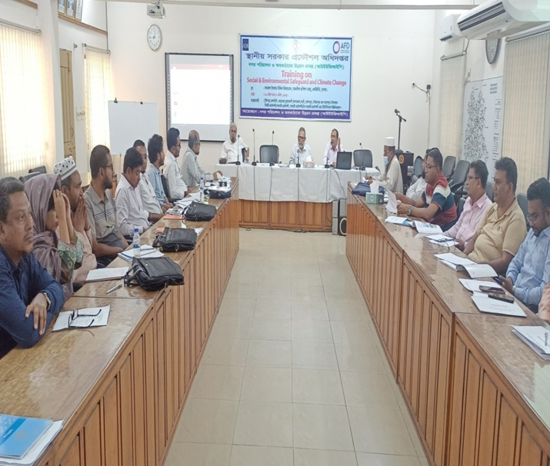 | 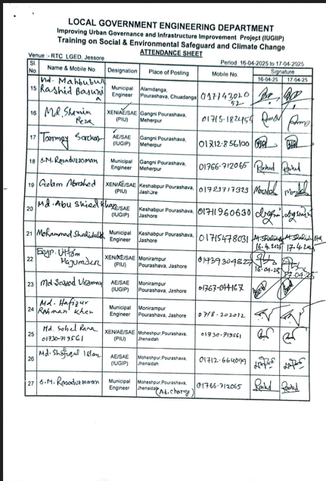
2 | Mymensing  RTC,LGED. | May 04 & 05, 2025 | 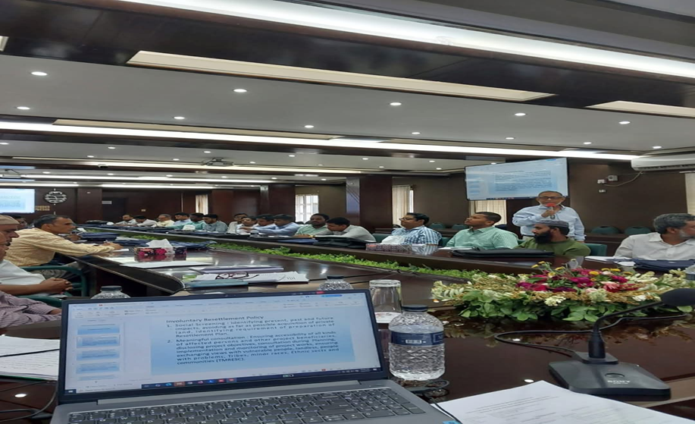 | 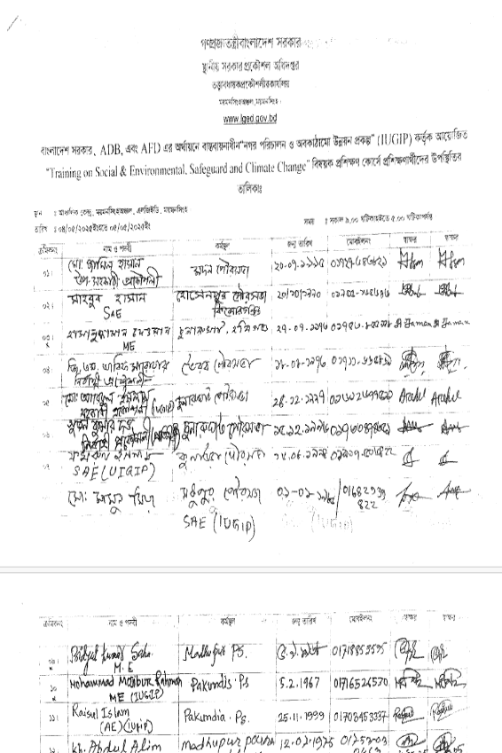
3 | Bogra. RTC, LGED, | May13 &14, 2025 | 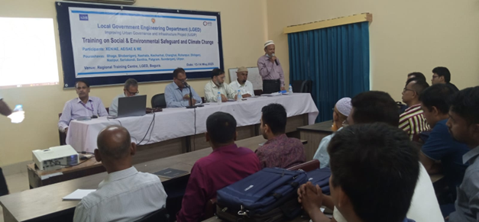 | 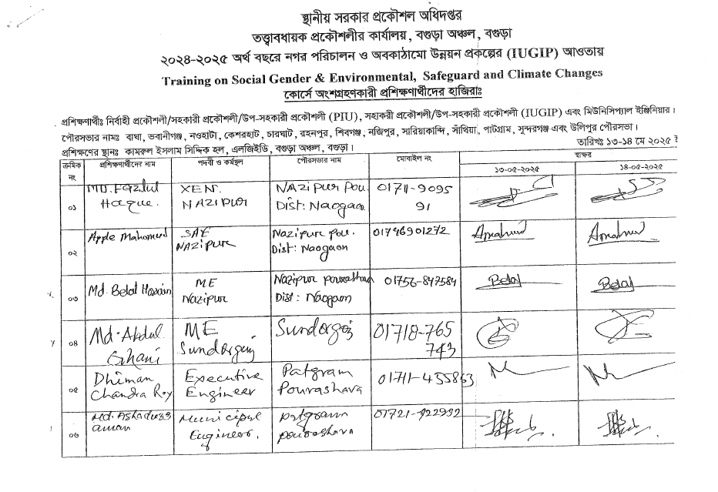
4 | Chattogram RTC,LGED, | May 25 &26,2025 | 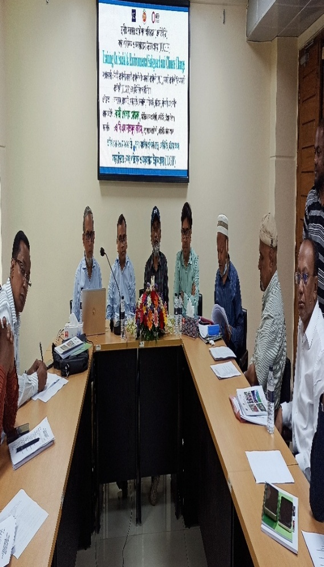 | 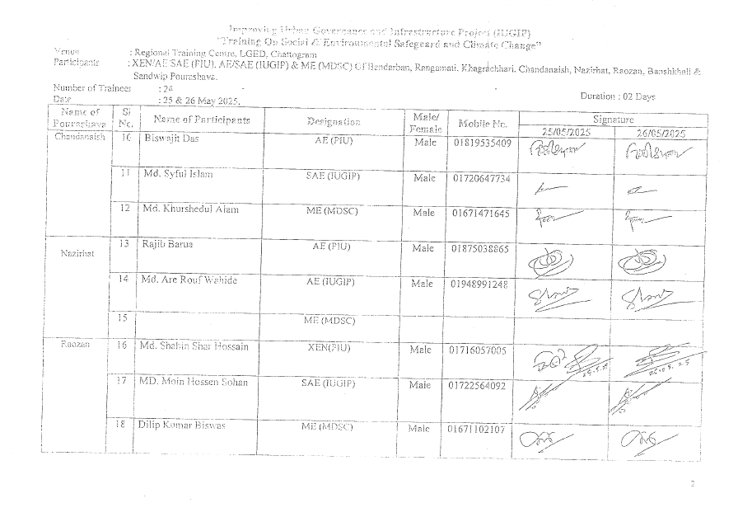
5 | Comilla RTC,LGED, | May 27 & 28, 2025: | 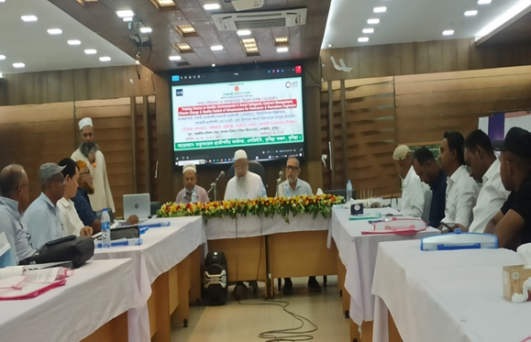 | 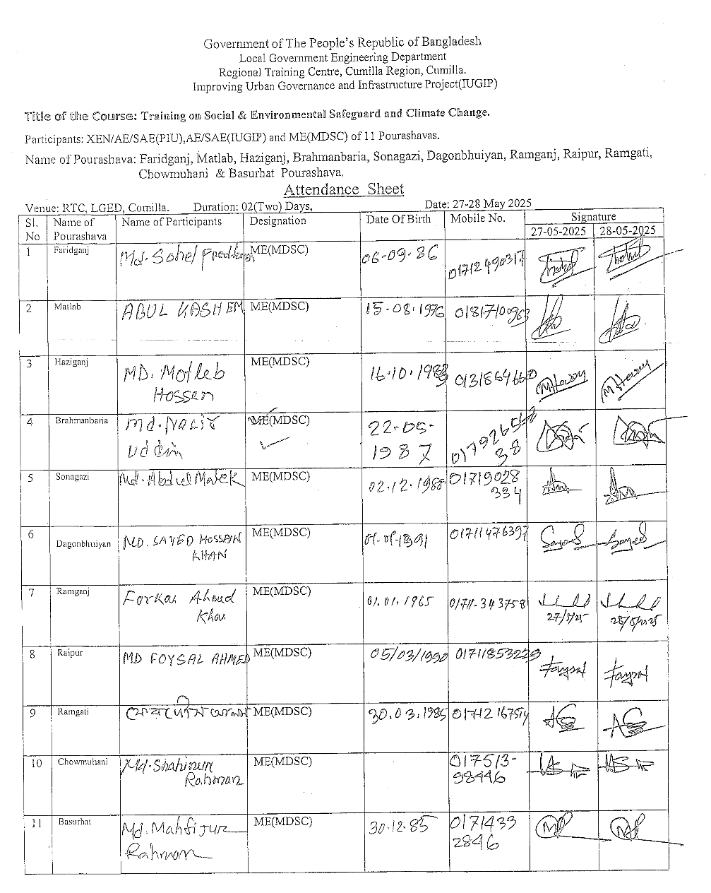
6 | Comilla RTC,LGED, | May 29, 2025 | 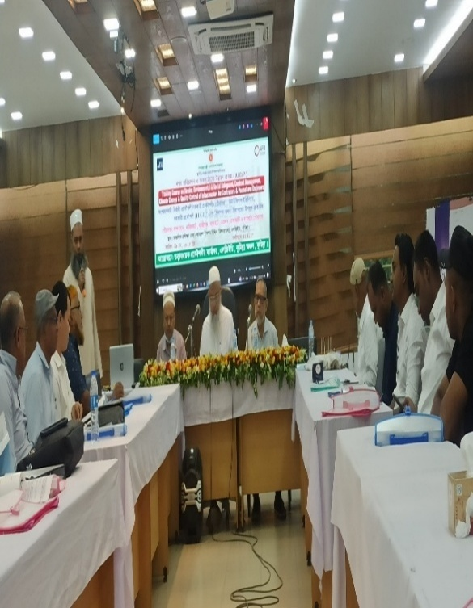 | 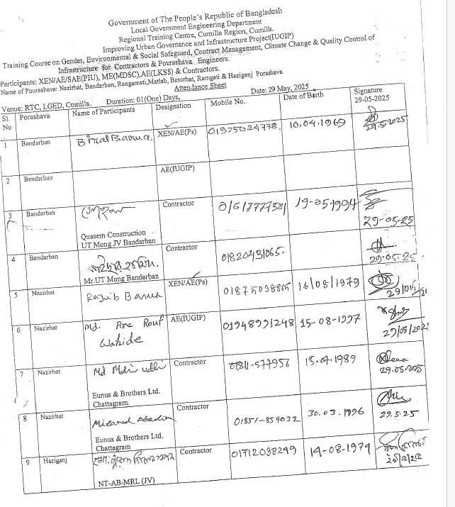
7 | Dhaka RDEC Bhaban, Level-11 | June 19, 2025 | 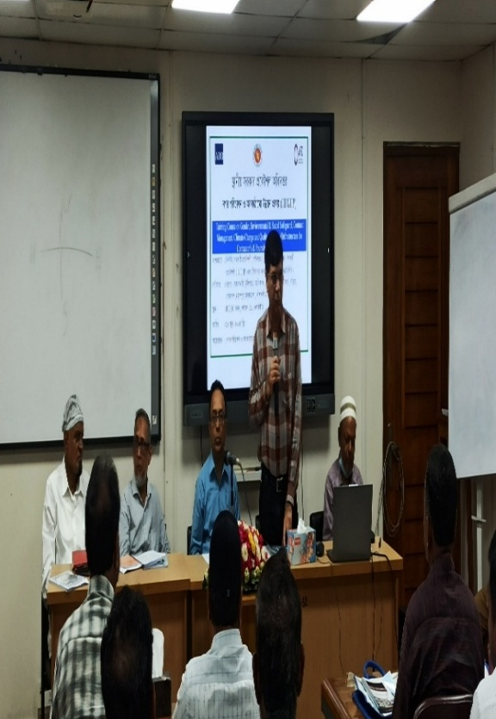 | 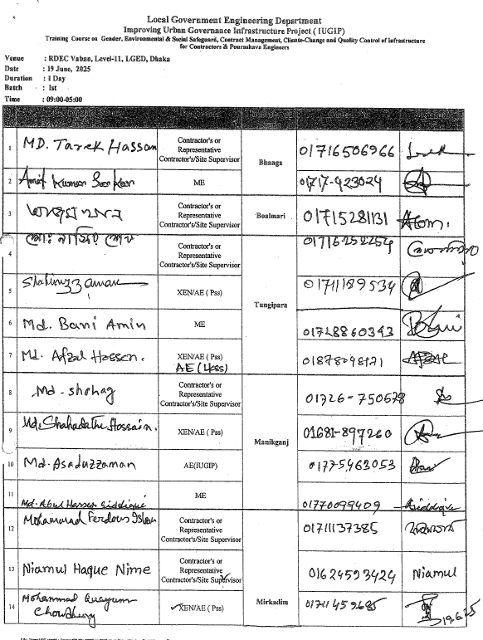
8 | Dhaka RDEC Bhaban, Level-11 | June 22, 2025 | 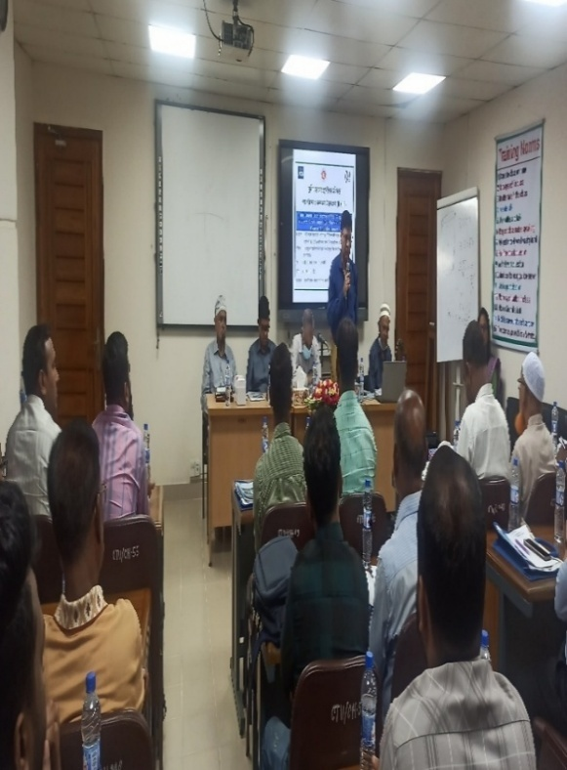 | 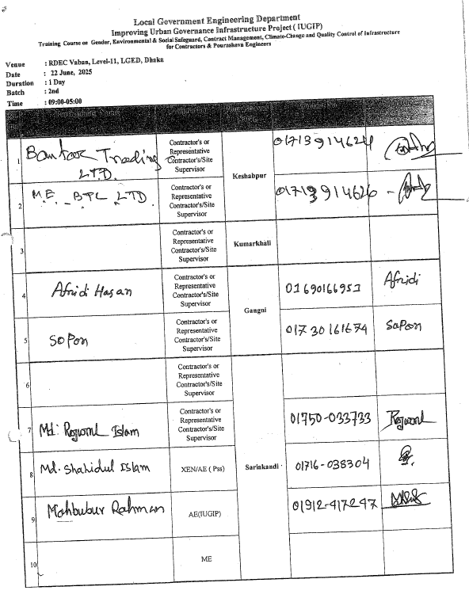

Annex 3: Environmental and Social Management Plan Checklist
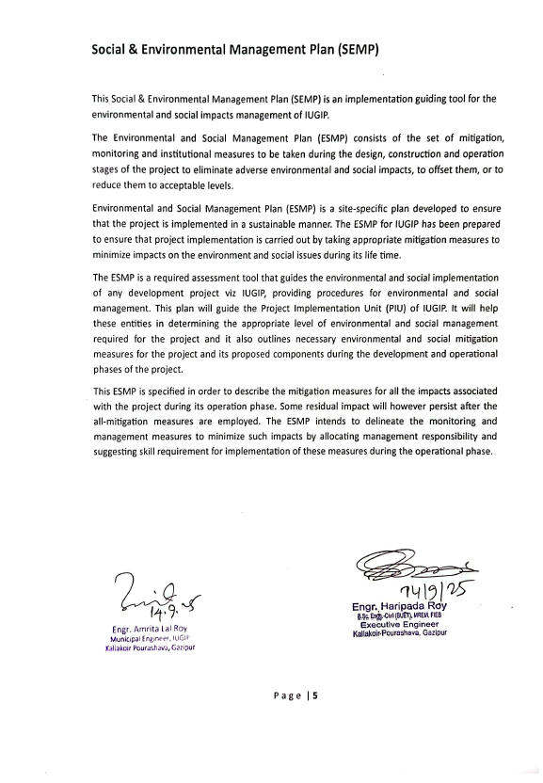

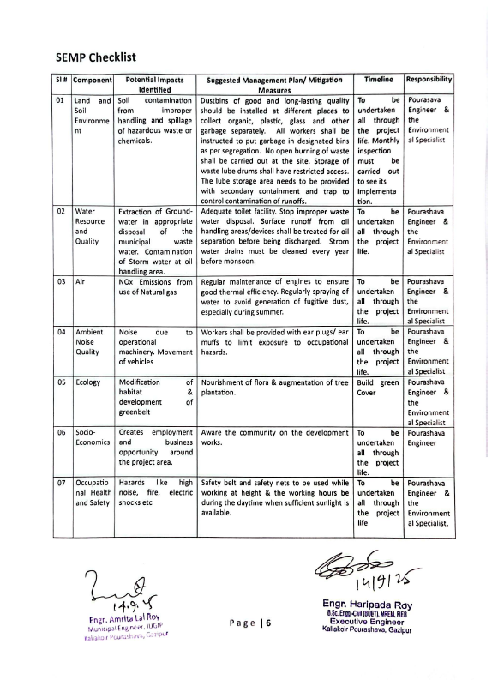

Annex 4: Site-specific environment management plan (SEMP) in Bangla
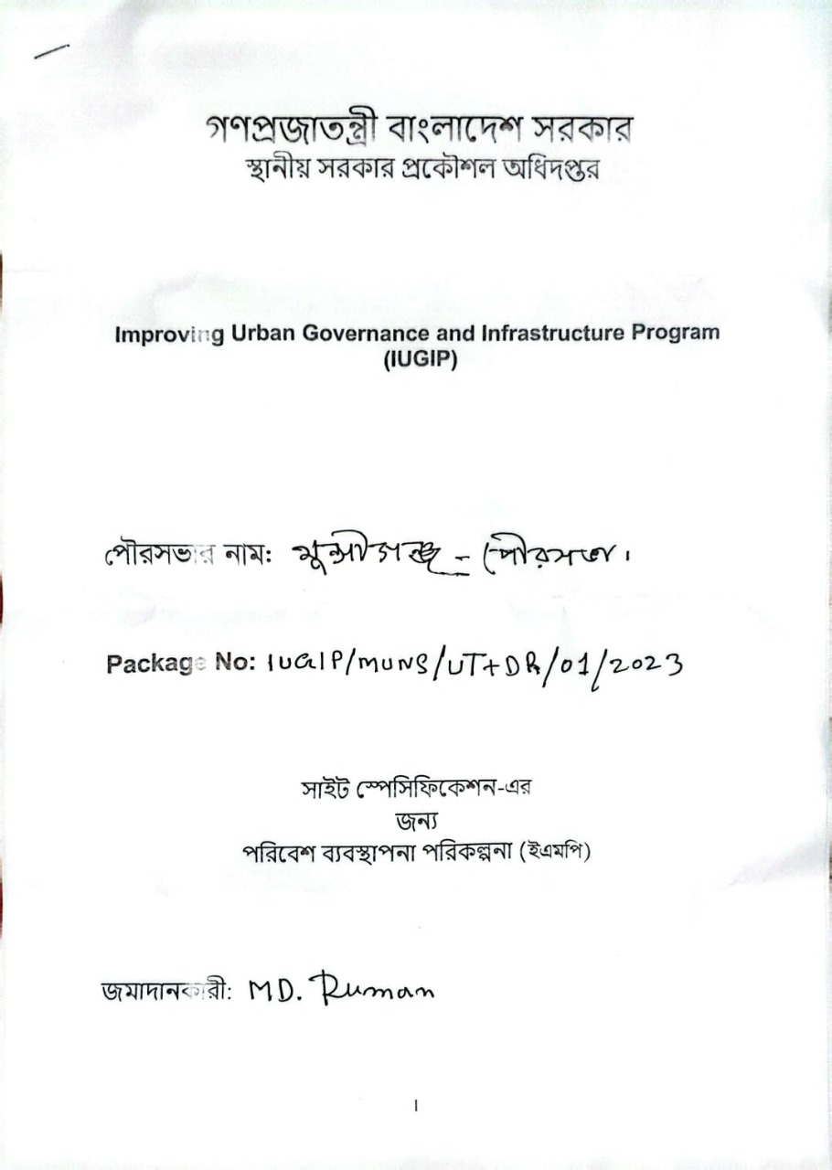

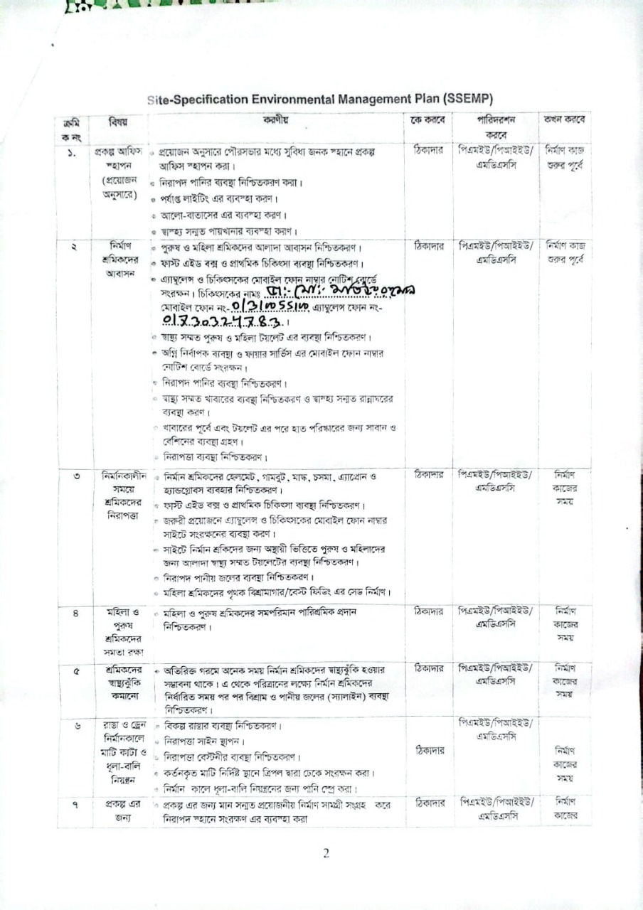

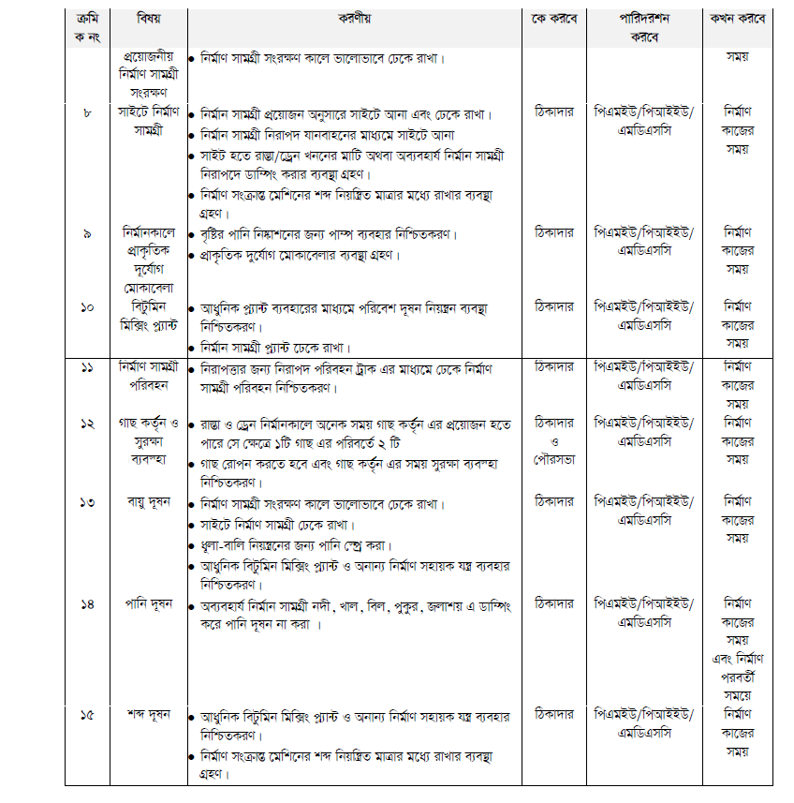

Annex 5: DoE’s letter on ECC exemption

(Environmental Clearance from the Department of Environment, GoB)

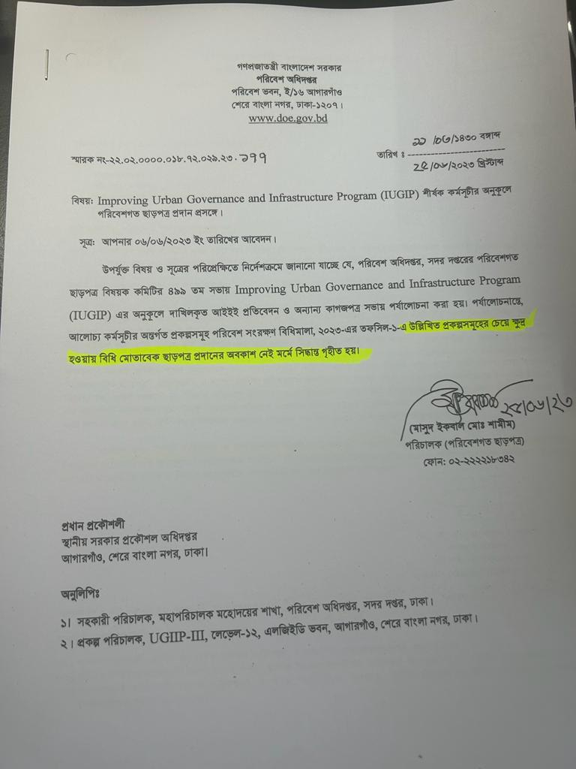

Transcript:
Subject: Regarding Providing Environmental Clearance for Improving Urban Governance and Infrastructure Program (IUGIP)
Reference: Application dated 06/06/2023
The Environmental Clearance Committee under Department of Environment, Government of Bangladesh, in it’s 499th meeting discussed on the Initial Environmental Examination Reports (IEE) and other documents submitted by ‘Improving Urban Governance and Infrastructure Program’ (IUGIP) and decided on the environmental clearance requirement for the project. It is observed that the proposed project components are less significant than the projects enlisted under Environment Conservation Rules, Schedule 1 (A), 2023, hence, there is no requirement to provide environmental clearance.
Signed/Director

Annex 6: Checklist on mitigation & monitoring of Environmental Compliance of Kaliakoir Poureshava
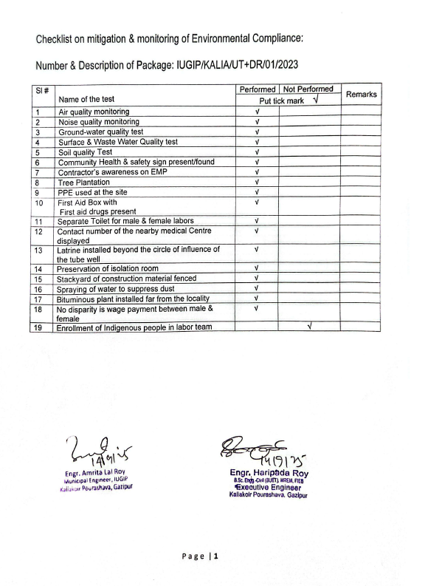

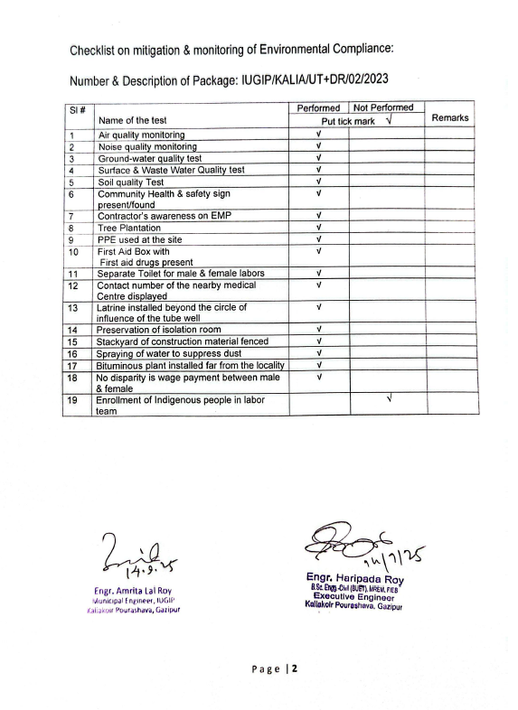

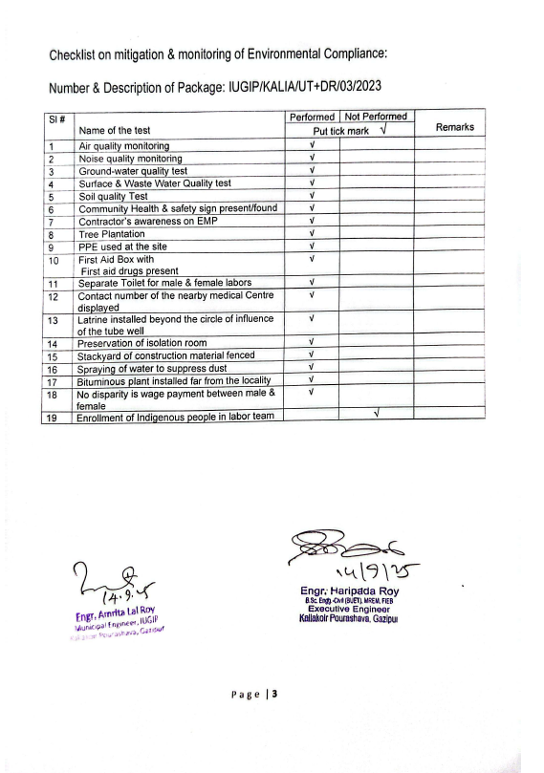

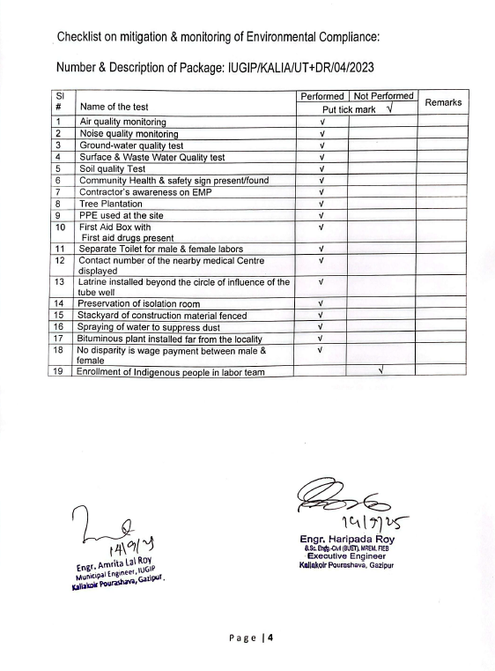

Annex 7: RBL and REA Checklist
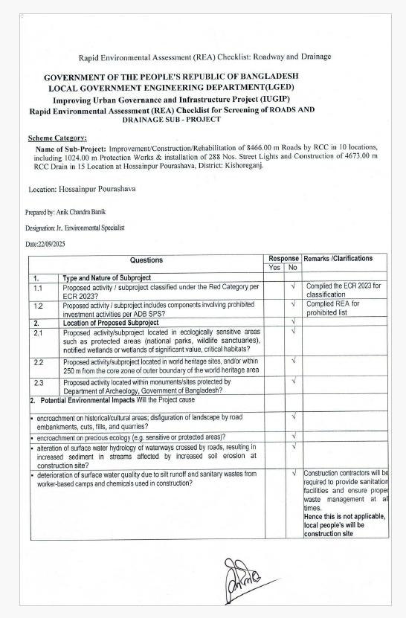

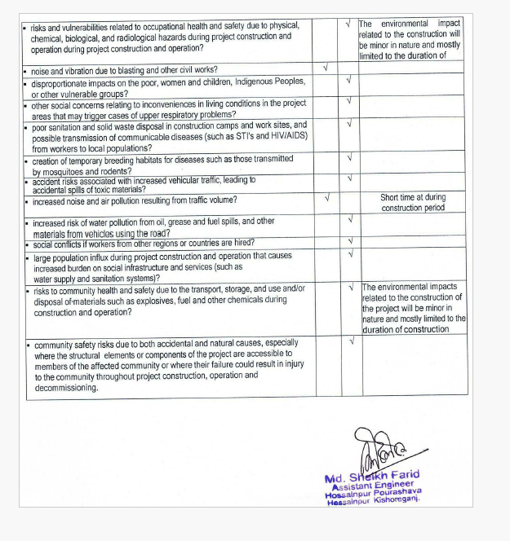

Annex 8: GRM Diagram

Field/ward level:
Contractor, PIU designated social safeguard focal person
Pourashava level (GRC):
PIU designated safeguard focal person, MDSC regional resettlement specialists
PIU level:
PMU Safeguard Officer and MDSC Senior resettlement specialists
Affected person
1st Level Grievance
3rdLevel Grievance
2nd Level Grievance
Yes
Within 7 days

within7 days
Grievance redressed and record keeping
Grievance redressed and record keeping
Grievance redressed and record keeping
Yes,
Within 15 days
Yes
Within 30 days
Note: GRC = Grievance Redress Cell; PIU = Program Implementation Unit; MDSC = Management. Design and Supervision Consultants; PIU = Program Implementation Unit.

Annex 9 : EMP Test Total Report

(During-Construction period)
Sundarganj Pourasava, Gaibandha District
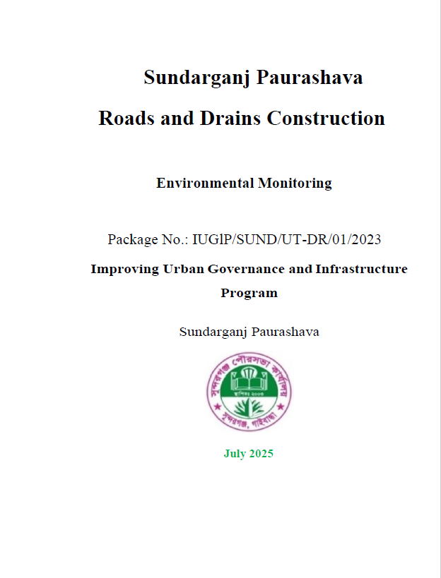

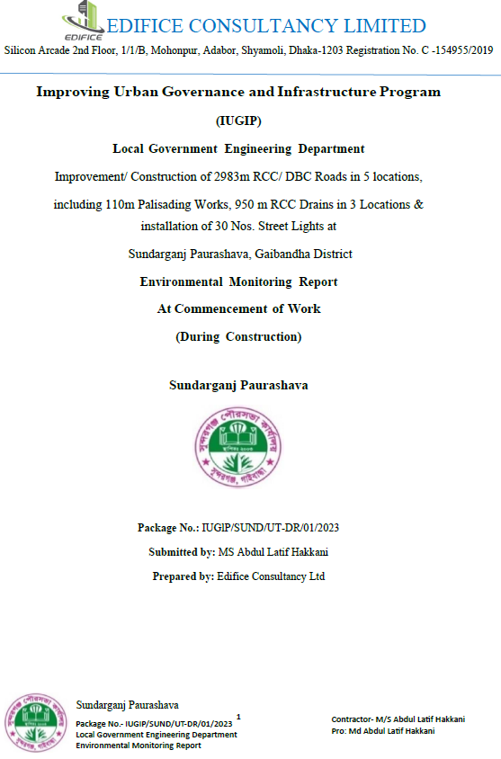

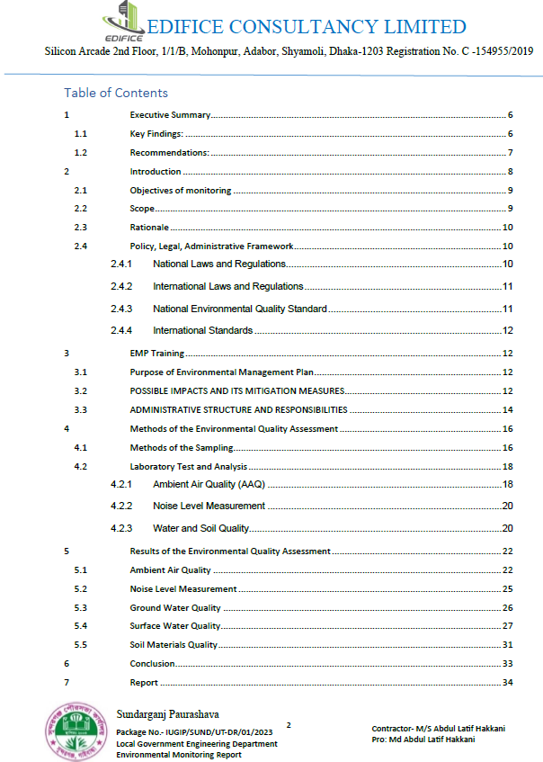

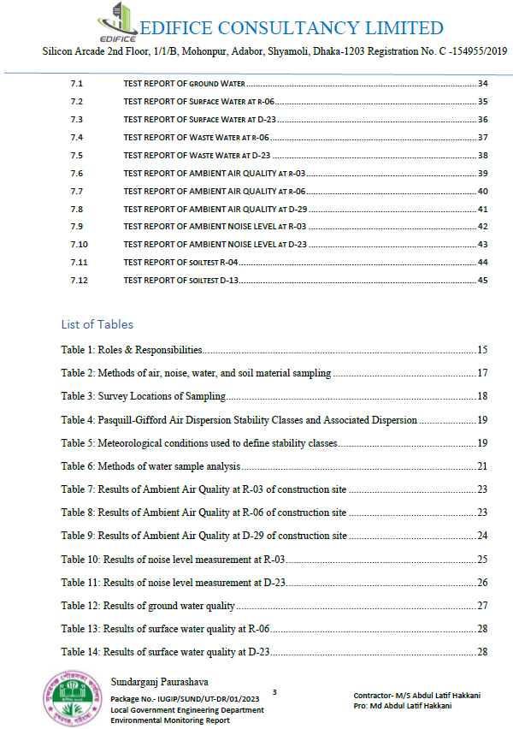

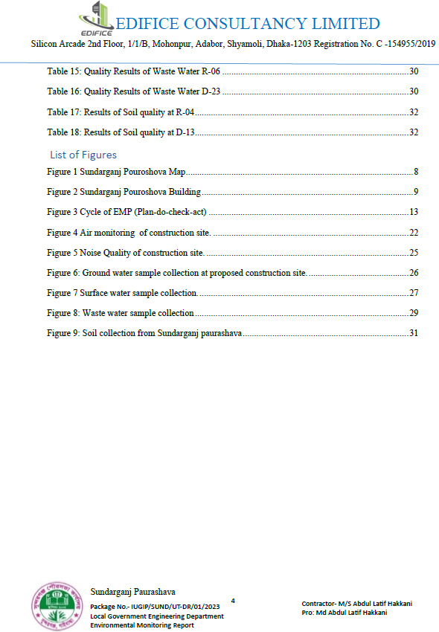

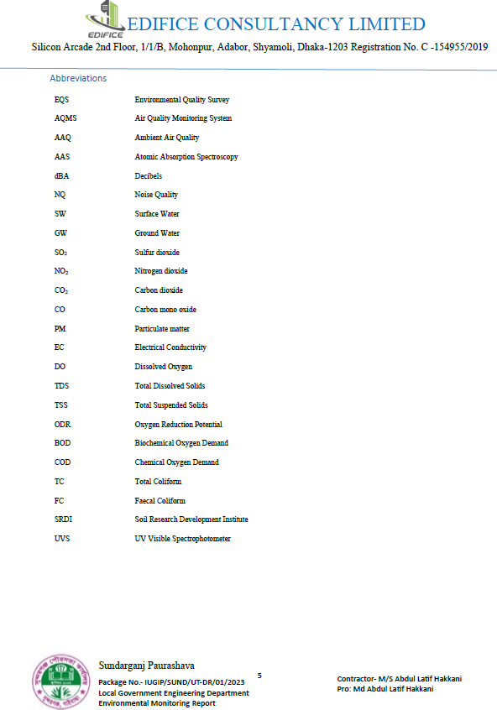

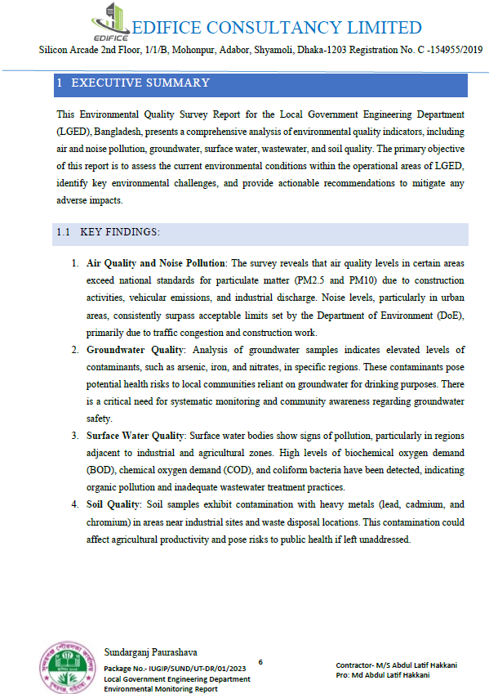

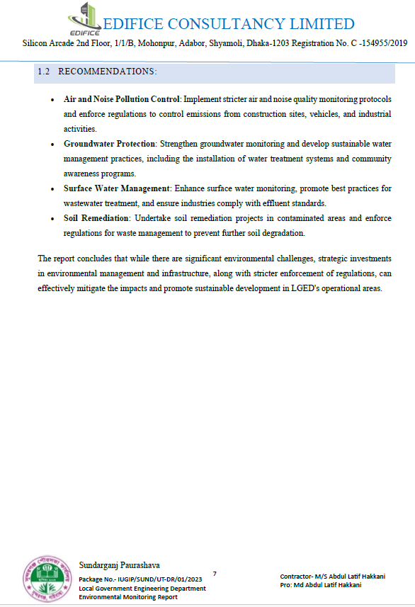

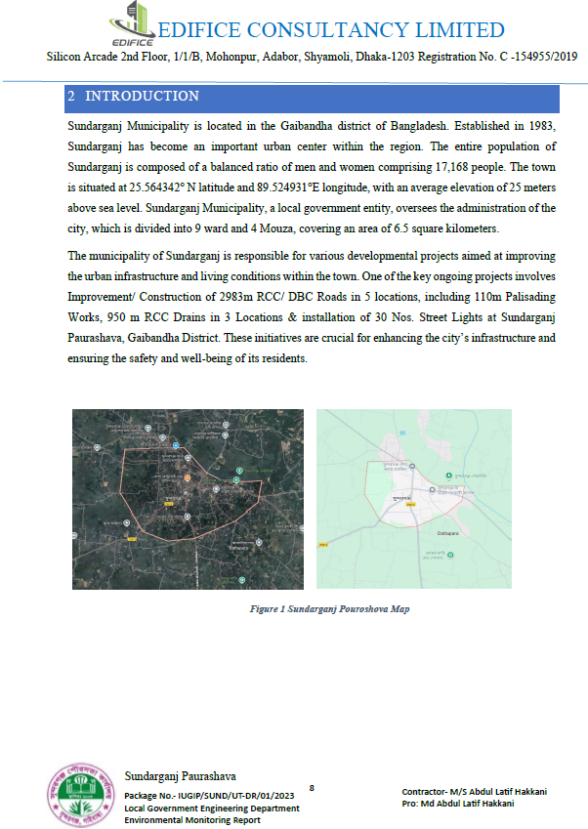

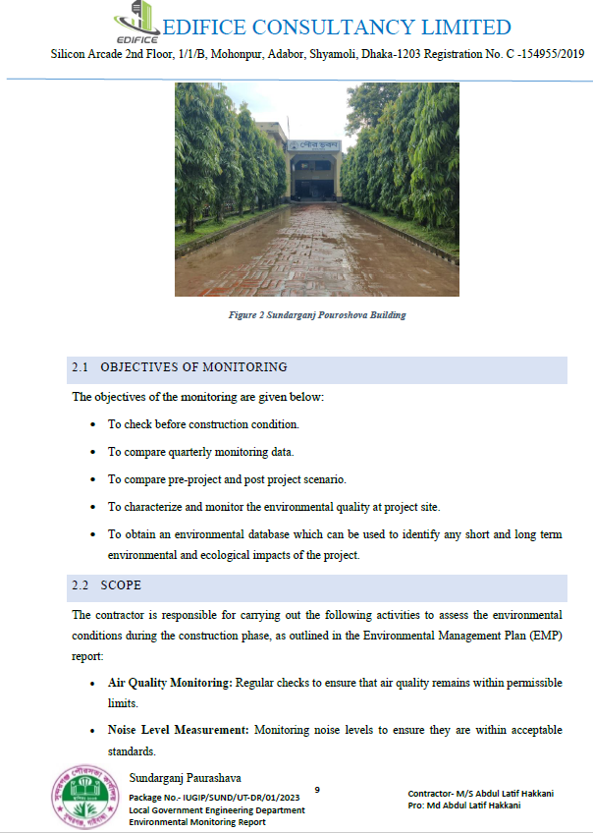

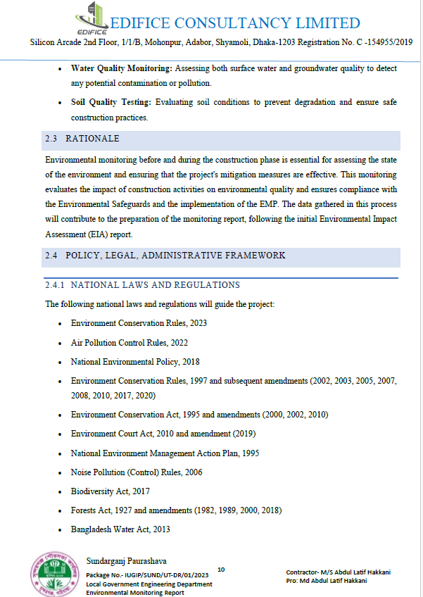

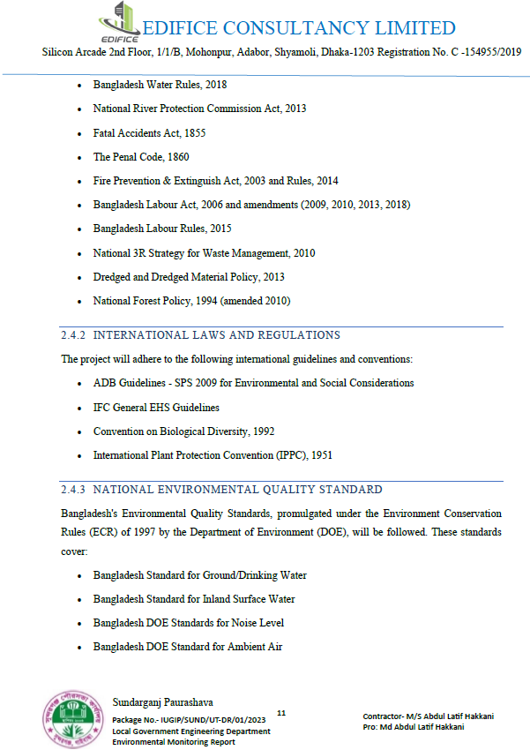

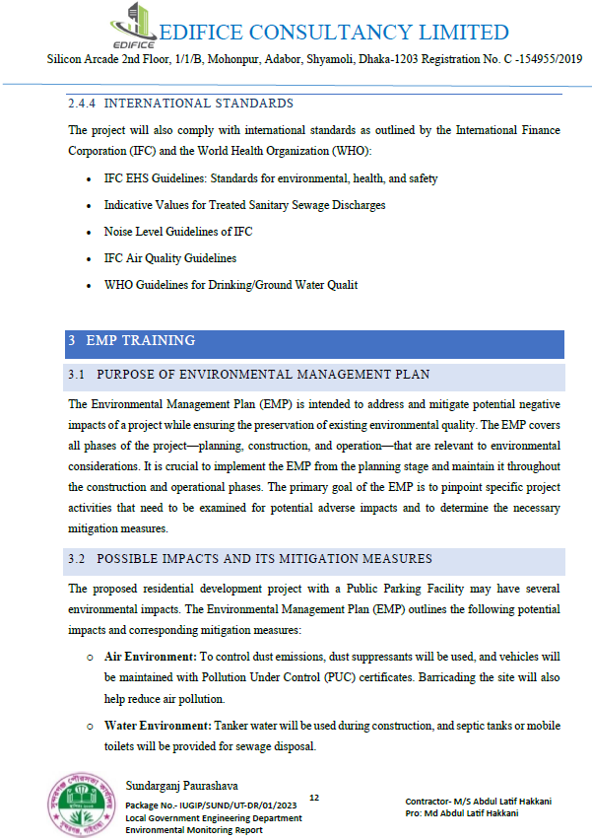

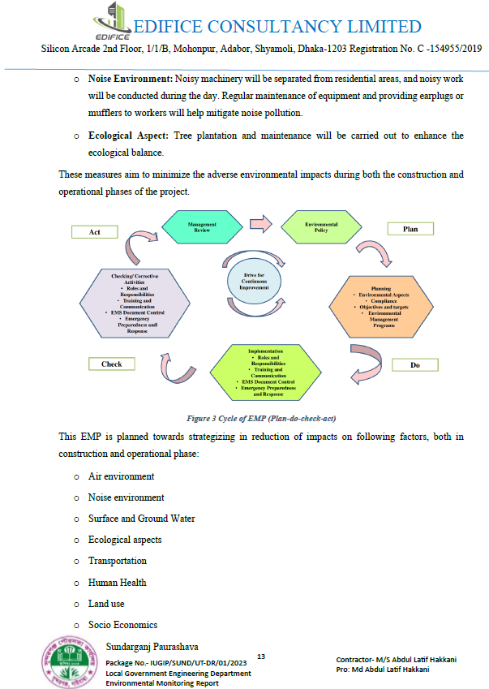

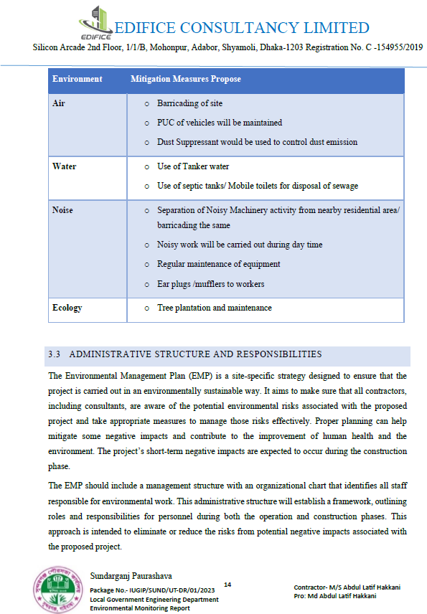

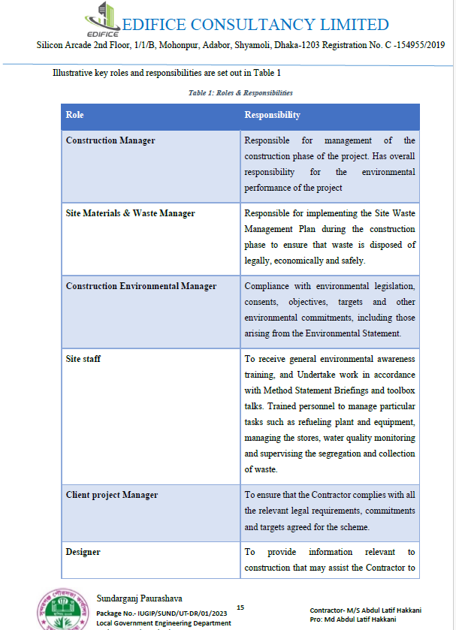

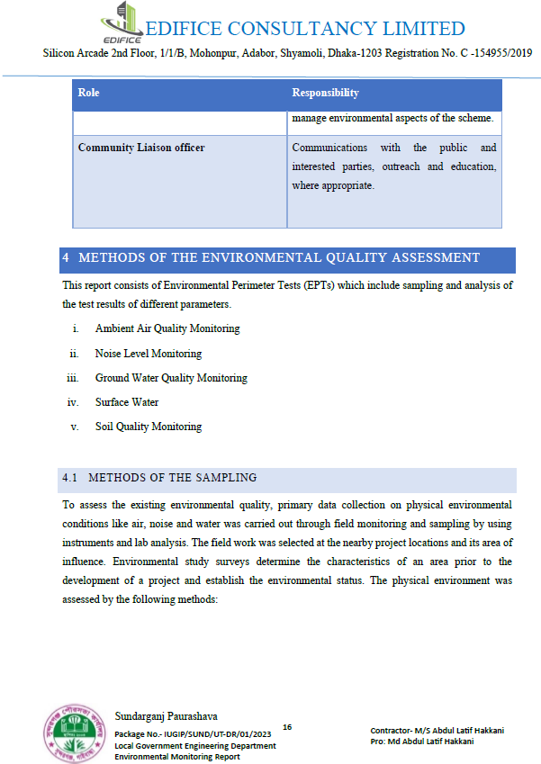

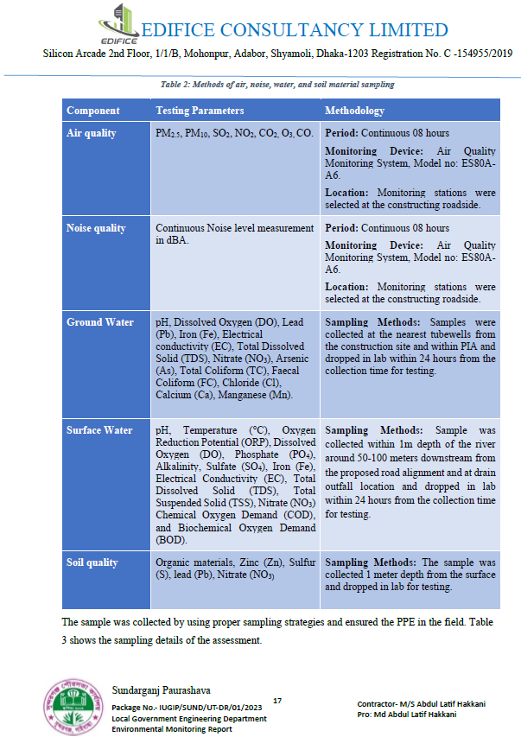

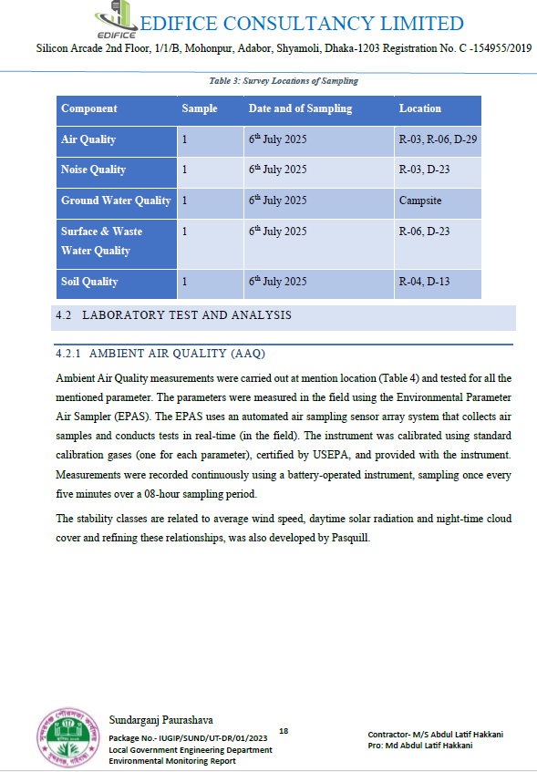

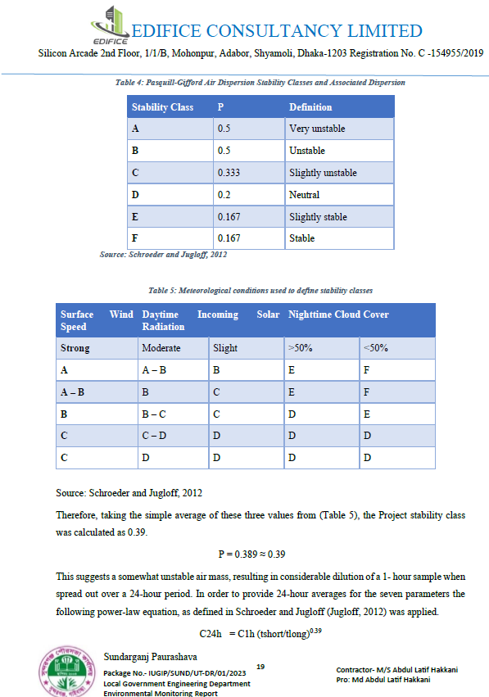

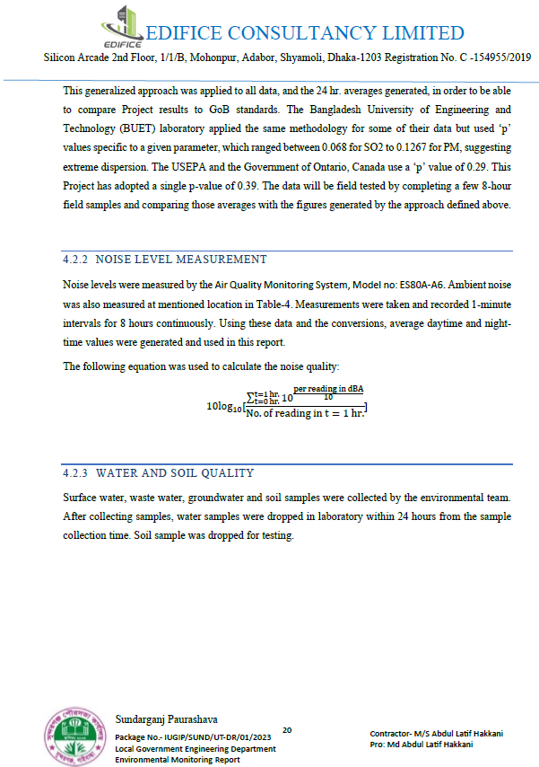

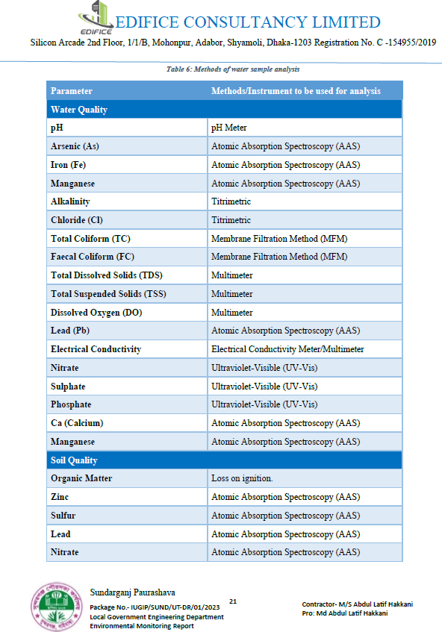

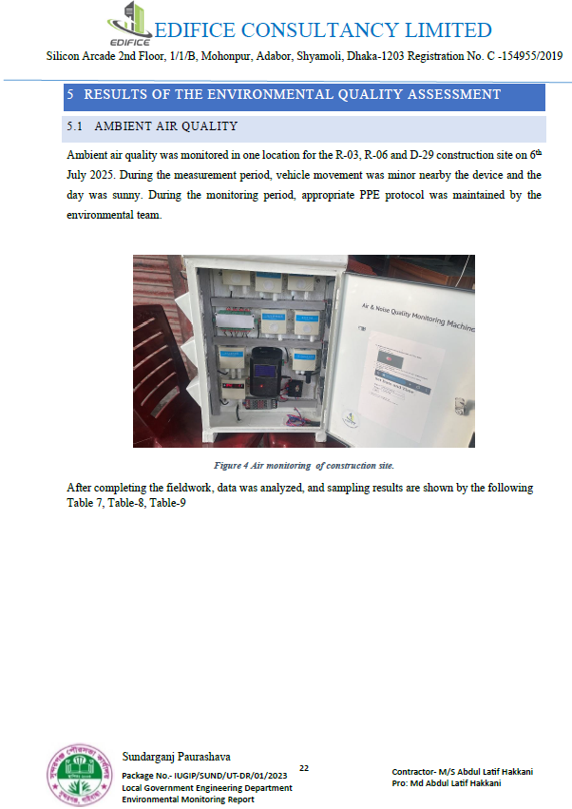

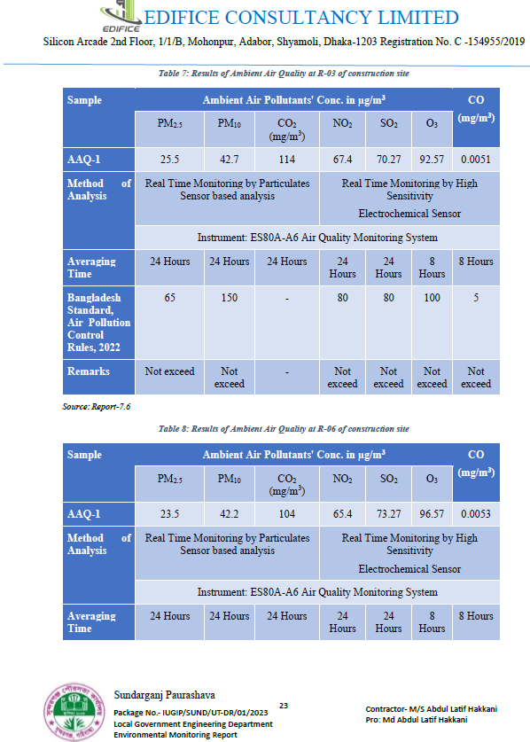

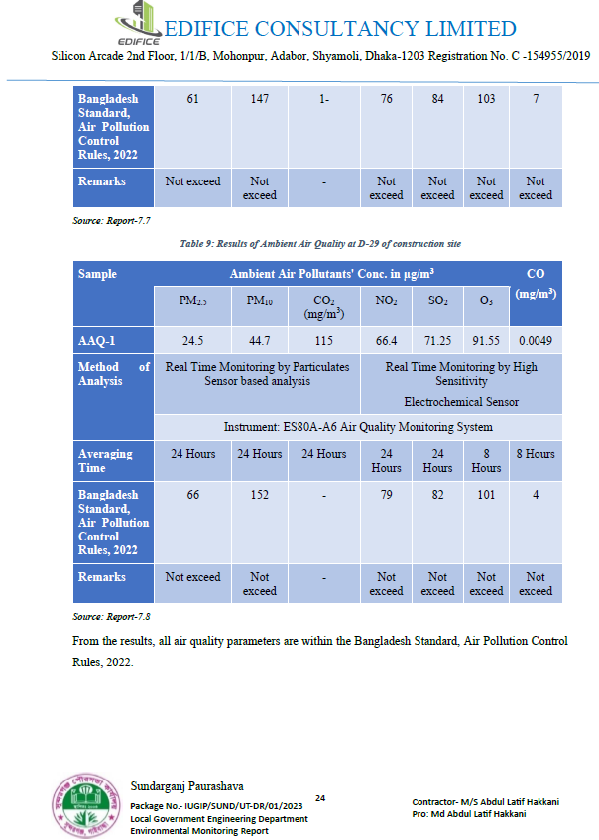

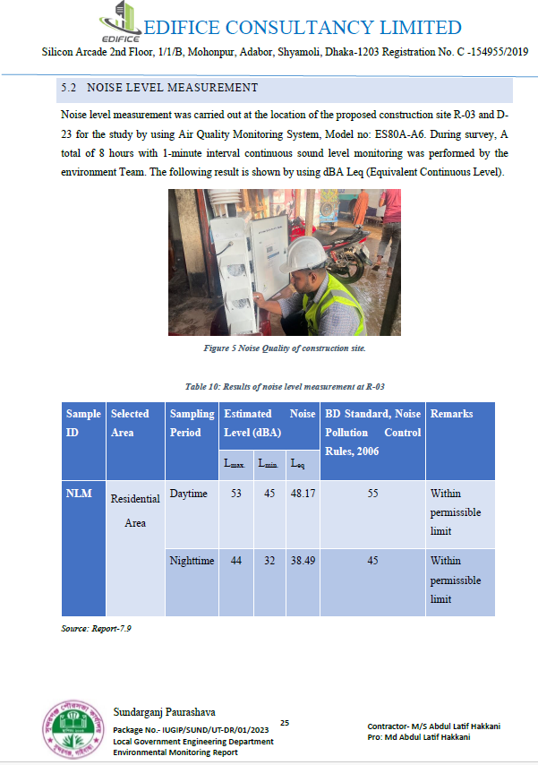

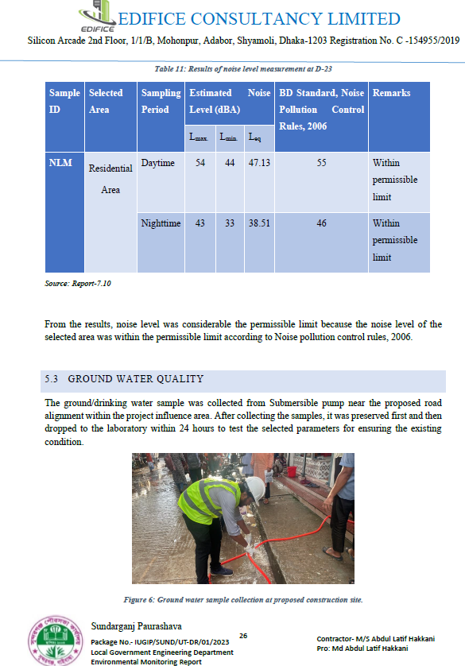

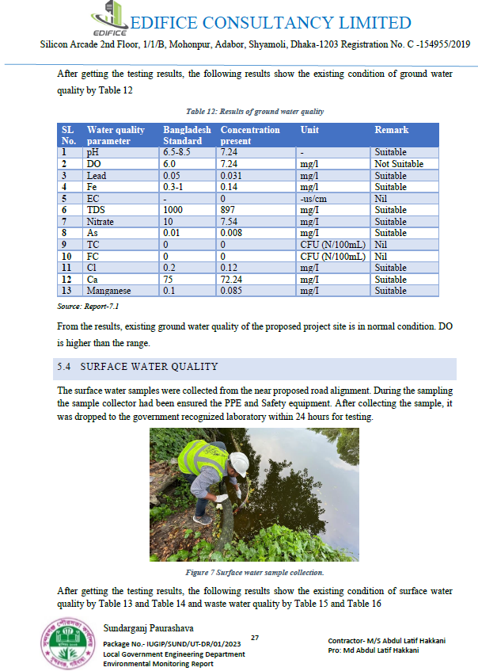

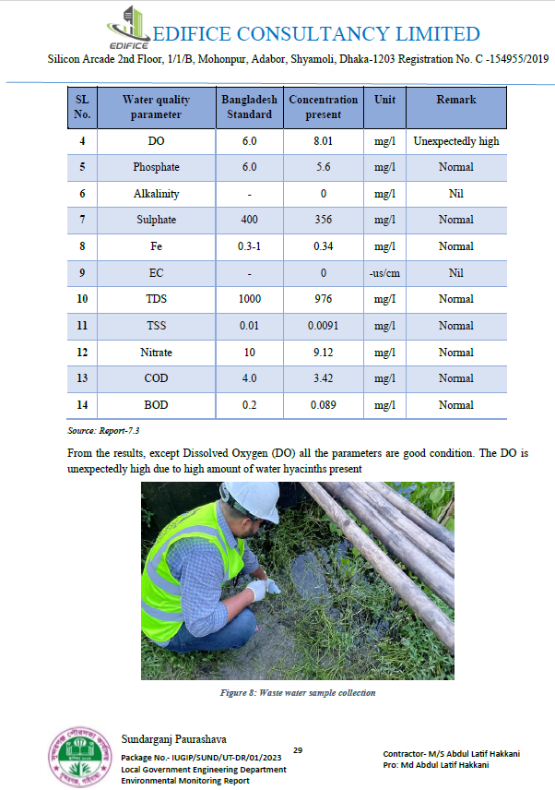

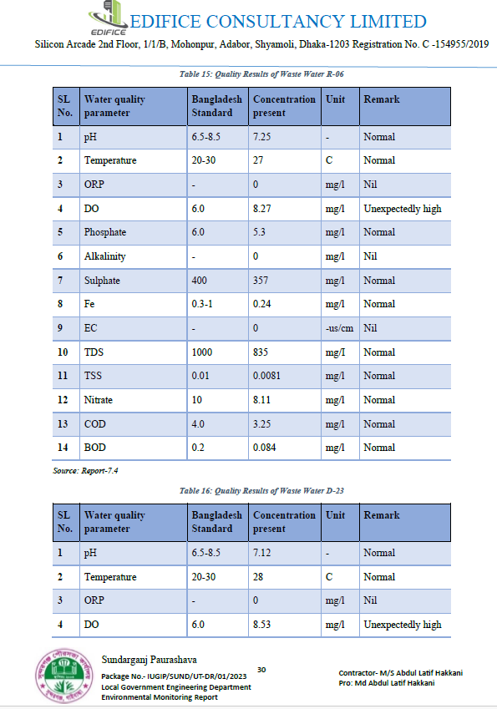

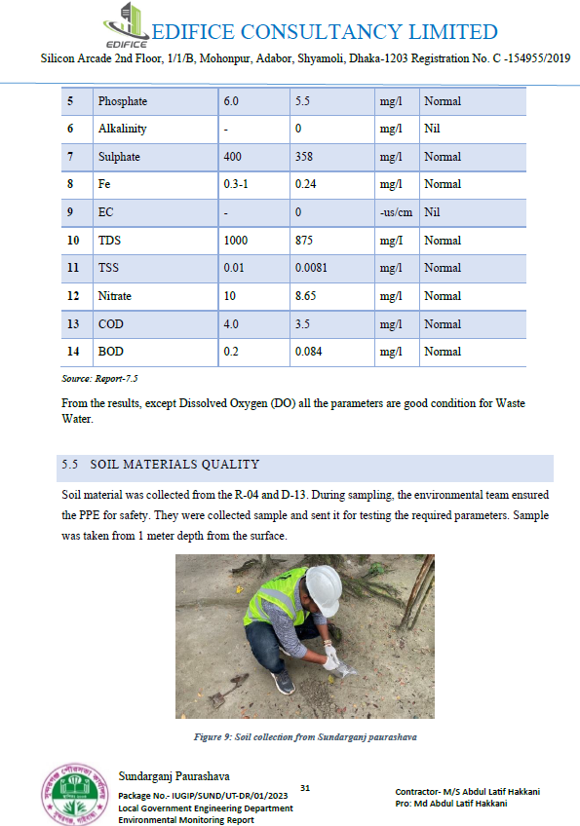

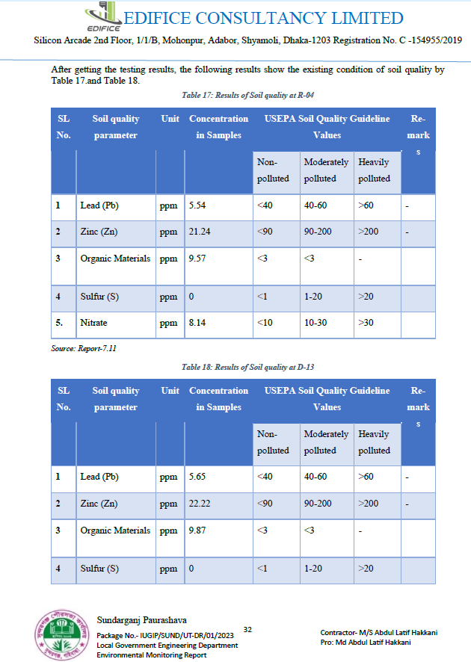

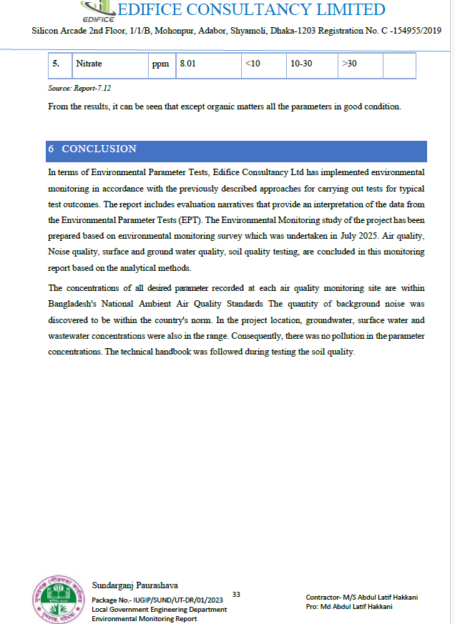

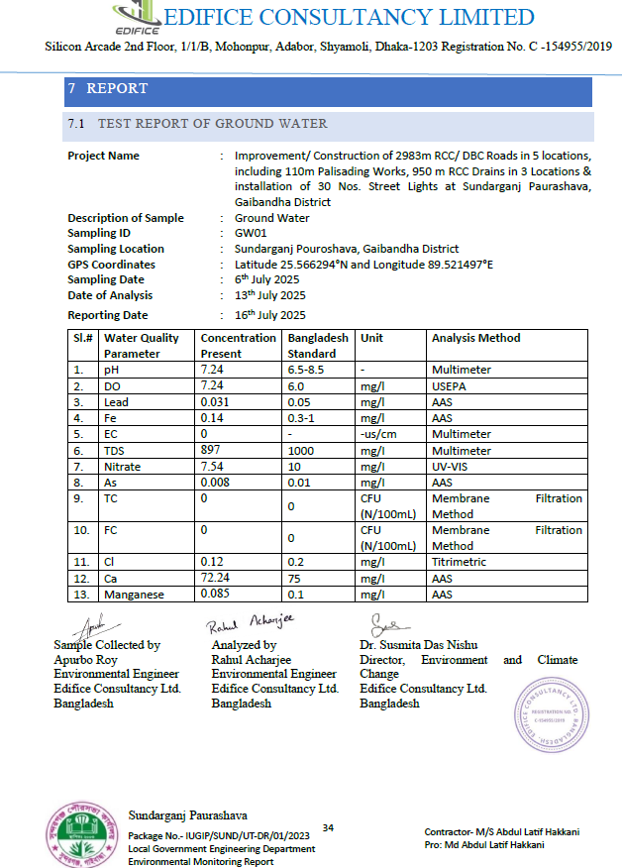

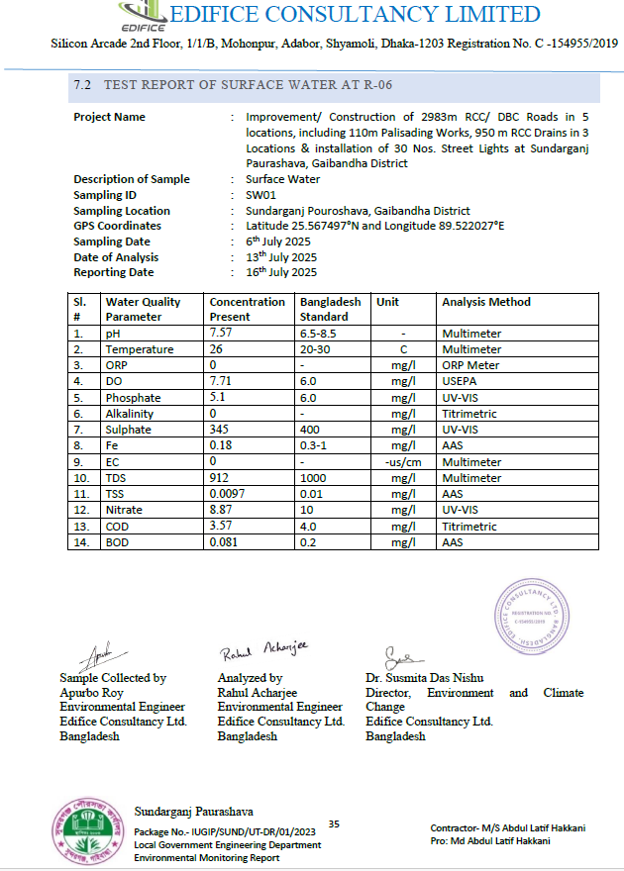

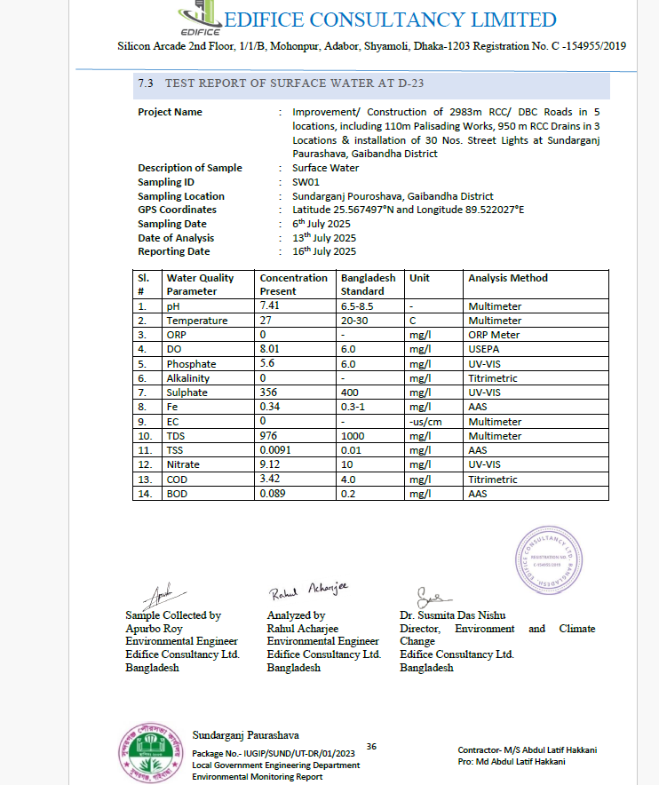

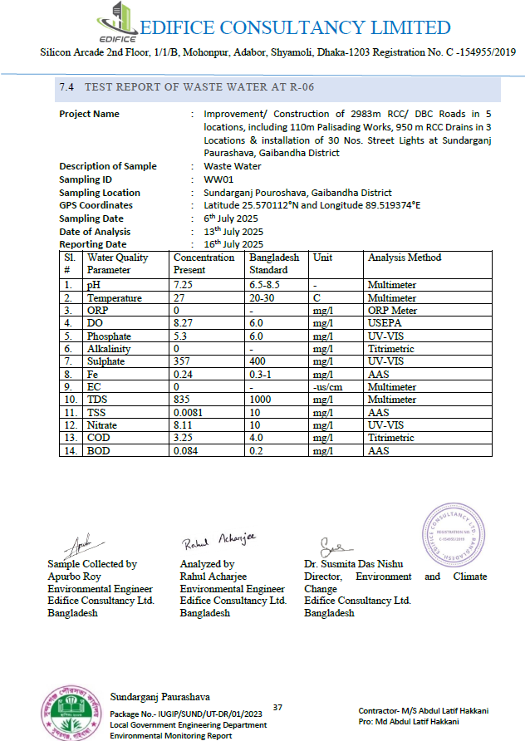

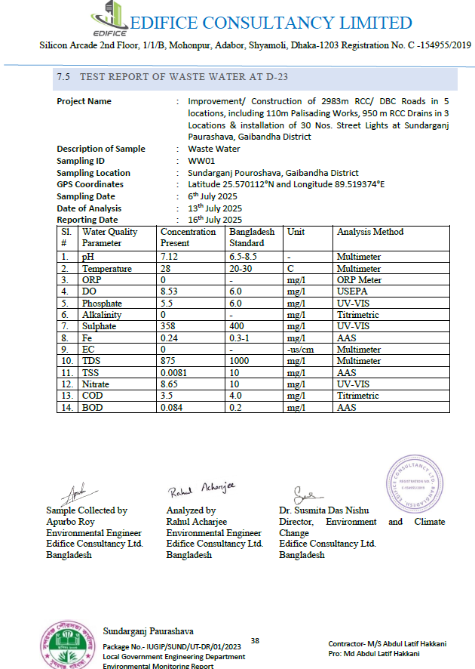

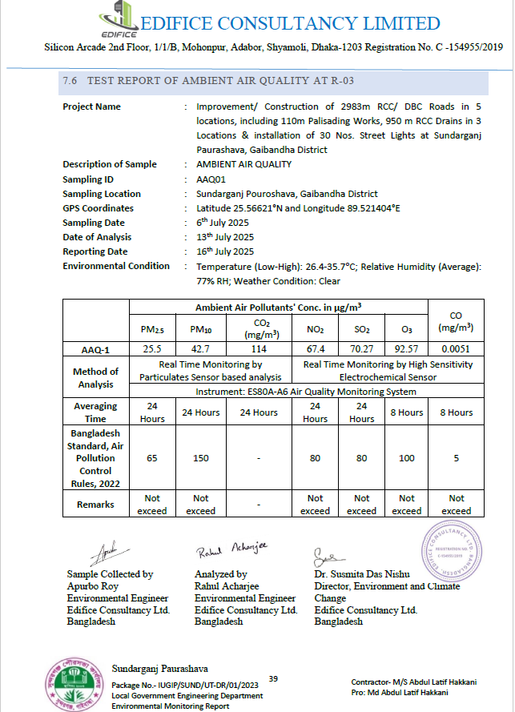

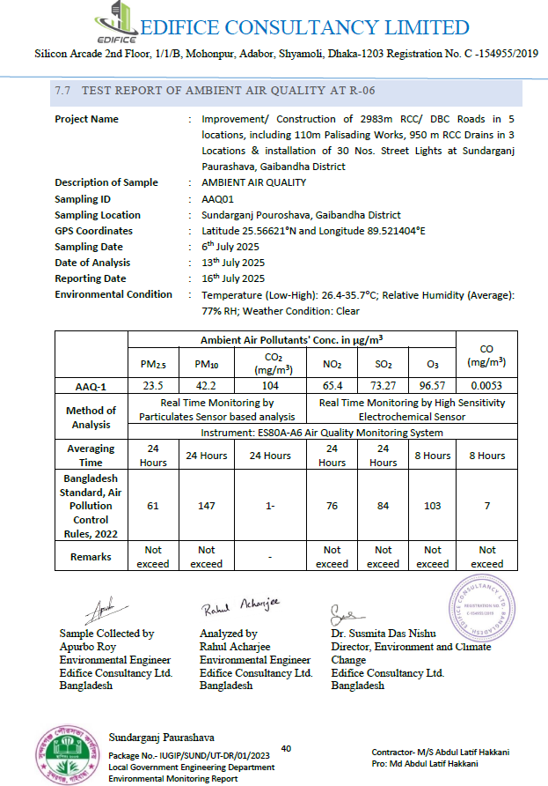

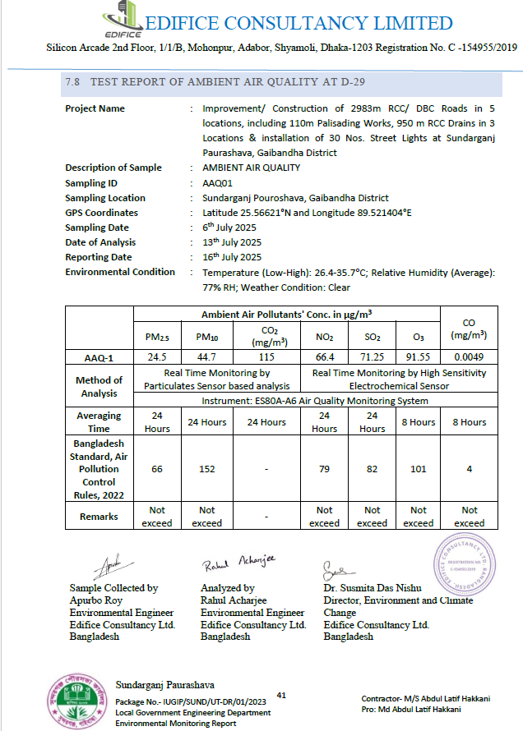

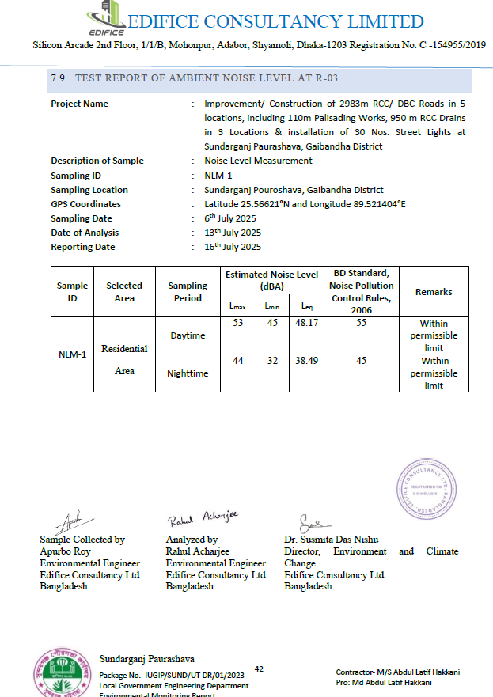

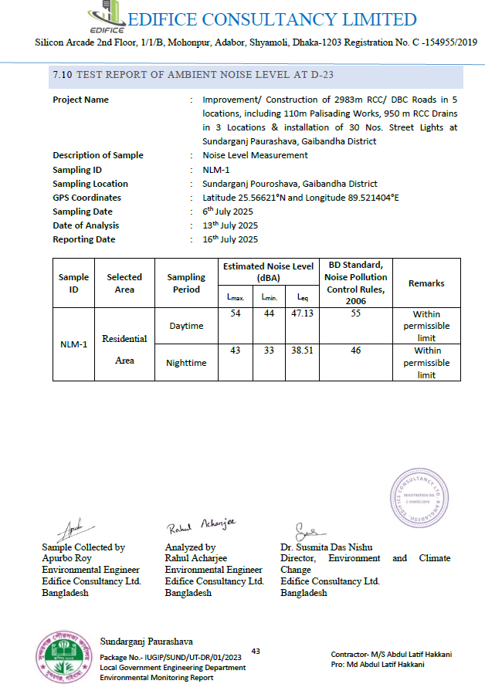

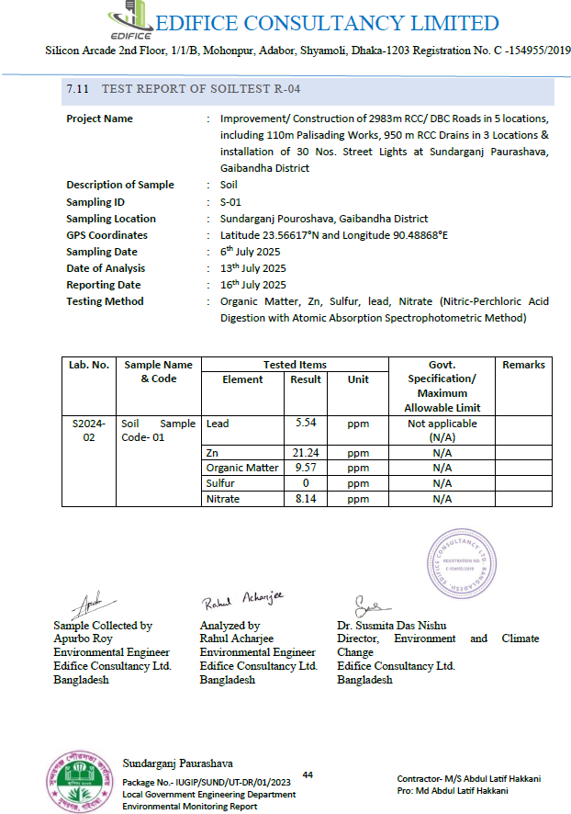

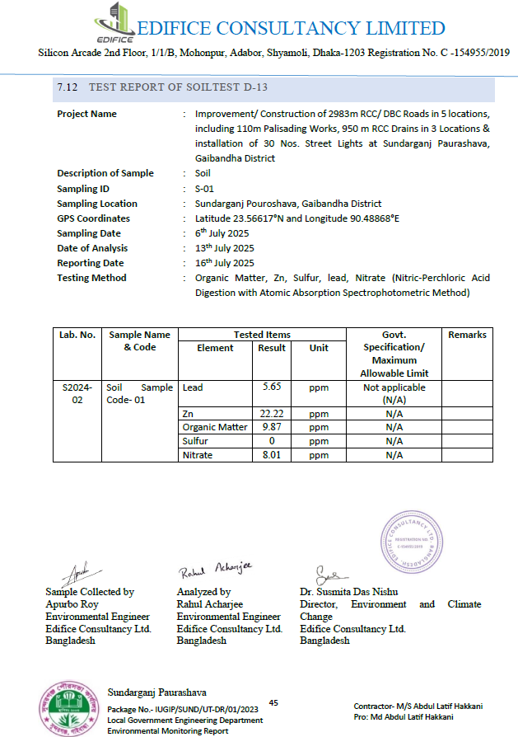

Annex 10: Environmental management Plan (EMP) items in BOQ Matlab Pourasava, Chandpur.
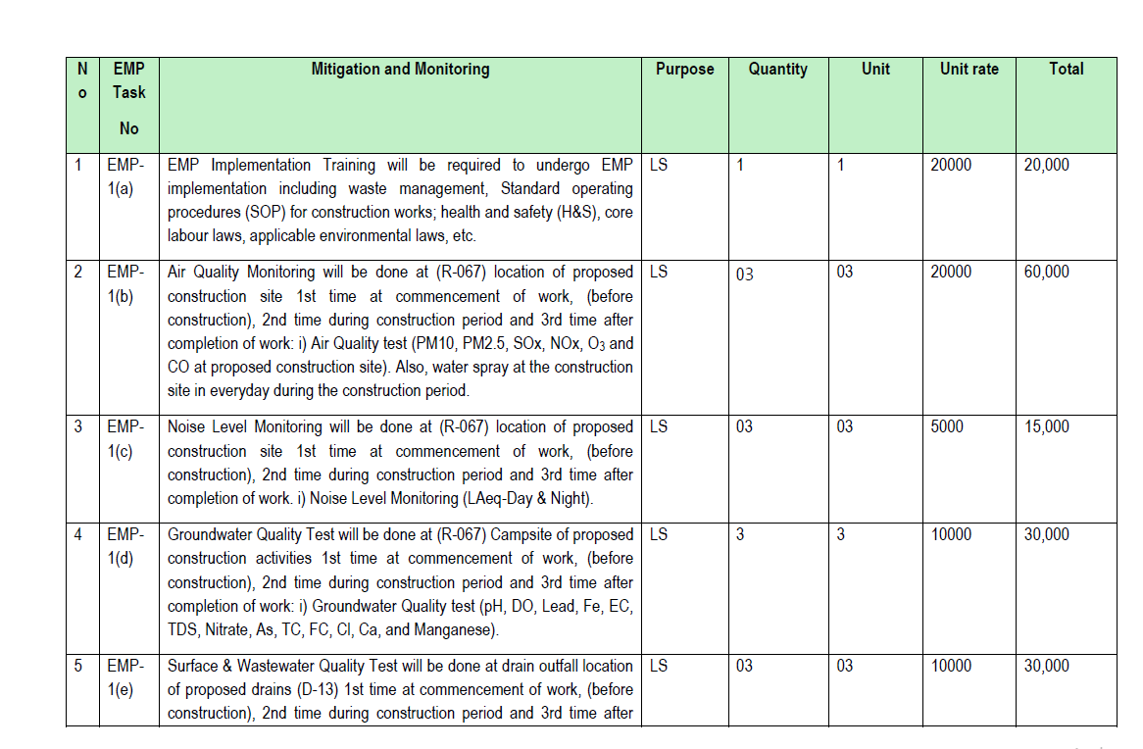

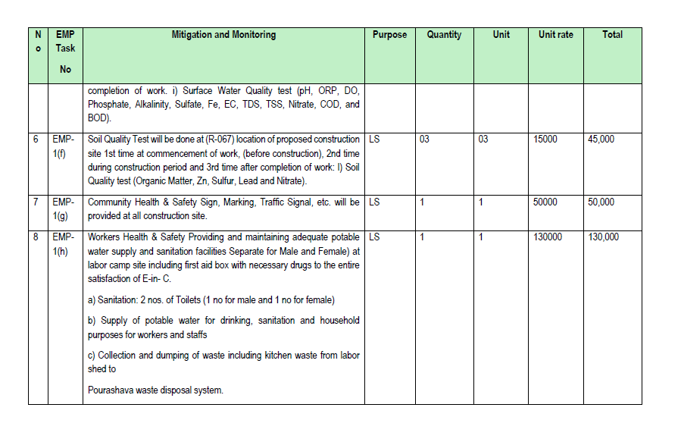

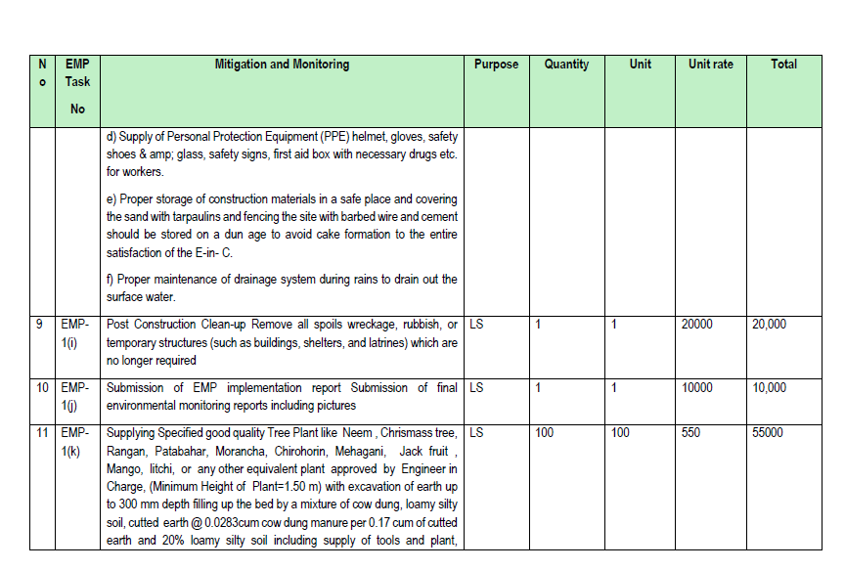

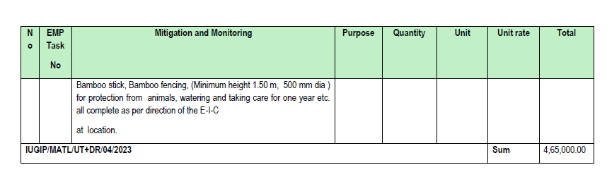

Annex 11: Environmental management Plan (EMP) items in detail Estimate Munshiganj Pourasava.
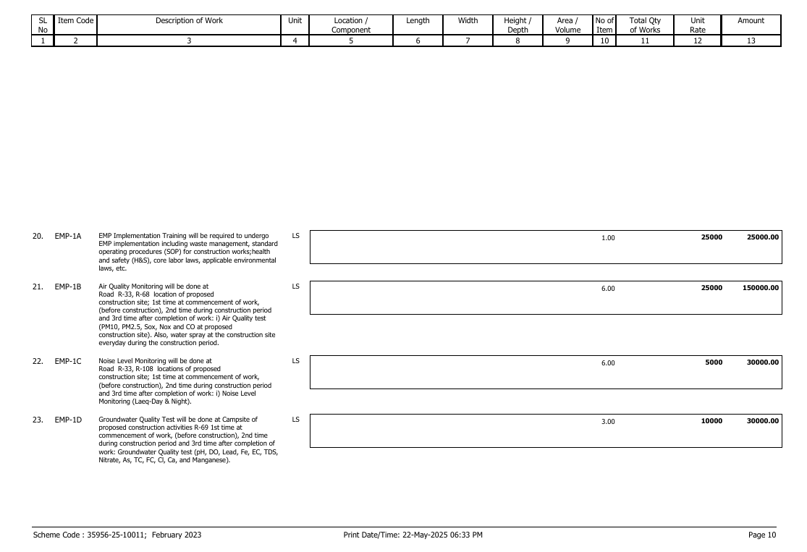

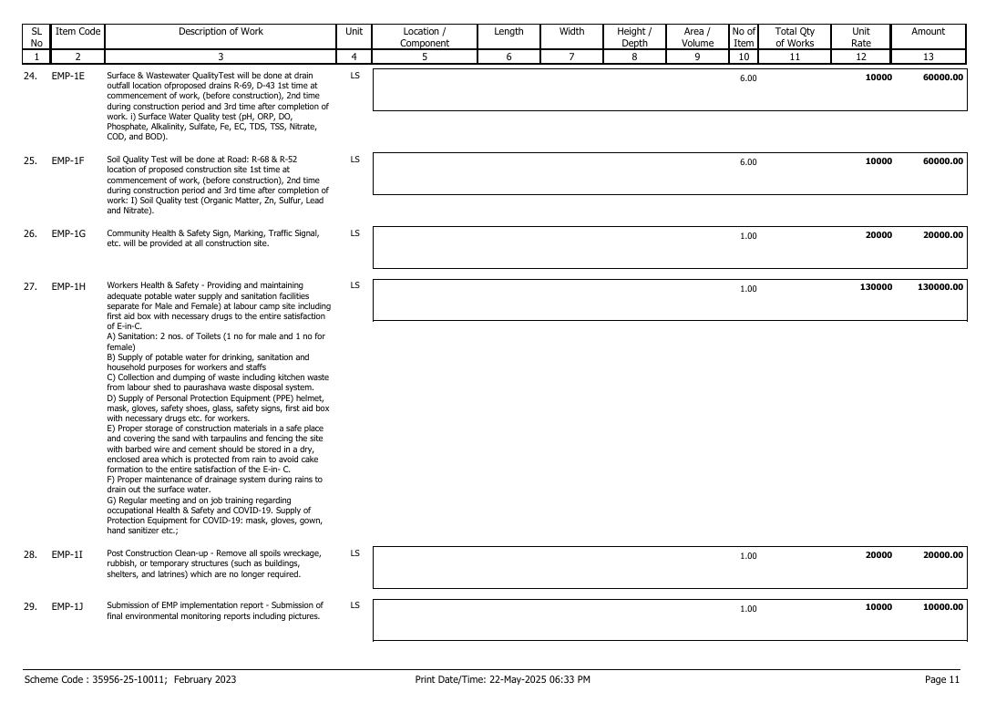

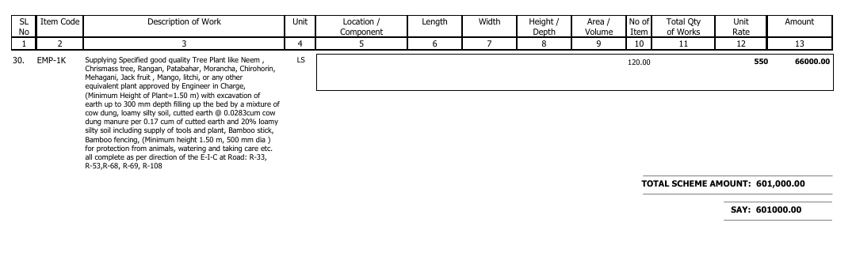

Annex 12 :Quarterly Environmental Monitoring Report of Araihazar Pourashava
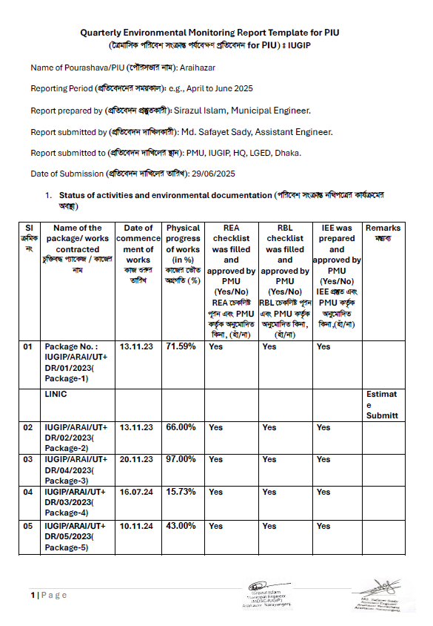

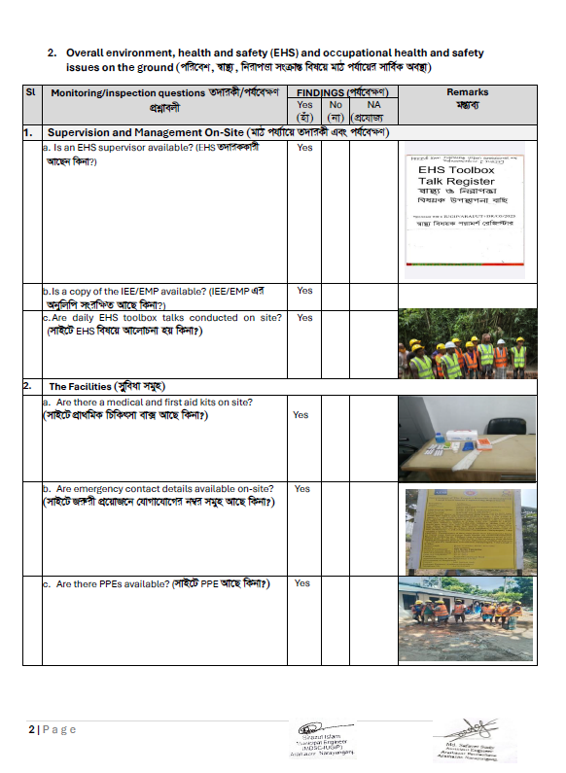

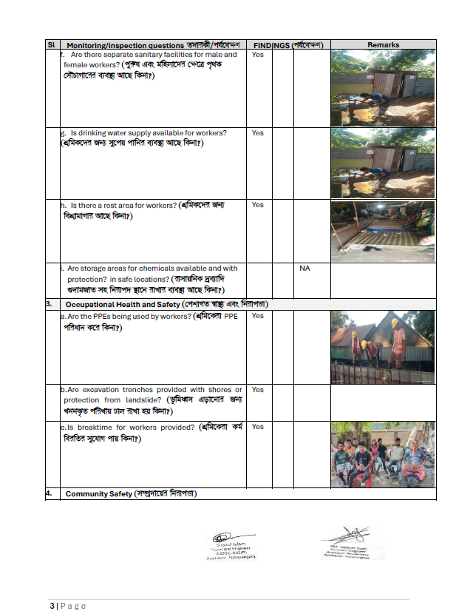

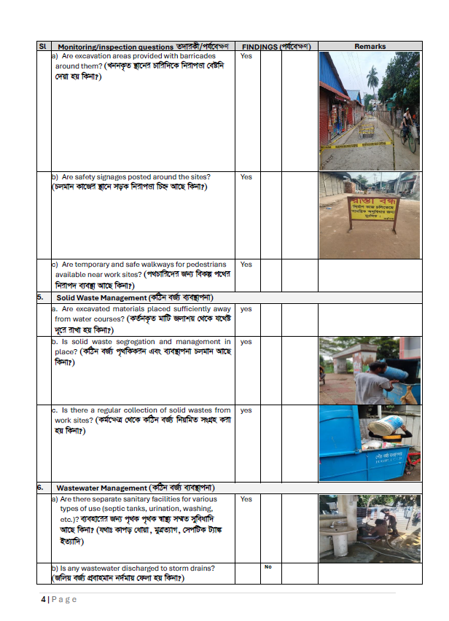

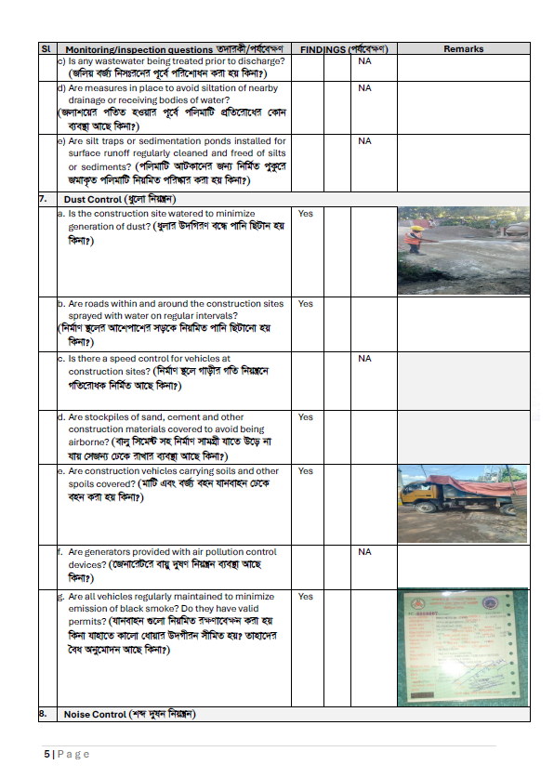

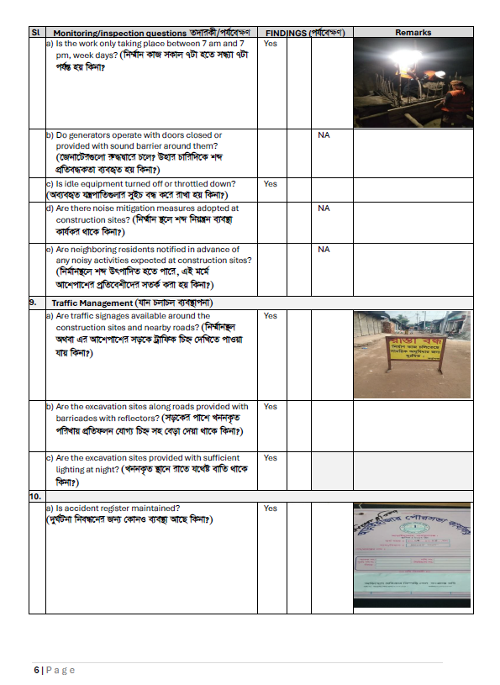

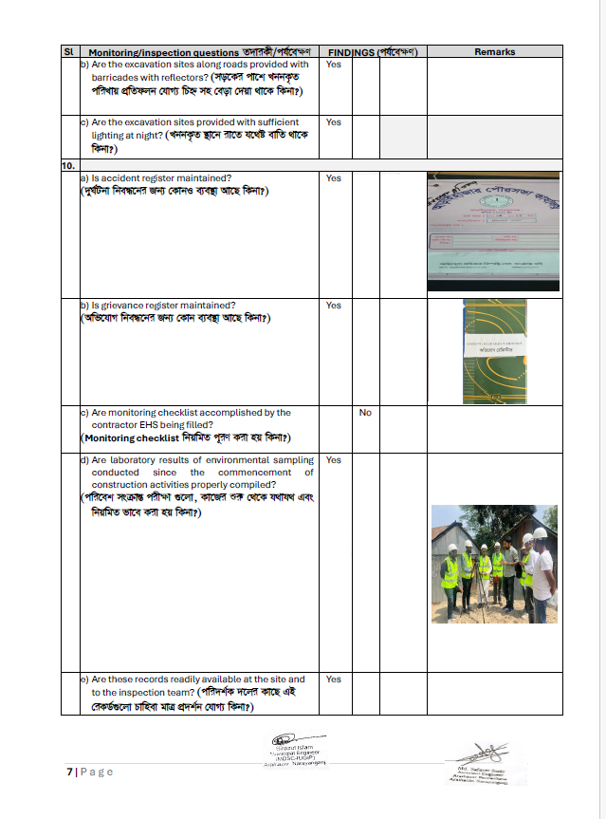

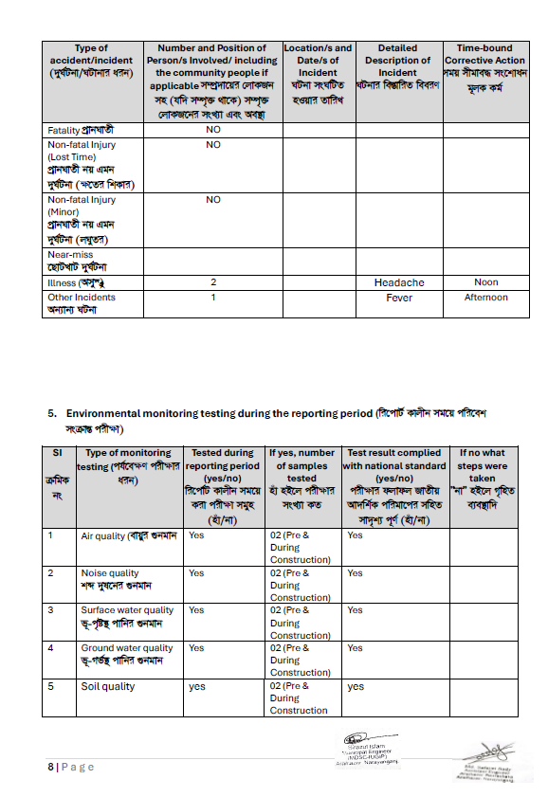

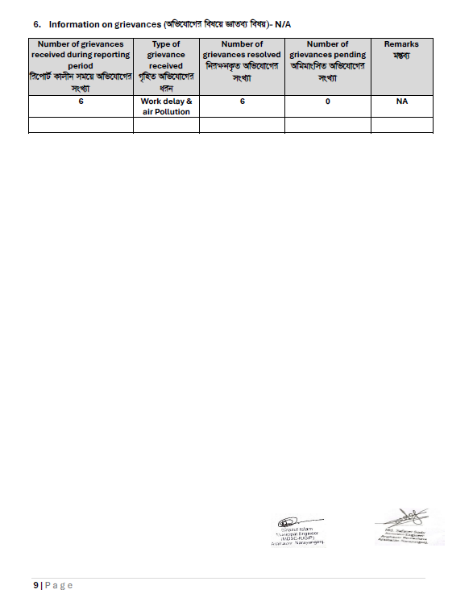

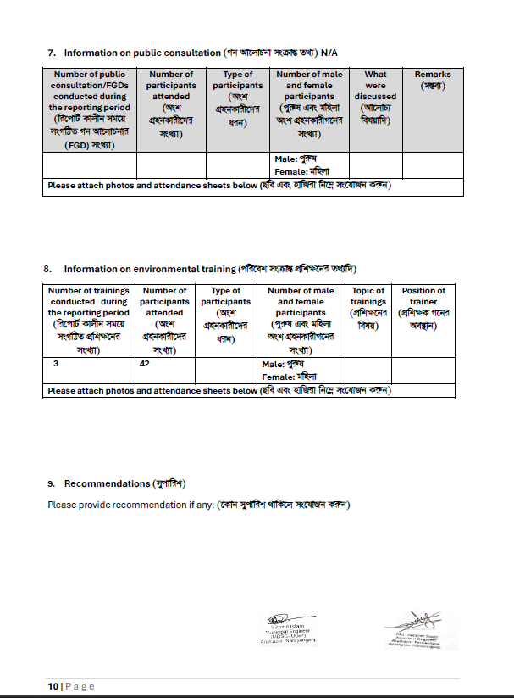

Annex 13 : Program Related Photographs
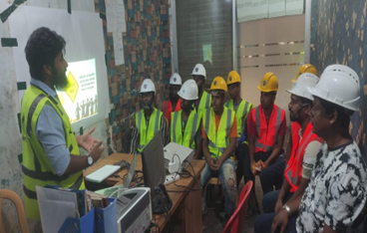
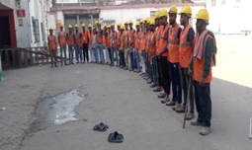

EMP Training of Brahmanbaria pourashava, Brahmanbaria
Health and Safety Talking before starting work Kaliakoir Paurashava, Gazipur.
.
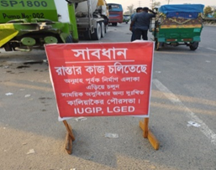
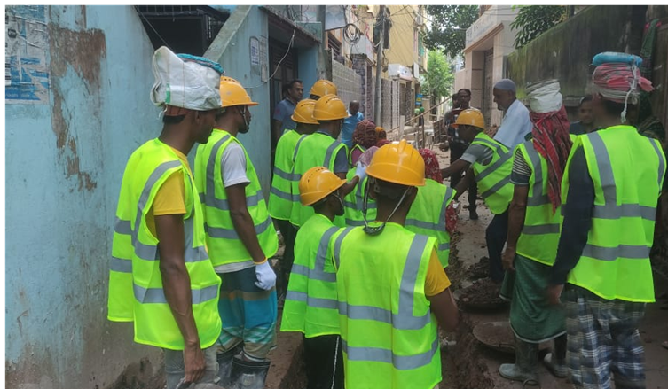

safety signage
Kaliakoir Paurashava, Gazipur.
Brahmanbaria pourashava, Brahmanbaria.

Annex 14 : Sample of Grievance and Accident Register book picture
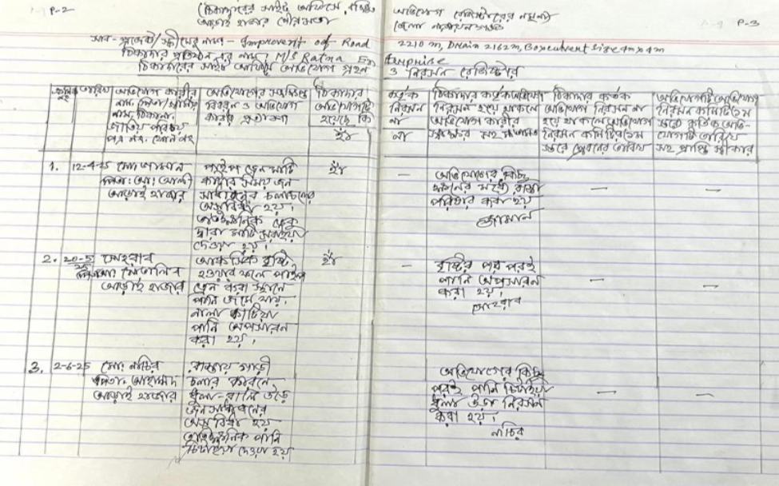

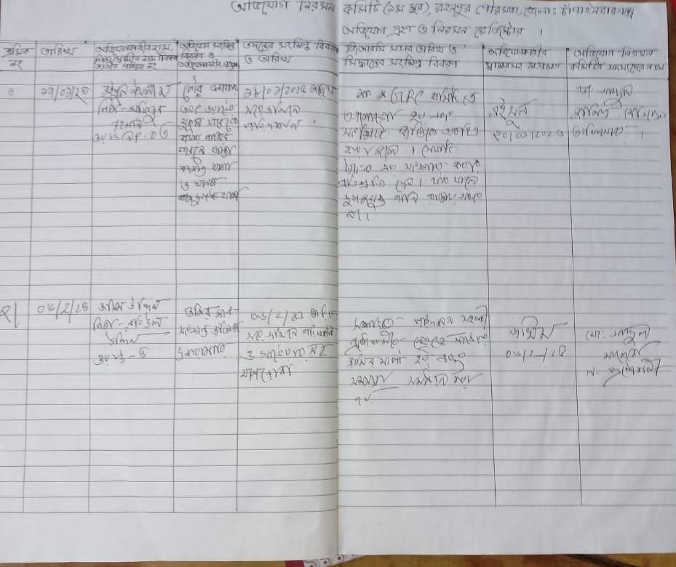

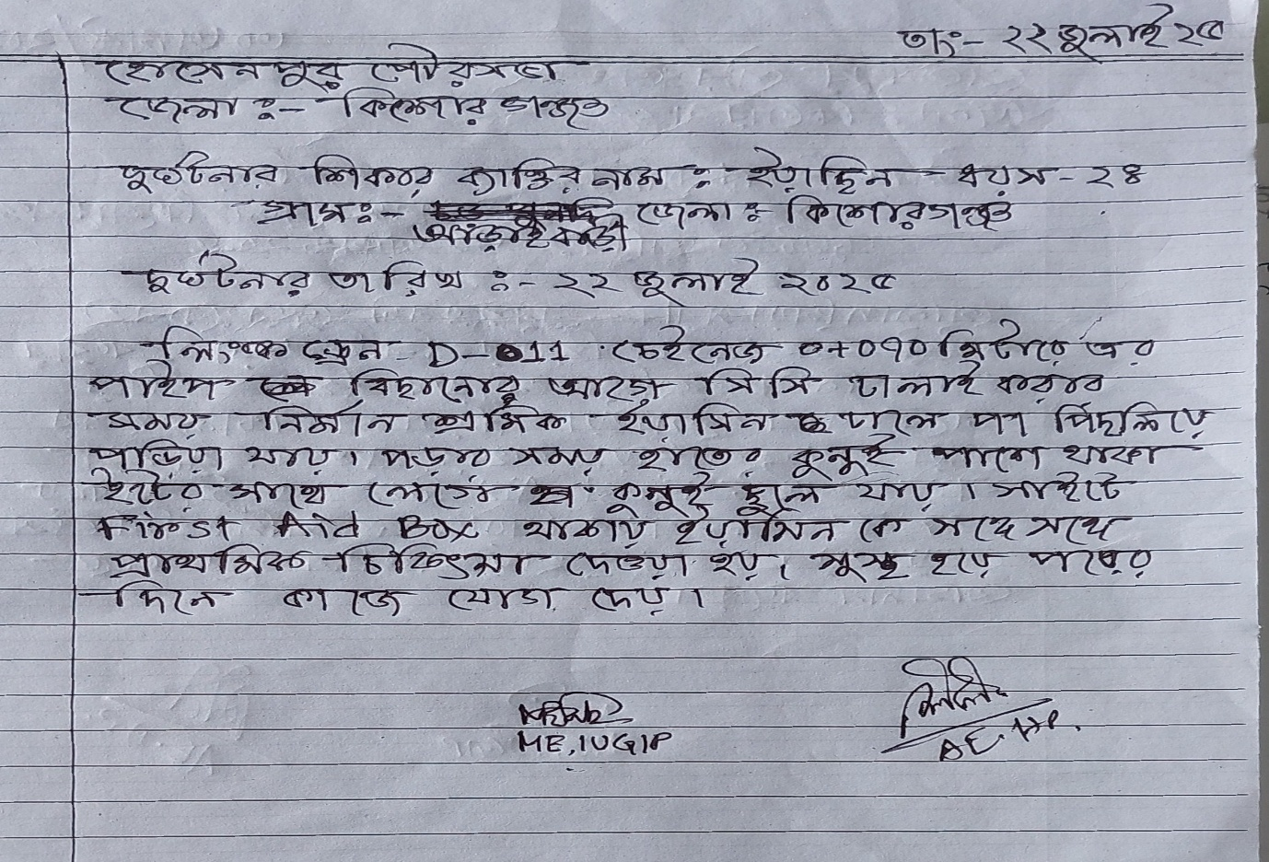

Annex 15 : Monthly Progress Report of subproject

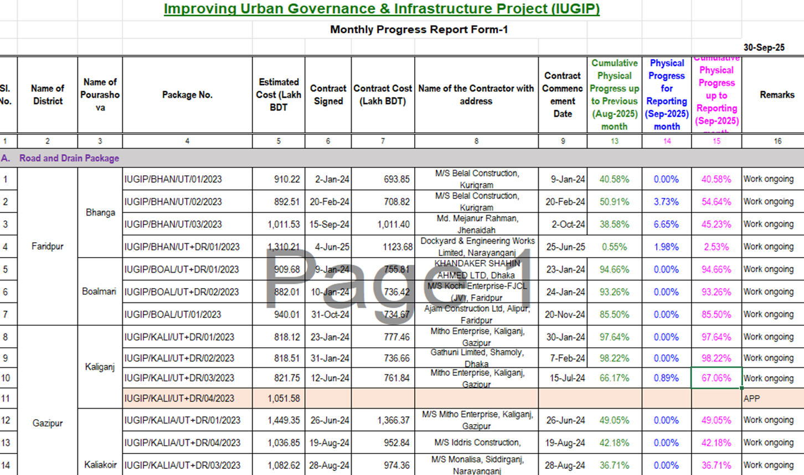

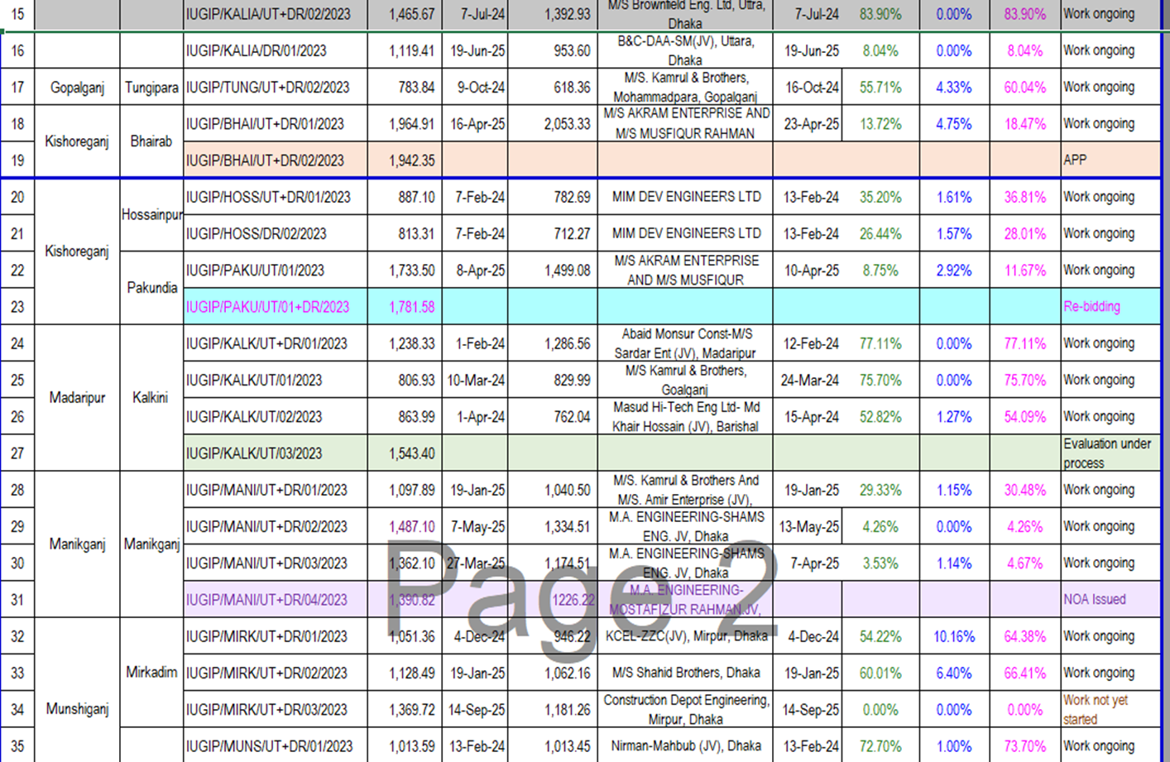

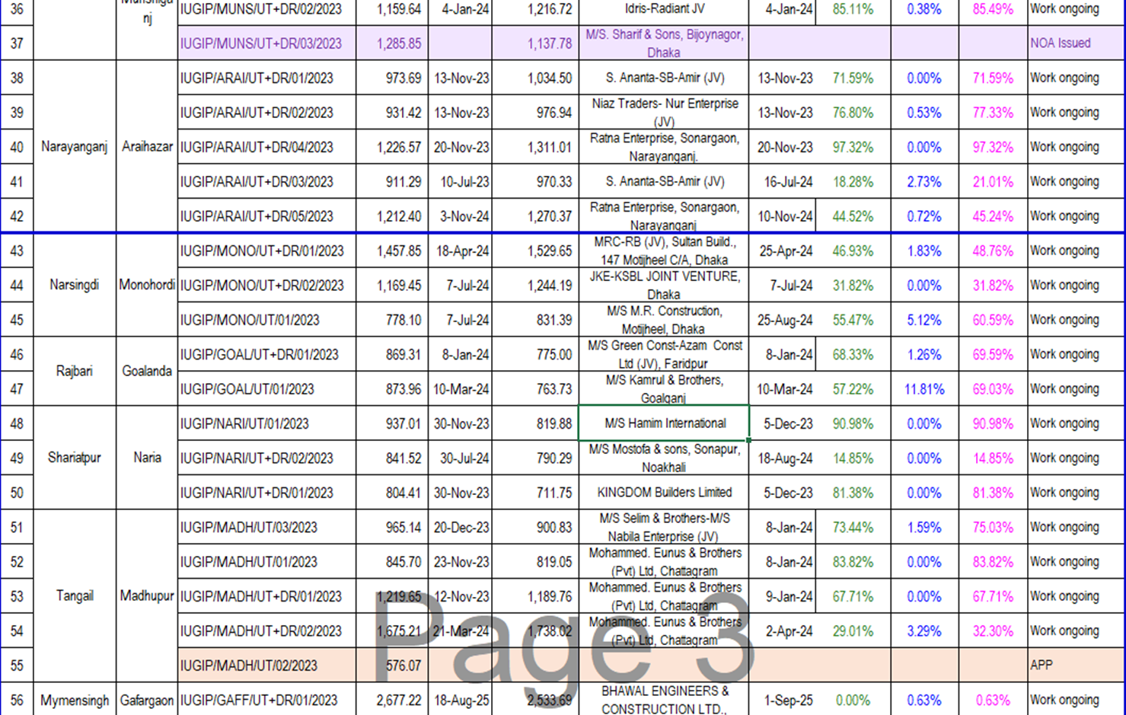

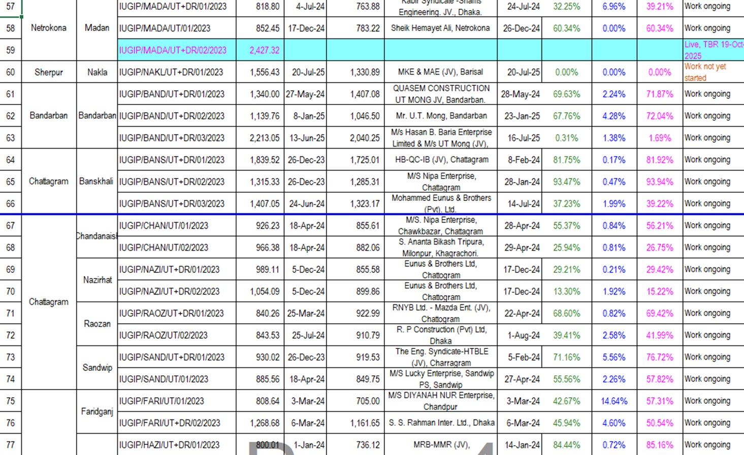
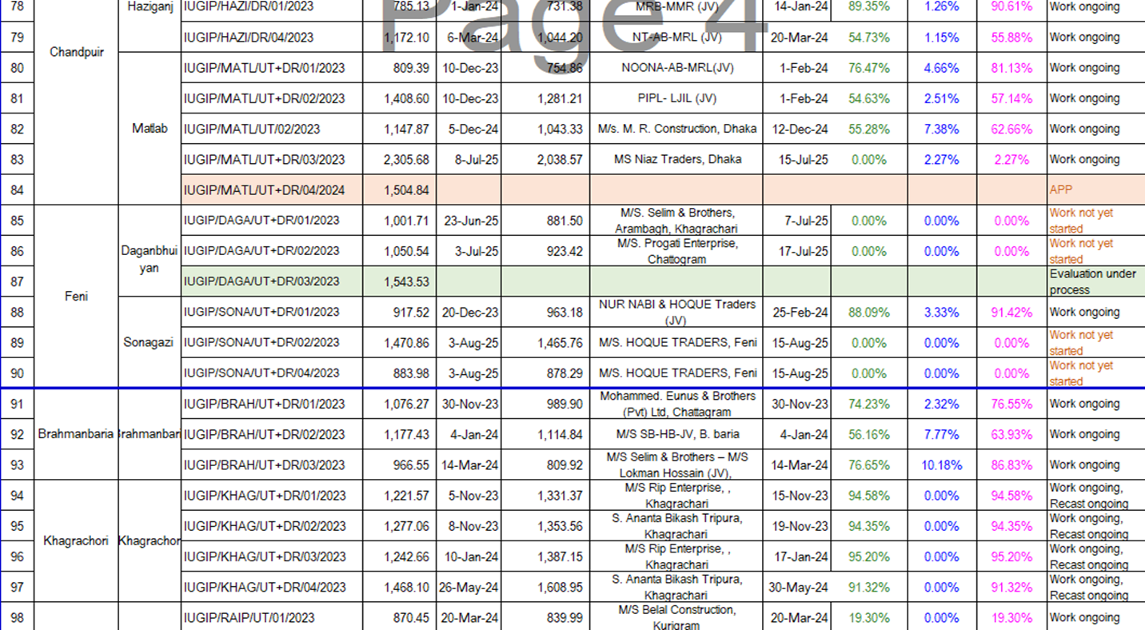

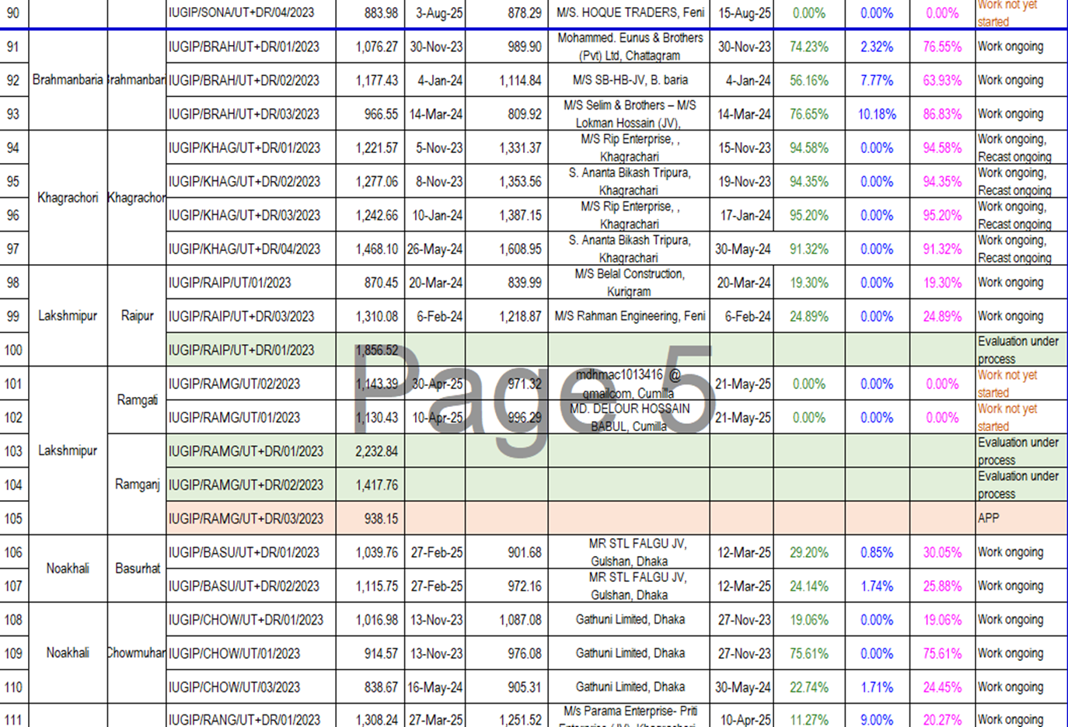

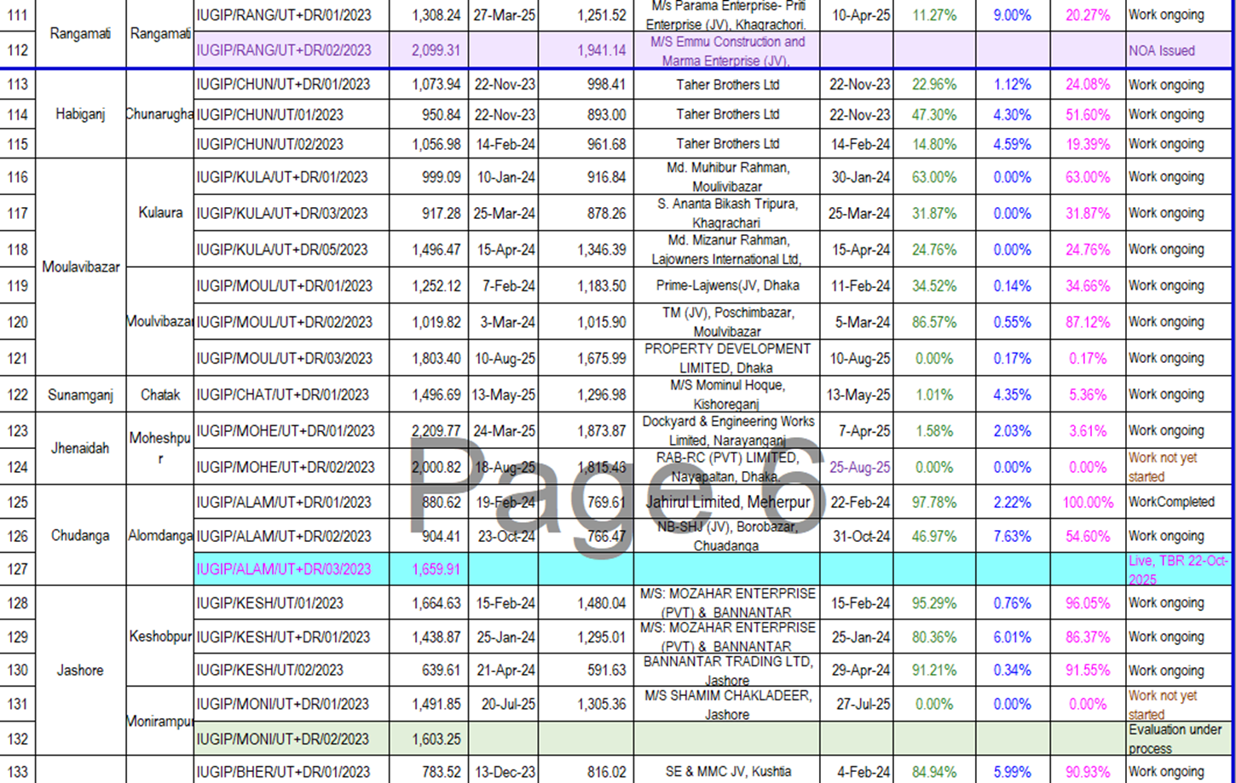

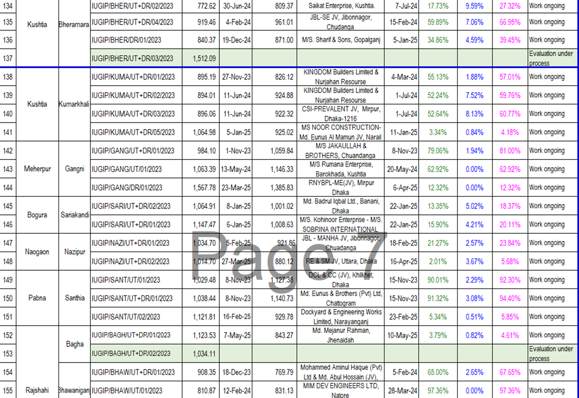

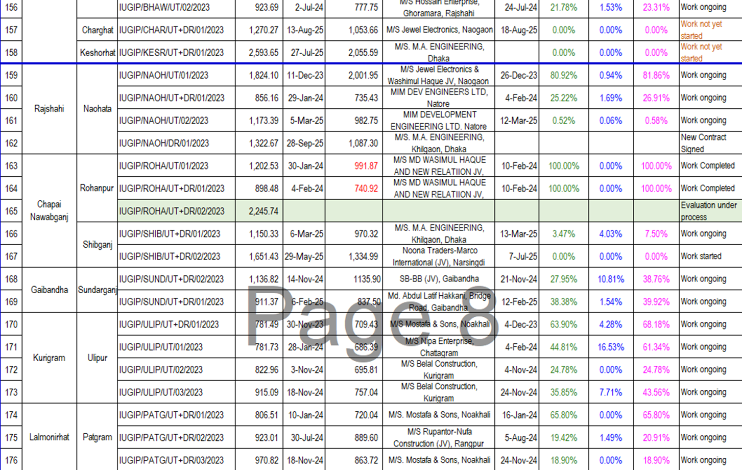
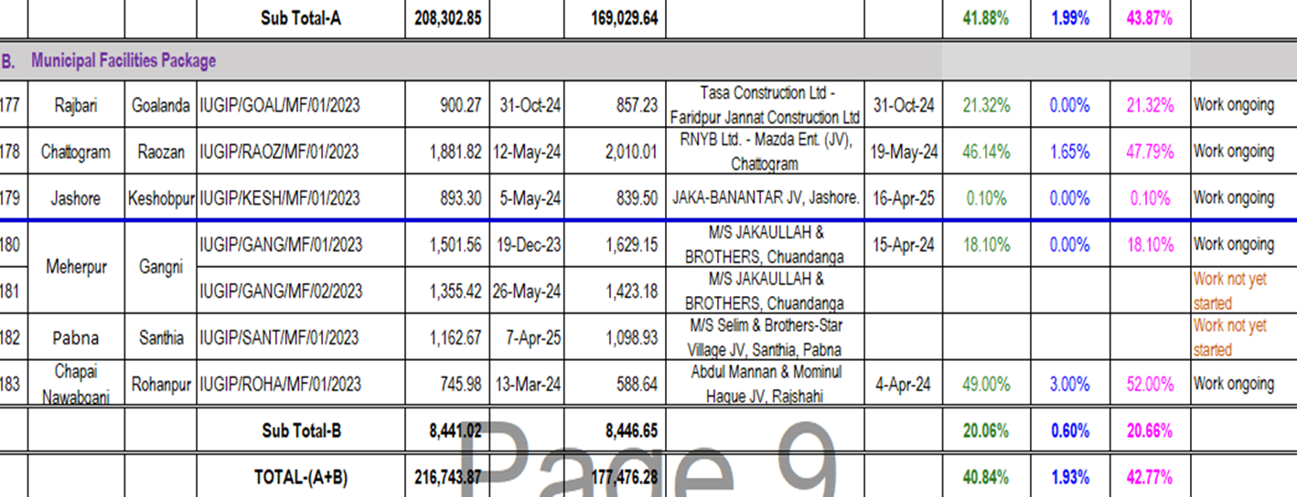

Annex 16 : Monthly Progress Report of LIN
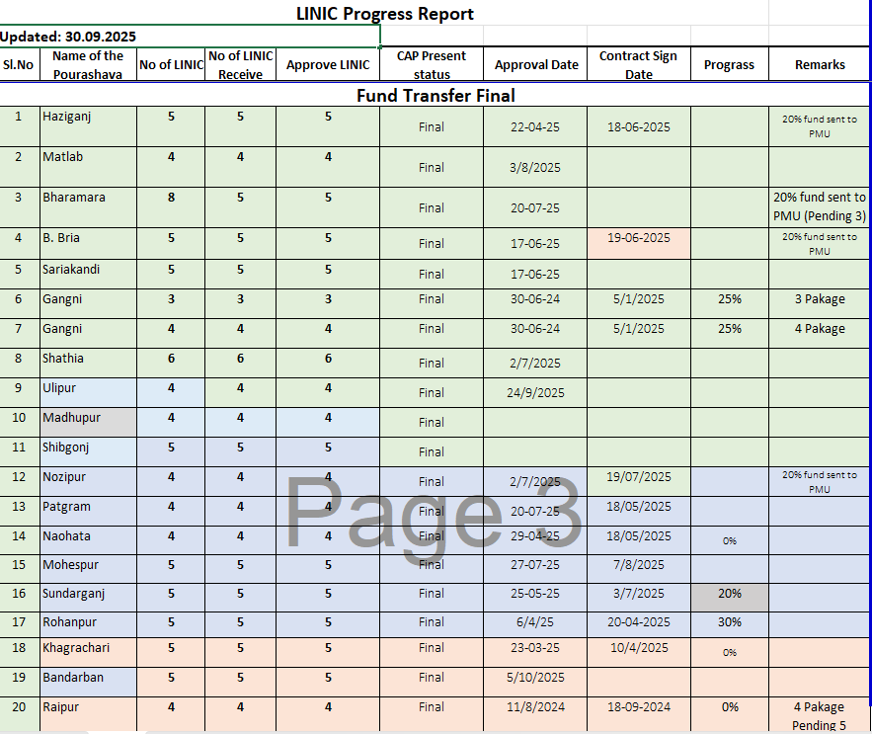

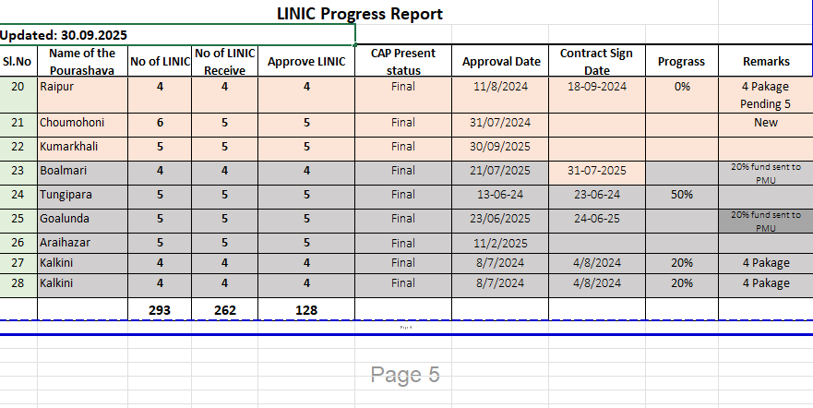

Annex 17 : Environmental Focal Person & Safeguard Officer list
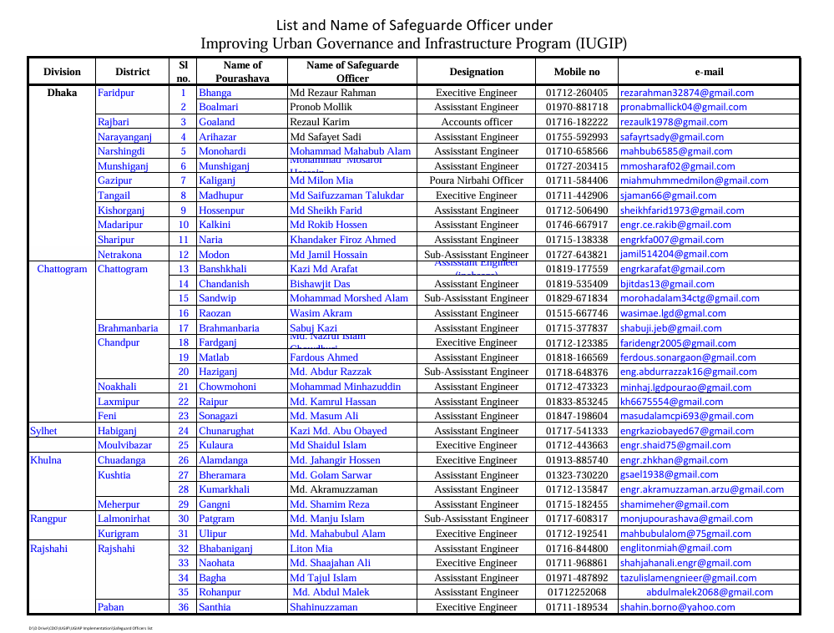

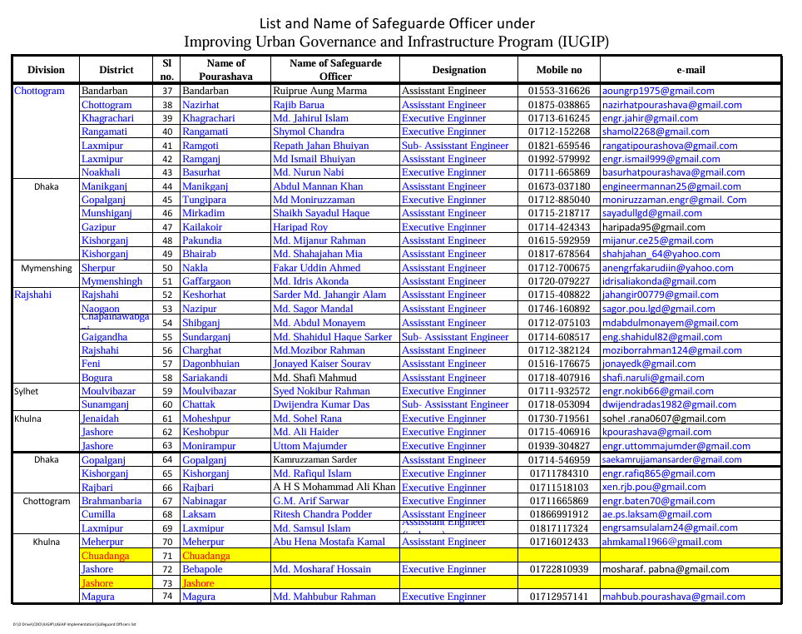

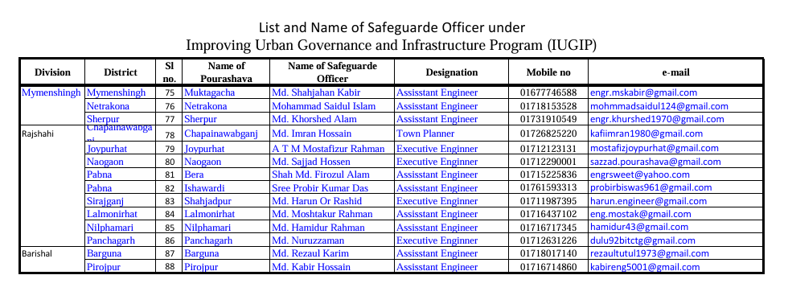

End of the Report

Not required as no such impact that require clearance from forest department or other organization.
DoE has confirmed based on the ECR, 2023 that activities of this program will not require obtaining any ECC their nature of small in scale.
https://www.adb.org/sites/default/files/institURional-document/526346/mainstreaming-rbl-programs.pdf
https://www.adb.org/sites/default/files/institURional-document/32056/safeguard-policy-statement-june2009.pdf
Latest SEMR was prepared covering Oct 2024-Mar 2025, submitted to ADB and finalized upon receiving ADB’s comments that have been disclosed both in ADB website and LGED website. Link of disclosed SEMR in ADB website: https://www.adb.org/projects/documents/ban-55307-001-emr-1 Link of disclosed SEMR in LGED website: https://www.iugip-lged.org/document_archieve/document.archieve.viewer.php

